**Walchand College Of Engineering, Sangli**

**Data Mining LAB BOOK**

**(2022-23)-Sem VII**

**Name: Rohan Nivas Chavan**

**PRN:2019BTEIT00084**

| **Sr. No** | **Title** | **Page No.** |
| --- | --- | --- |
| 1. | Study and use of different types of graphs and charts  (use MS-XLS). | 2. |
| 2. | Perform Normalization of data  (Min-max and Z-score). | 7. |
| 3. | Find Info Gain of an attribute from given data. | 17. |
| 4. | Find t and d weight of a data. | 27. |
| 5. | Find 5 no summary of a dataset. | 32. |
| 6. | Find frequent item sets from given transaction data. | 39. |
| 7. | Extend program 6, to find association rules. | 56 |
| 8. | Find correlation between items/entities. | 71 |
| 9. | Distance and cluster | 75 |
| 10. | Agglomerative Hierarchical Single Linkage Clustering | 86 |
| 11. | Attribute for classification A. Gain B. Gini index | 98 |
| 12. | WAP for Bayes classification | 109 |
| 13. | WAP a program to implement any DM concept on complex data type | 118 |
| 14. | Homework | 121 |

**vExperiment No.1**

Study and use of different types of graphs.

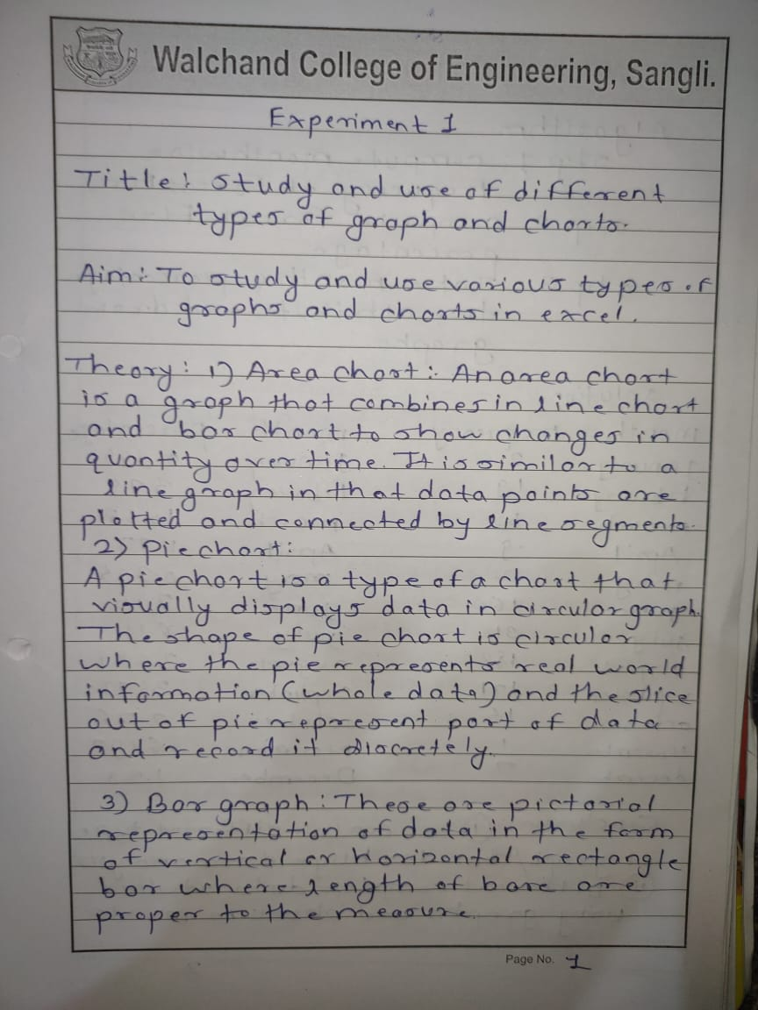

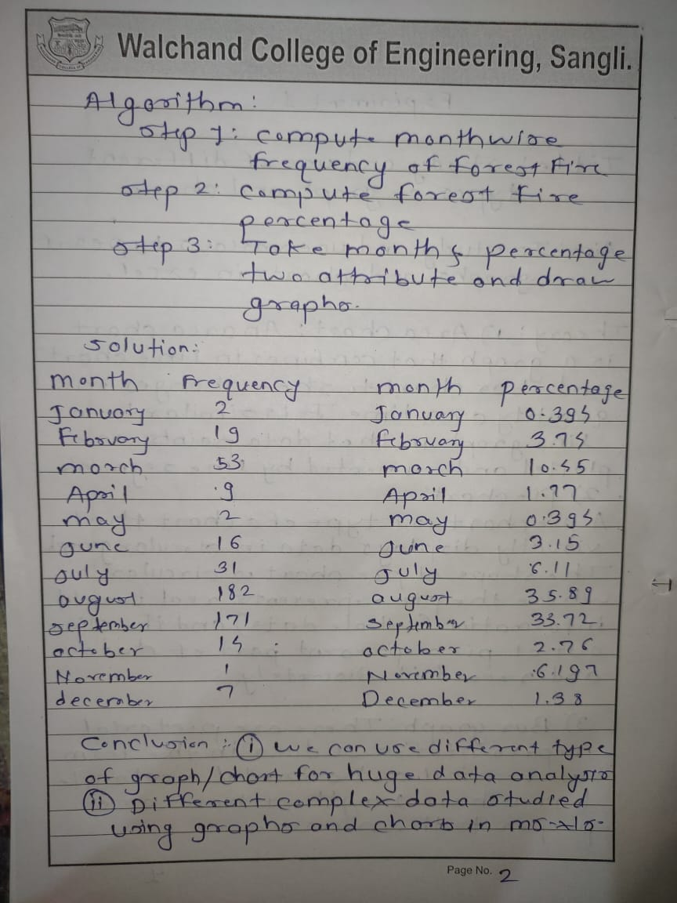

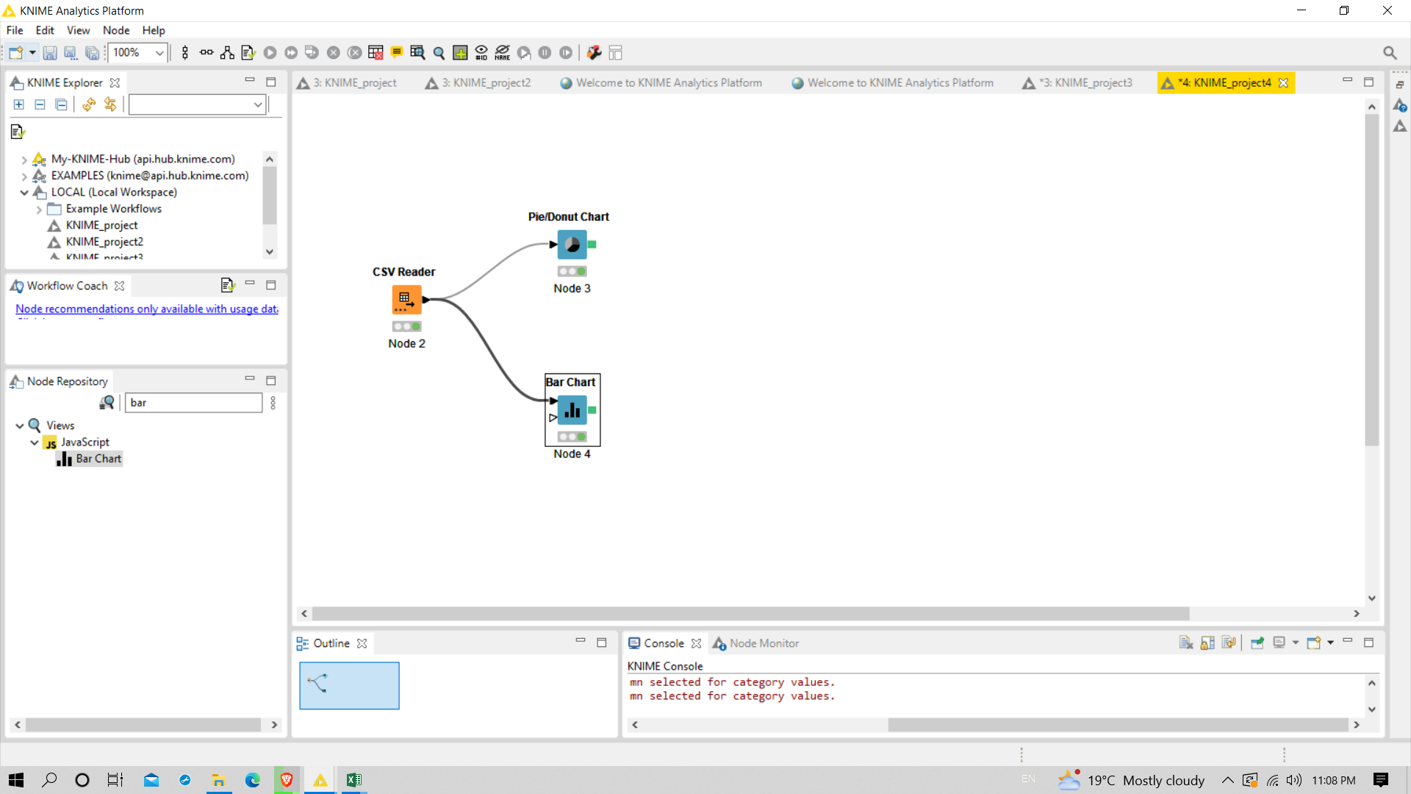

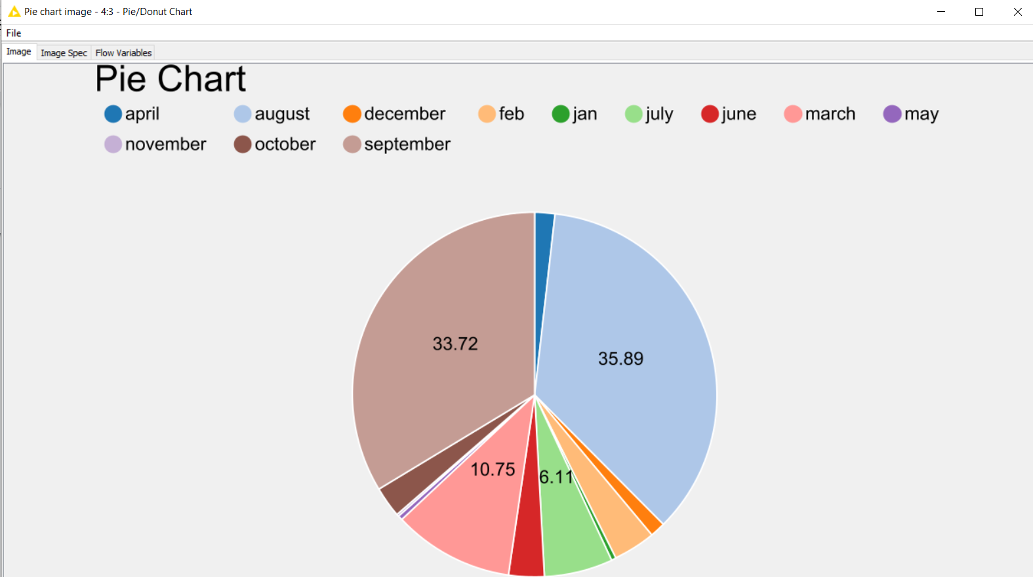

**Data set(Forest Fire)**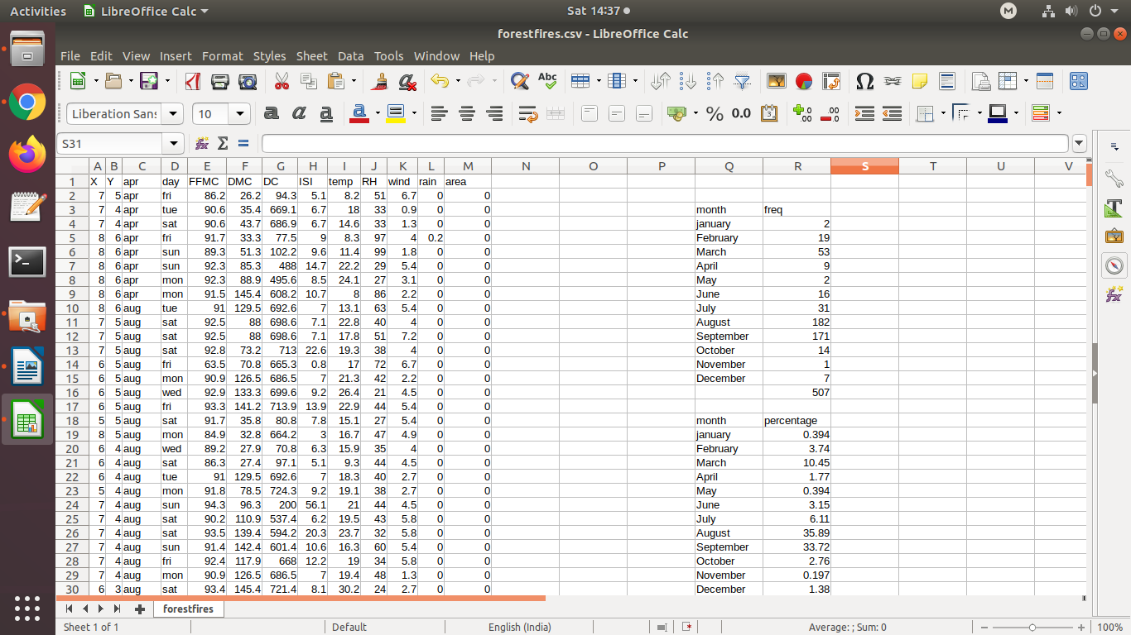

**Output:**

**1)Pie chart**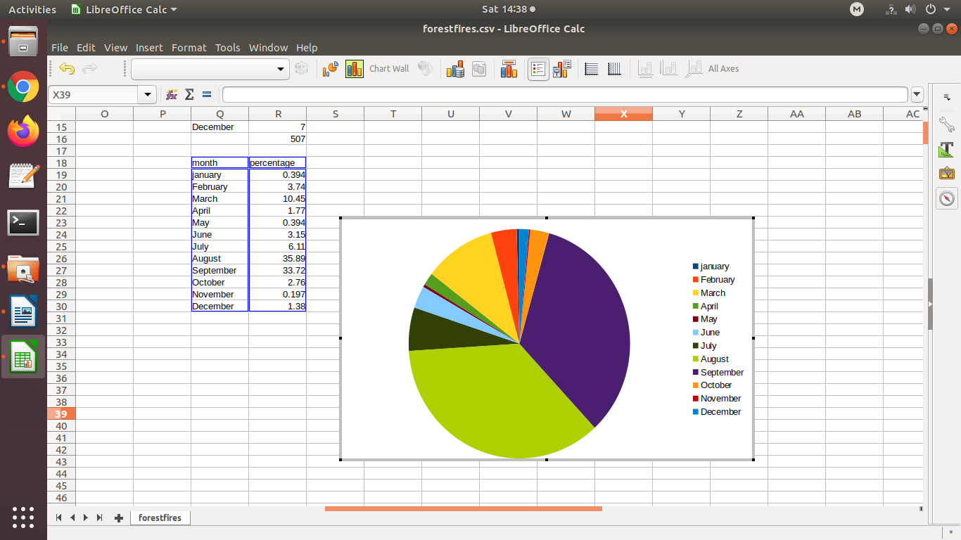

2)Line chart

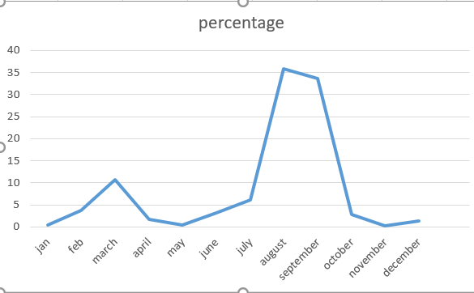

3)bar chart

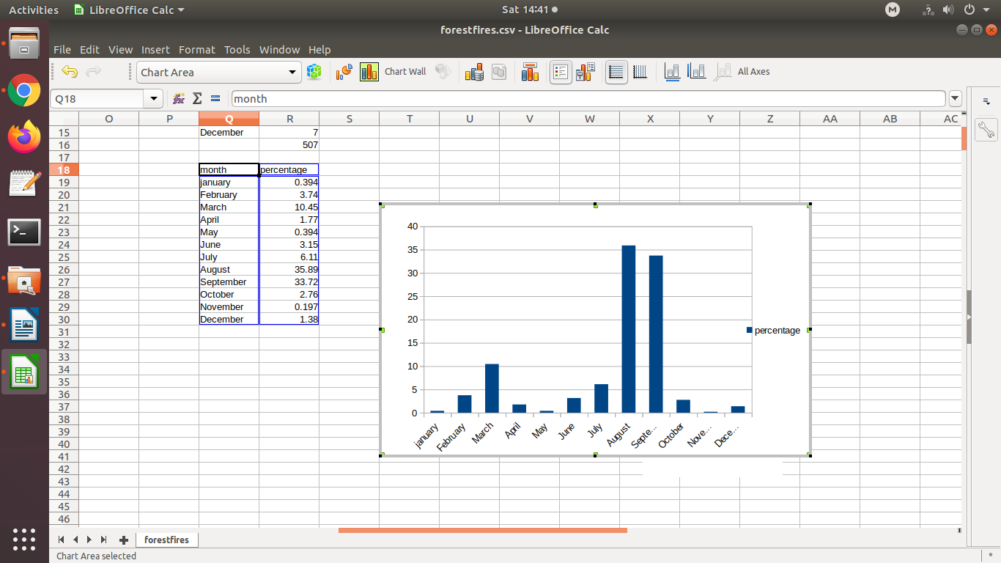

**Conclusion: By using forest fire dataset provided by UCI machine learning repository, we can able to understand the various graphs, charts. Also i draw graph for huge data set by performing some calculations.**

**Experiment No.2**

**Perform Normalization of Data(Min-Max and Z-score)**

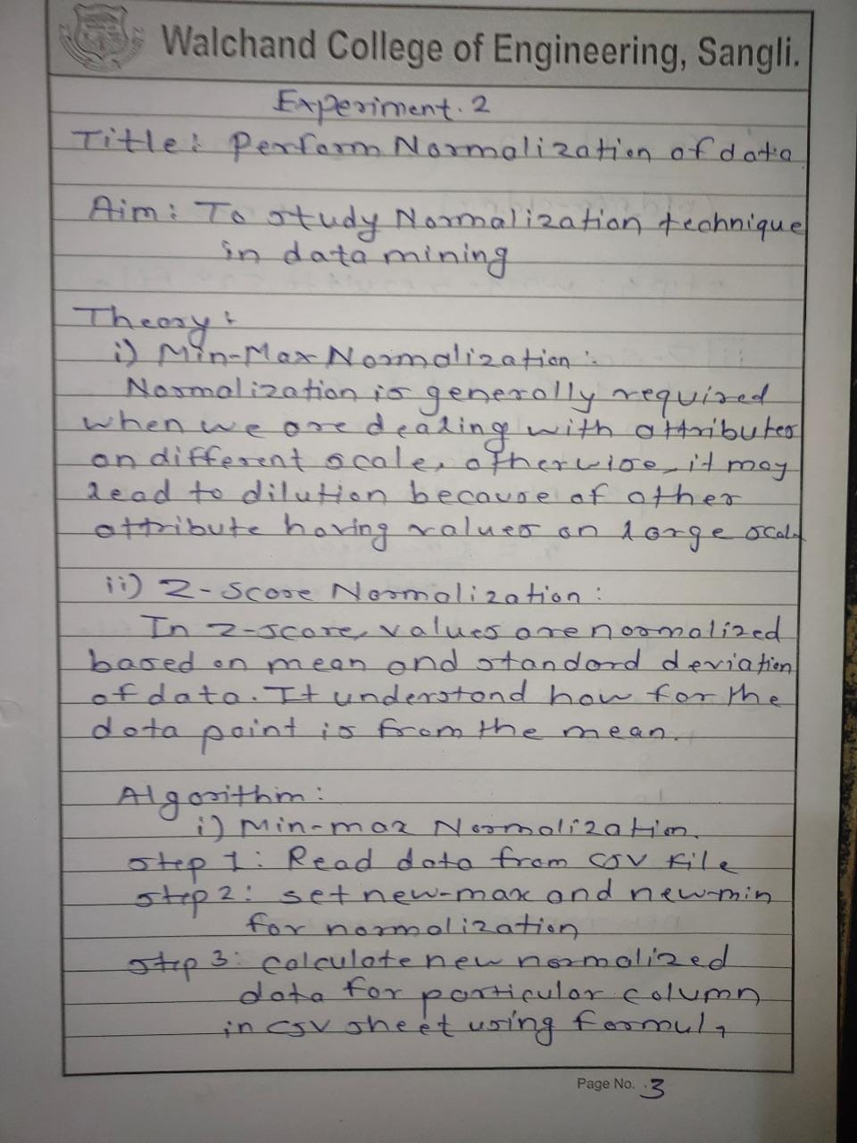

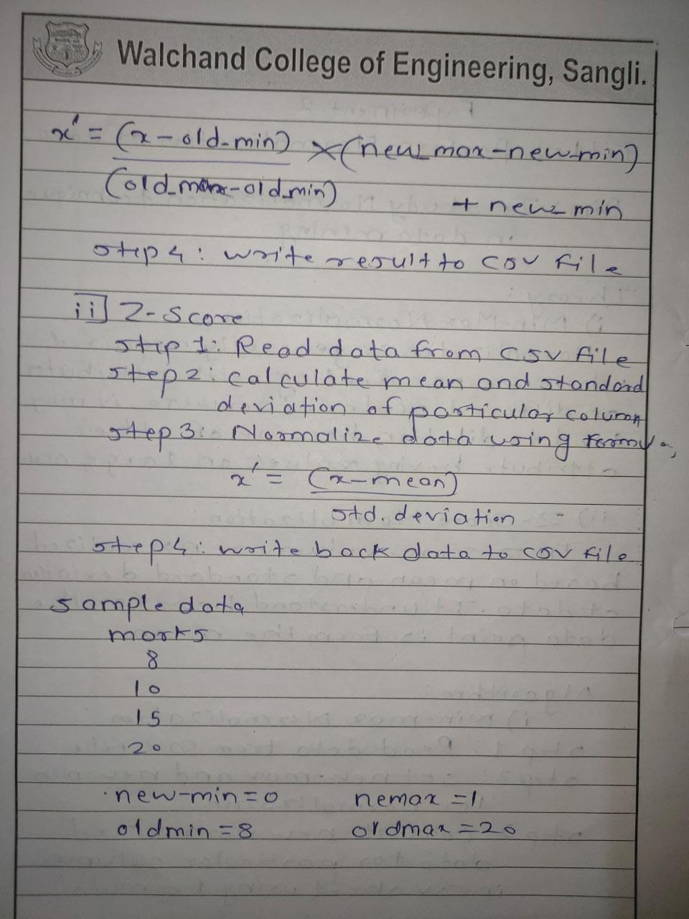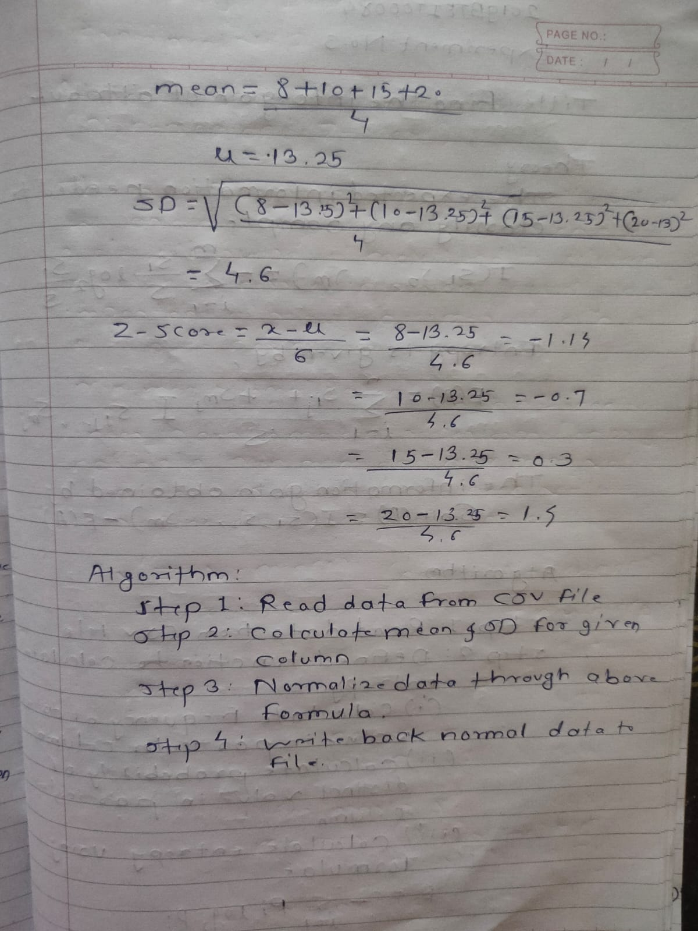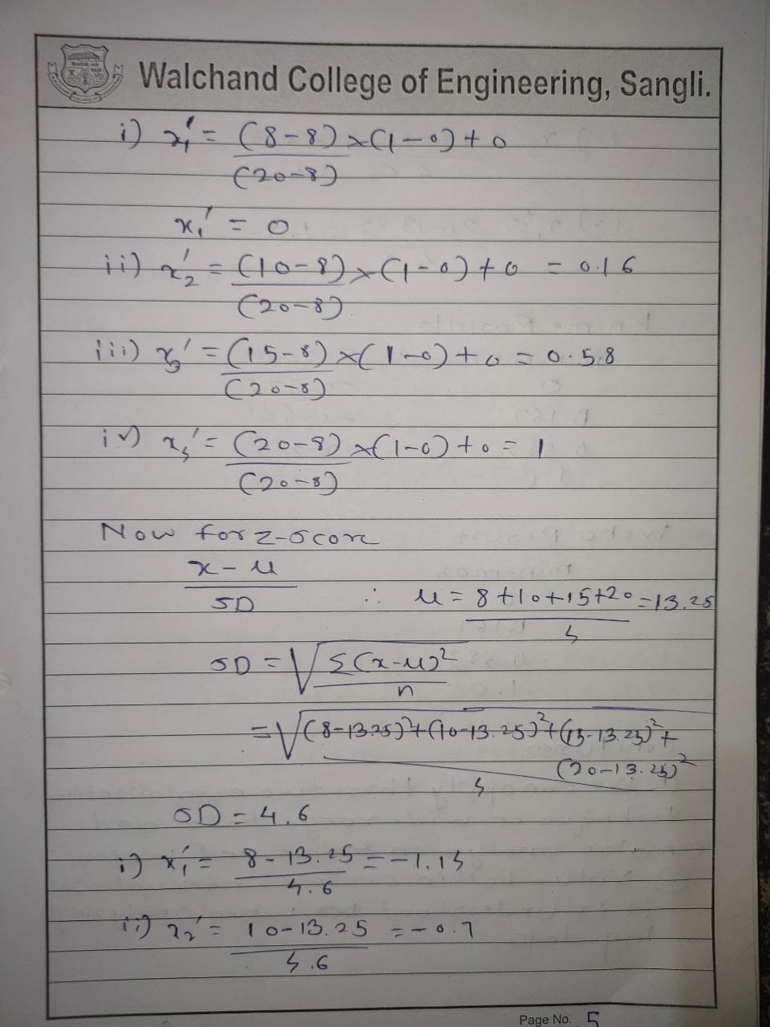

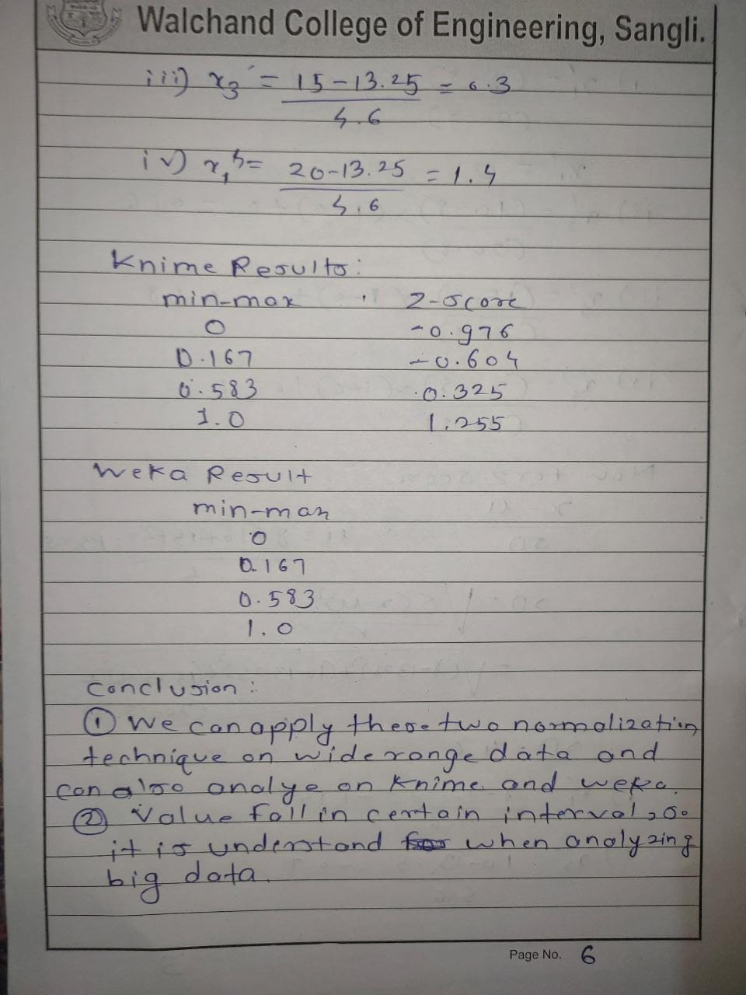

Using Knime

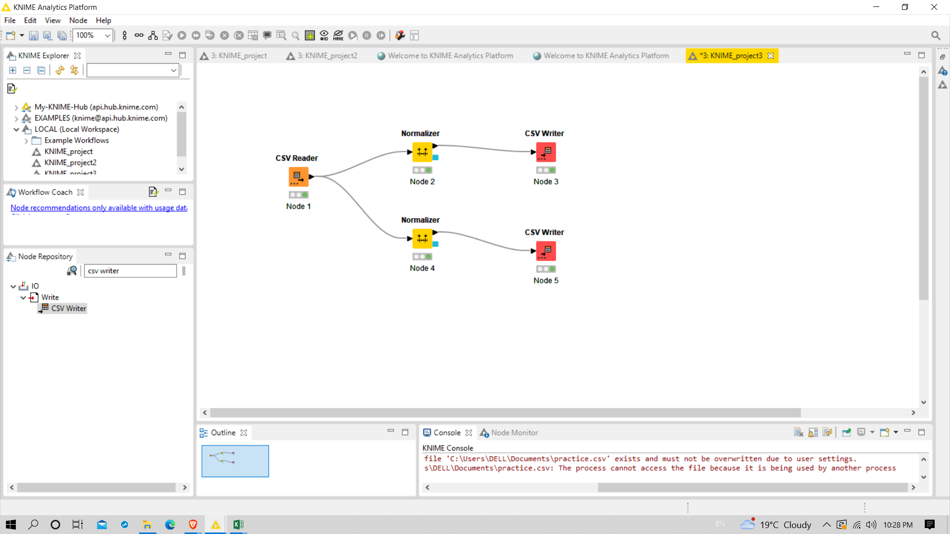

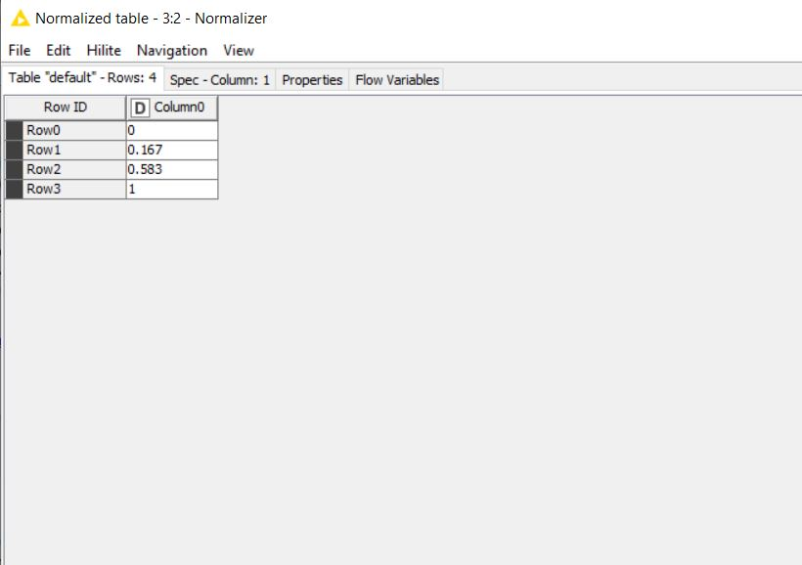

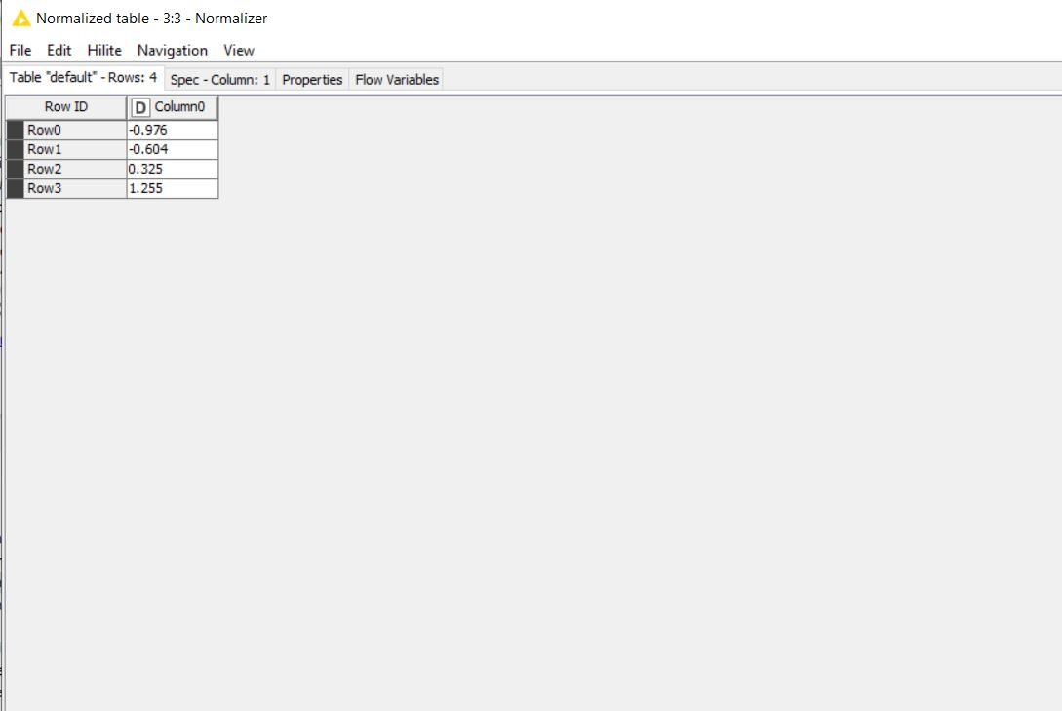

**Program:**

//PRN:2019BTEIT00084

//NAME:Rohan Nivas Chavan

import java.lang.*;

import java.util.*;

import java.io.*;

public class Normalization

{

public static void main(String[] args) throws Exception

{

BufferedReader in = new BufferedReader(new FileReader("C://Users/Dell/Desktop/input_Norm.csv"));

String inputLine = in.readLine();

String [] fields = inputLine.split(","); // Splits at the space

int i=0;

int [] arr=new int[fields.length];

for(String str:fields){

int x=Integer.parseInt(str); //prints out name

arr[i++]=x;

}

int max1=Integer.MIN_VALUE;

int min1=Integer.MAX_VALUE;

for( i=0;i<arr.length;i++)

{

if(arr[i]>max1)

max1=arr[i];

}

for( i=0;i<arr.length;i++)

{

if(arr[i]<min1)

min1=arr[i];

}

int max2=1;

int min2=0;

double normArray[]=new double[arr.length];

for( i=0;i<arr.length;i++)

{

normArray[i]=(double)((double)(arr[i]-min1)/(double)(max1-min1));//using min_max method.

}

//writing data to file.

PrintWriter out=new PrintWriter(new File("output_normalization.csv"));

out.printf("%s,%s,%s","Value","min_max_norm","z-score_norm");

double mean=0.0;

double sum=0.0;

for(i=0;i<arr.length;i++)

{

sum+=arr[i];

}

mean=sum/arr.length;

int n=arr.length;

double sd=0.0;

double sqrsum=0.0;

for( i=0;i<n;i++)

{

sqrsum=sqrsum+(arr[i]-mean)*(arr[i]-mean);//calculating standard deviation

}

sqrsum=sqrsum/n;

sd=Math.sqrt(sqrsum);

double zscore[]=new double[n];

for( i=0;i<n;i++)

{

zscore[i]=(arr[i]-mean)/sd;//calculating z score

}

for(i=0;i<n;i++)

{

out.printf("\n");

out.printf("%d,%.3f,%.3f",arr[i],normArray[i],zscore[i]);

}

out.close();

}

}

**Input:**

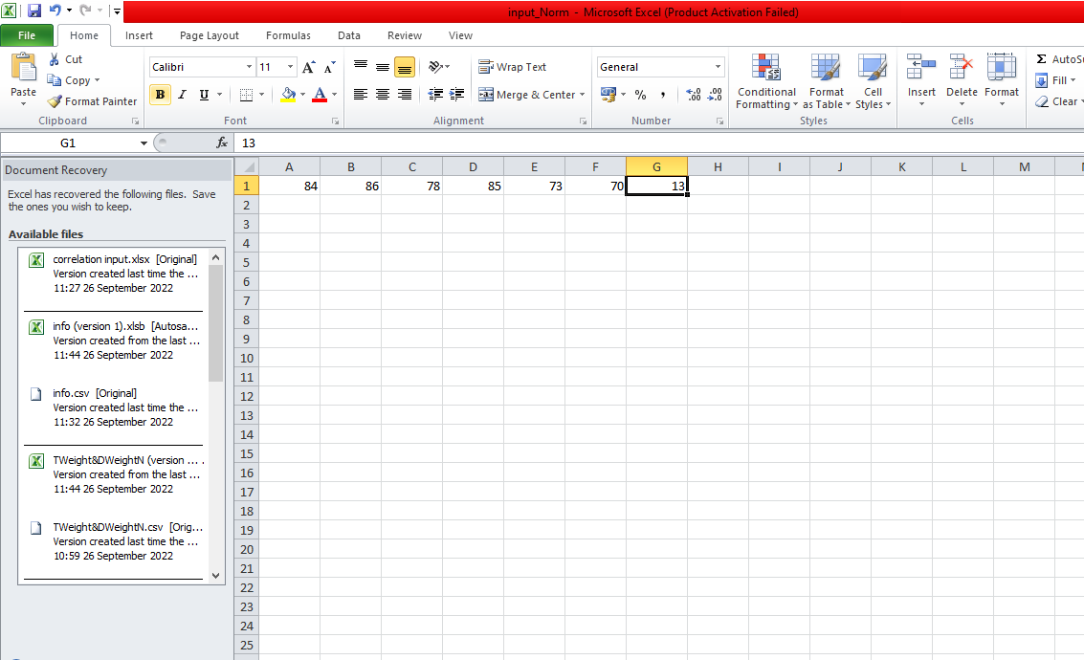

**Output:**

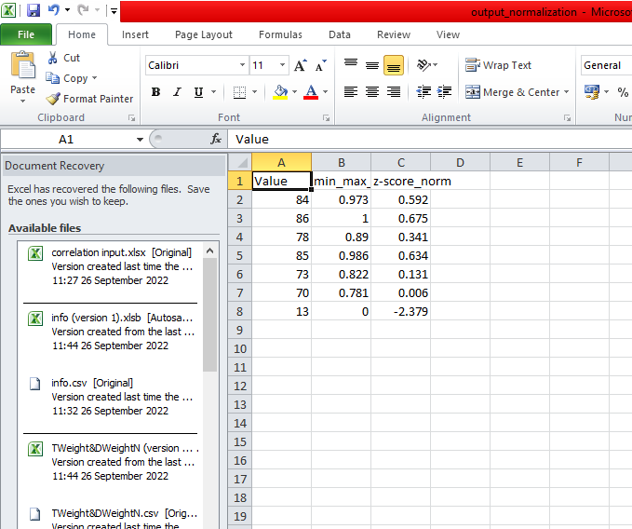

**Conclusion:**

**Successfully performed min-max and z-score normalization with code**

**implementation.**

**2019BTEIT00084**

**DM Lab**

**Experiment No.3**

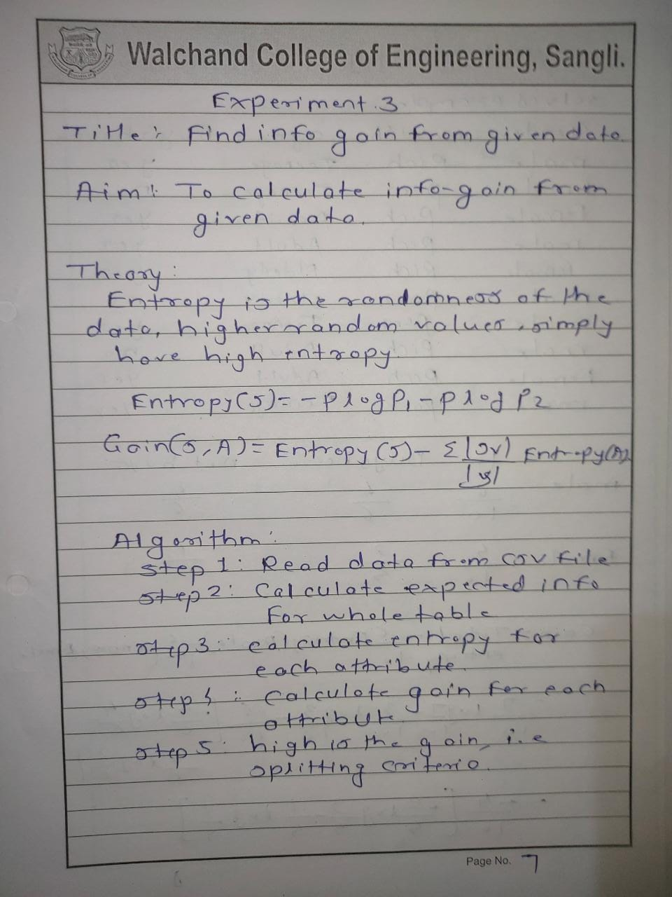

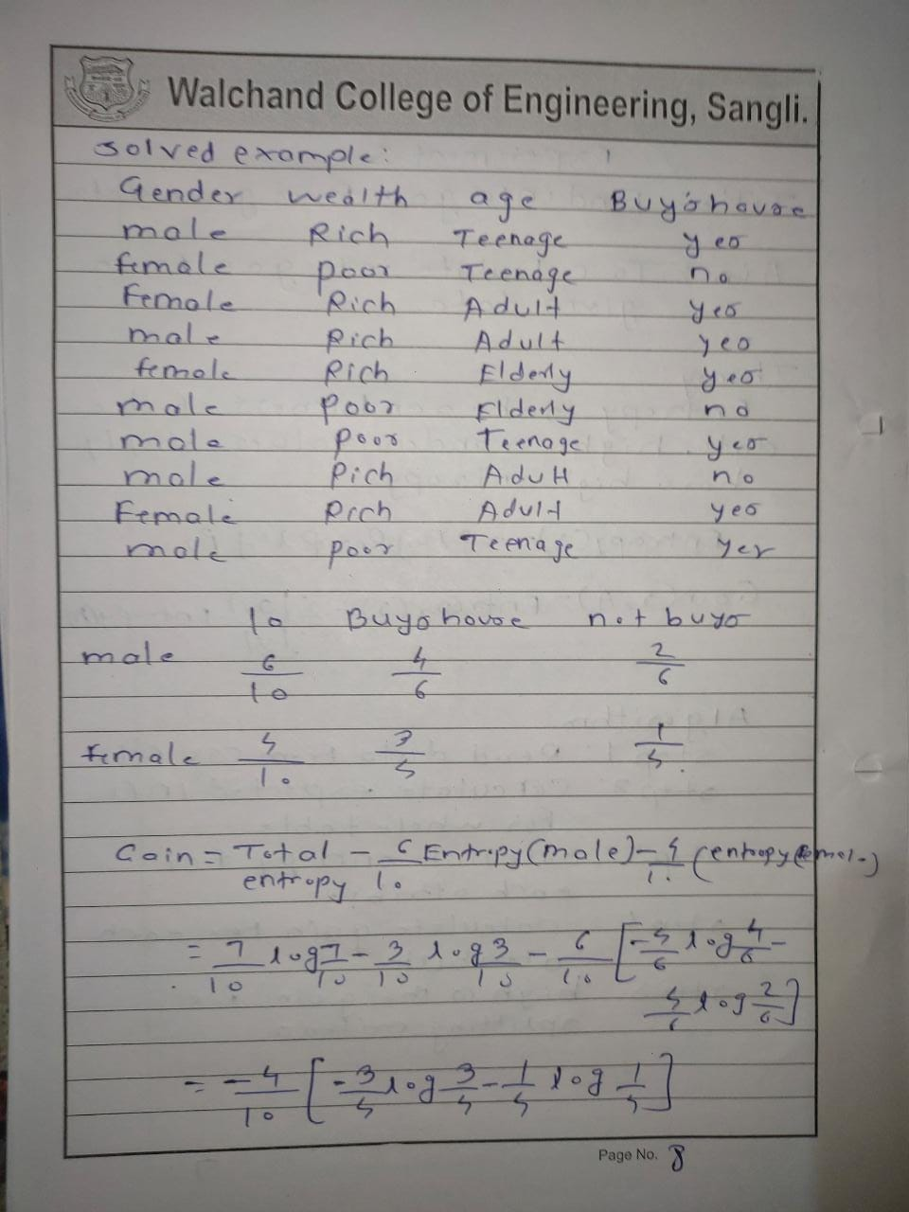

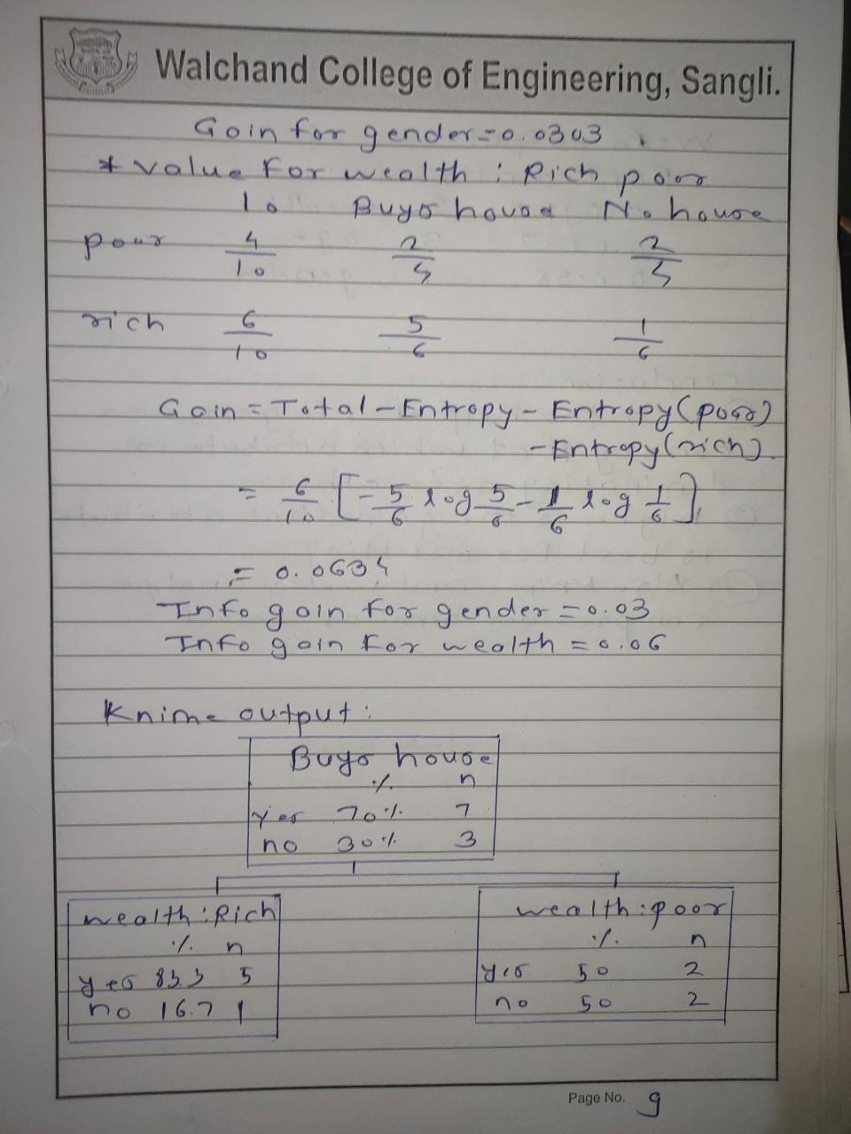

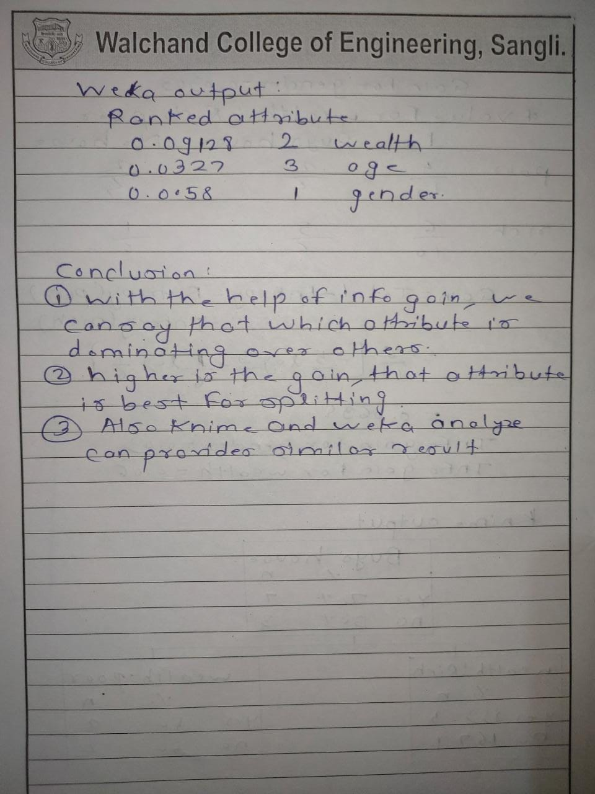

**Using knime**

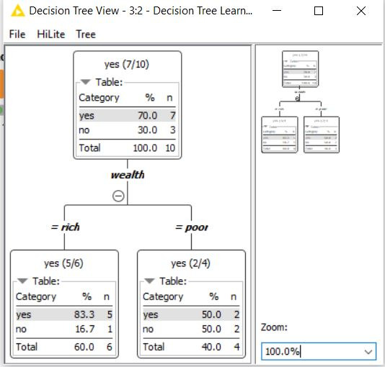

**Weka**

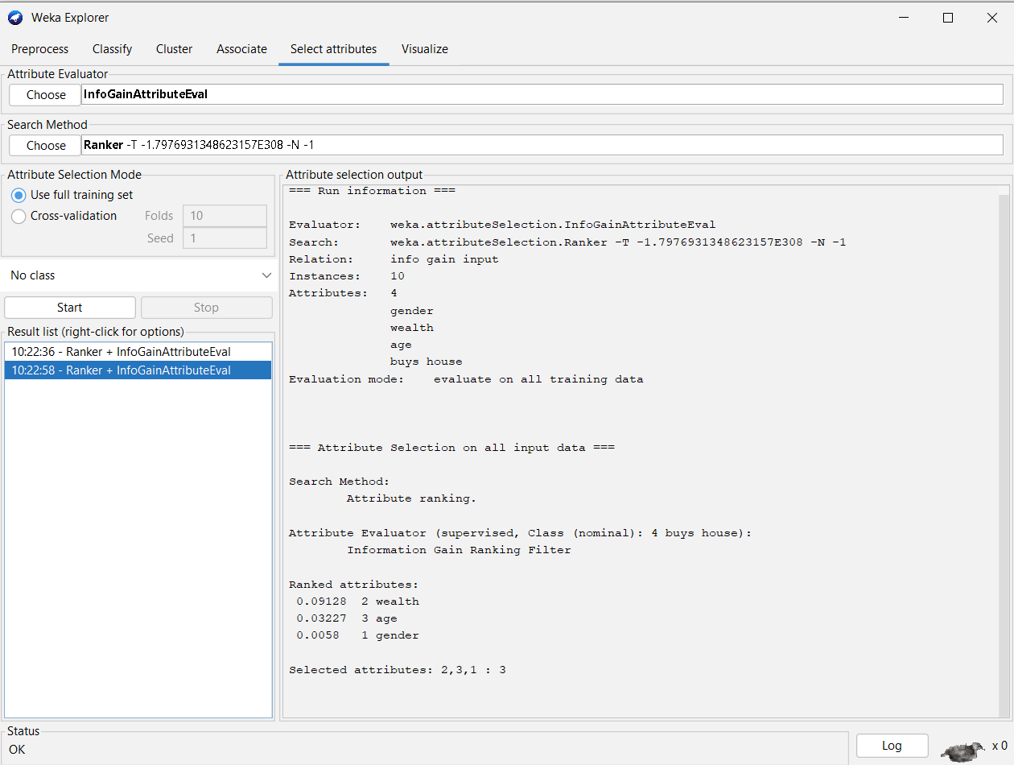

**Program:**

//PRN:2019BTEIT00084

//NAME:Rohan Nivas Chavan

import java.lang.*;

import java.util.*;

import java.io.*;

class Information_gain

{

public static void main(String[] args) throws Exception

{

BufferedReader br = new BufferedReader(new FileReader("C://Users/Dell/Desktop/info_gain.csv"));

ArrayList<ArrayList<String>> data = new ArrayList<>();

String line="";

while((line=br.readLine())!=null)

{

String str[] =line.split(",");

ArrayList<String> temp = new ArrayList<>();

for (String s : str)

temp.add(s);

data.add(temp);

}

int posR = 0, negR = 0;

for (int i = 0; i < data.size(); i++) {

if (data.get(i).get(5).equals("Yes"))//considering target value as 5th attribute

posR++;

else

negR++;

}

double totRecord = data.size();

double infoGain= -((1.0 * posR / totRecord) * (Math.log(1.0 * posR / totRecord)) / Math.log(2)) - ((1.0 * negR / totRecord) * (Math.log(1.0 * negR / totRecord) / Math.log(2)));

PrintWriter out=new PrintWriter(new File("output_infogain.csv"));

out.printf("%s,%s","Attribute","Info_Gain");

out.printf("\n");

for(int i=0;i<data.get(0).size()-1;i++)

{

out.printf("%s,%.3f\n",data.get(0).get(i),findAllEntropy(i,infoGain,data));

}

out.close();

}

private static double findAllEntropy(int i, double infoGain, ArrayList<ArrayList<String>> data) {

Set<String> attribute=new HashSet<>();

for(ArrayList<String>x:data)

attribute.add(x.get(i));

Map<String,double[]>total=new HashMap<>();

for(String x:attribute)

{

total.put(x,new double[2]);

}

for(ArrayList<String> x:data)

{

if(x.get(5).equals(("Yes")))

total.get(x.get(i))[0]++;

else

total.get(x.get(i))[1]++;

}

double totalE=0.0;

for(Map.Entry<String,double[]> x:total.entrySet())

{

double total1=x.getValue()[0]+x.getValue()[1];

if(x.getValue()[0]==0||x.getValue()[1]==0)

continue;

double temp= -((1.0 * x.getValue()[0] / total1) * (Math.log(1.0 * x.getValue()[0] / total1)) / Math.log(2)) - ((1.0 * x.getValue()[1]/ total1) * (Math.log(1.0 * x.getValue()[1] / total1) / Math.log(2)));

totalE+=(total1/ data.size())*temp;

}

double gain=infoGain-totalE;

return gain;

}

}

**Output:**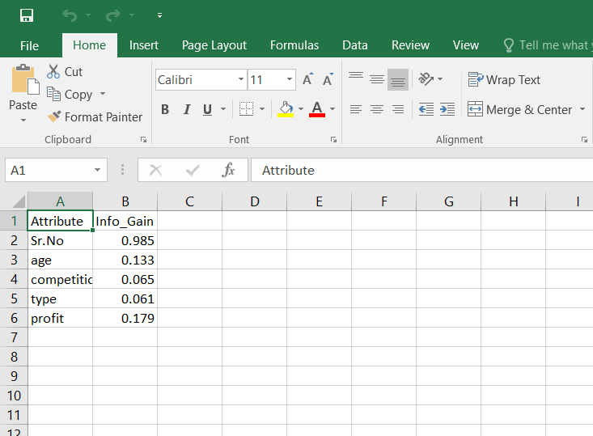

**Input file:**

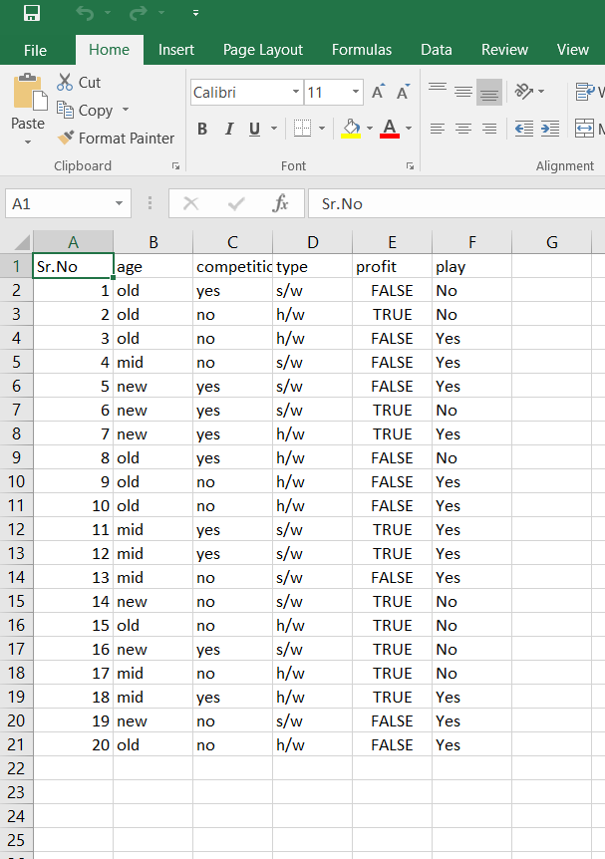

Conclusion:Successfully performed info gain for an attribut

***PRN:2019BTEIT00084***

***Exp No.4***

**Experiment No.4 *T and D weight***

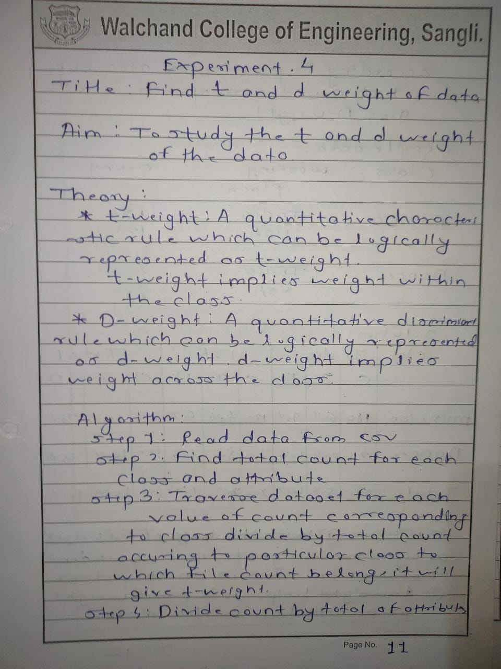

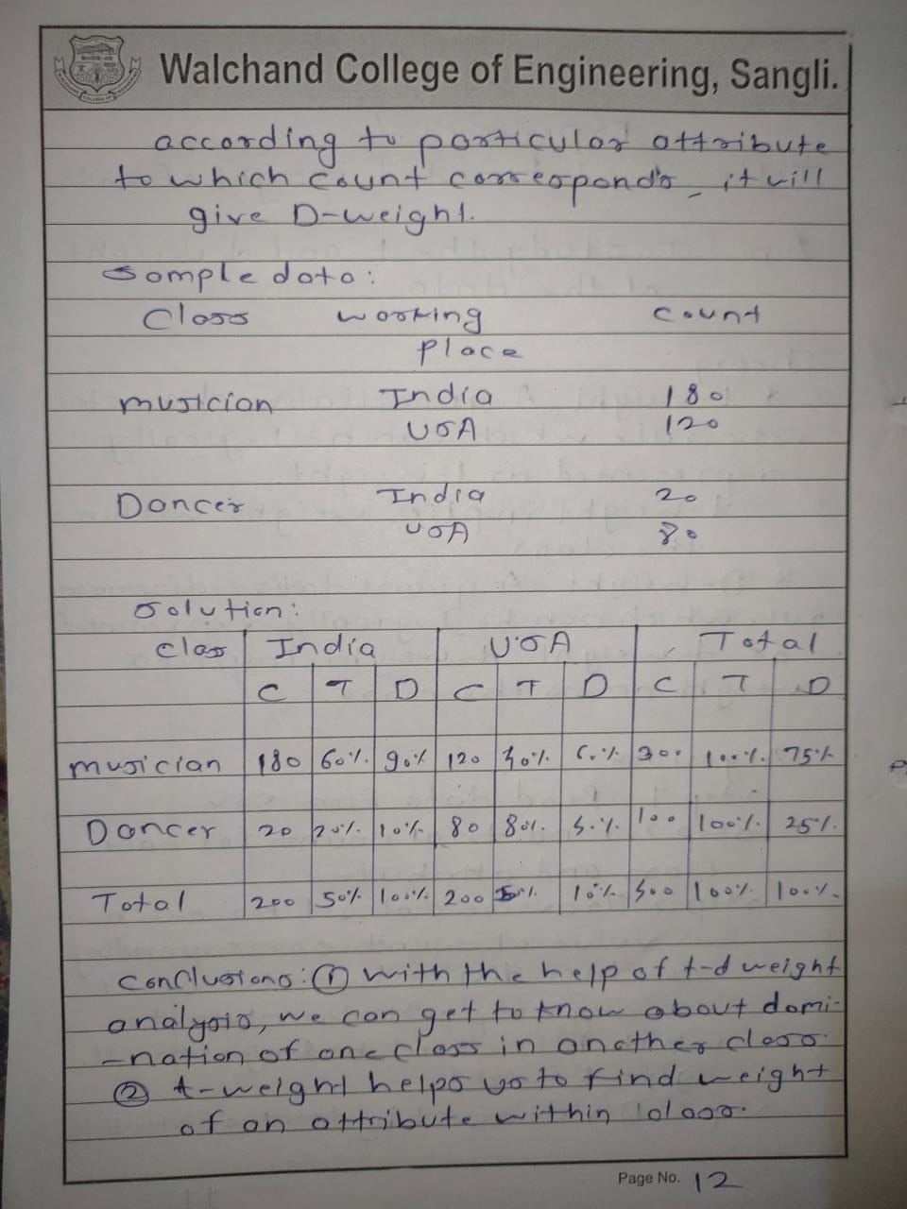

**Program**:

//PRN:2019BTEIT00084

//NAME:Rohan Nivas Chavan

import java.io.*;

import java.lang.*;

import java.util.*;

public class Tdweight

{

public static void main(String[] args) throws IOException

{

BufferedReader file=new BufferedReader(new FileReader("C://Users/Dell/Desktop/input_tdweight.csv"));

List<String[]> data=new ArrayList<>();

String str="";

while((str=file.readLine())!=null)

{

String[] line=str.split(",");

data.add(line);

}

List<Double> A_Tw=new ArrayList<>();

List<Double> B_Tw=new ArrayList<>();

List<Double> A_Dw=new ArrayList<>();

List<Double> B_Dw=new ArrayList<>();

int A_sum=0;//col1 sum

int B_sum=0;//col2 sum

for(int i=1;i<data.size();i++)

{

String[] x=data.get(i);

int p=Integer.parseInt(x[1]);

int q=Integer.parseInt(x[2]);

A_Tw.add((double)p/(p+q));

B_Tw.add((double)q/(p+q));

A_sum+=p;

B_sum+=q;

}

for(int i=1;i<data.size();i++)

{

String[] x=data.get(i);

int p=Integer.parseInt(x[1]);

int q=Integer.parseInt(x[2]);

A_Dw.add((double)p/(A_sum));

B_Dw.add((double)q/(B_sum));

}

//writing to file

PrintWriter out=new PrintWriter(new File("output_tdweight.csv"));

out.printf("%s,%s,%s,%s,%s,%s","A","B","A_Twt","B_Twt","A_Dwt","B_Dwt");

out.printf("\n");

for(int i=1;i<data.size();i++)

{

String[] x=data.get(i);

int p=Integer.parseInt(x[1]);

int q=Integer.parseInt(x[2]);

out.printf("%d,%d,%.3f,%.3f,%.3f,%.3f",p,q,A_Tw.get(i-1),B_Tw.get(i-1),A_Dw.get(i-1),B_Dw.get(i-1));

out.printf("\n");

}

out.close();

}

}

**Output**:

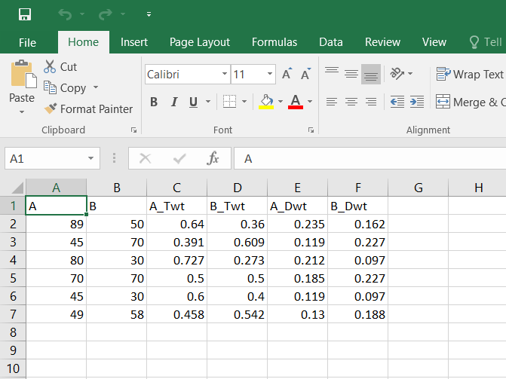

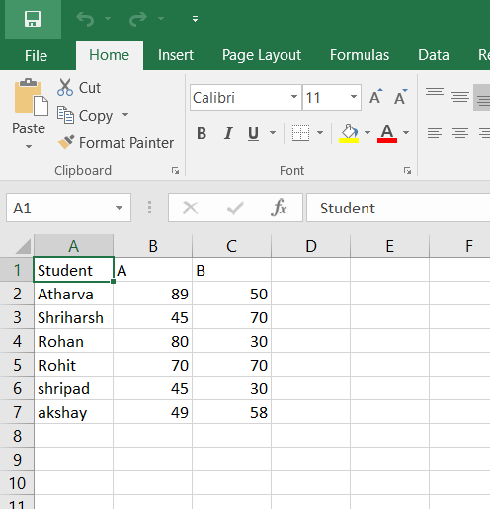

**Conclusion:Successfully performed t and d weight data analysis in data mining from table in csv file.**

**2019BTEIT00084**

**Data Mining Lab**

**Experiment No.5 Five number summary(Box-Plot)**

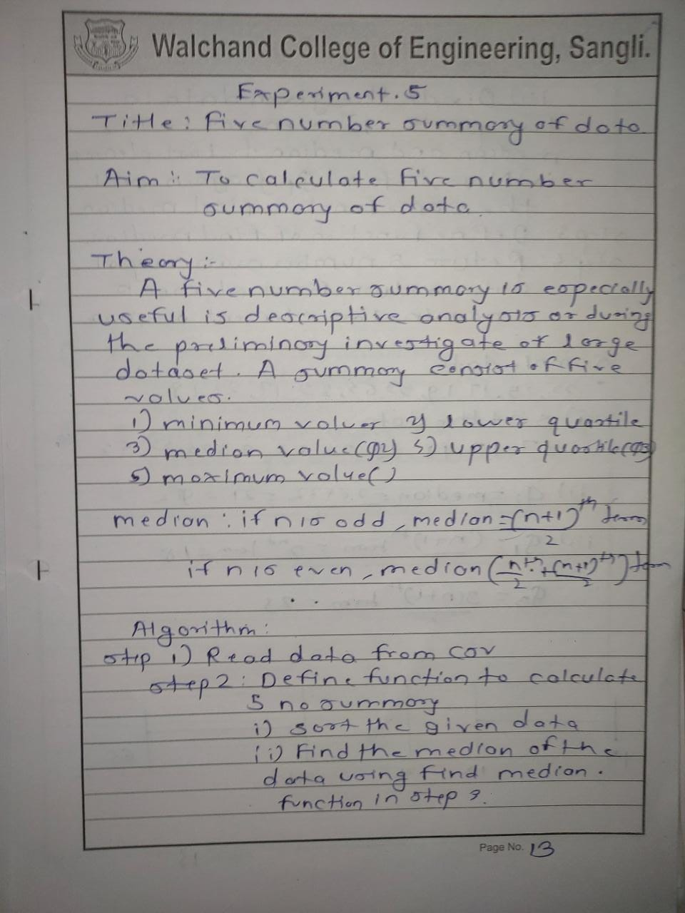

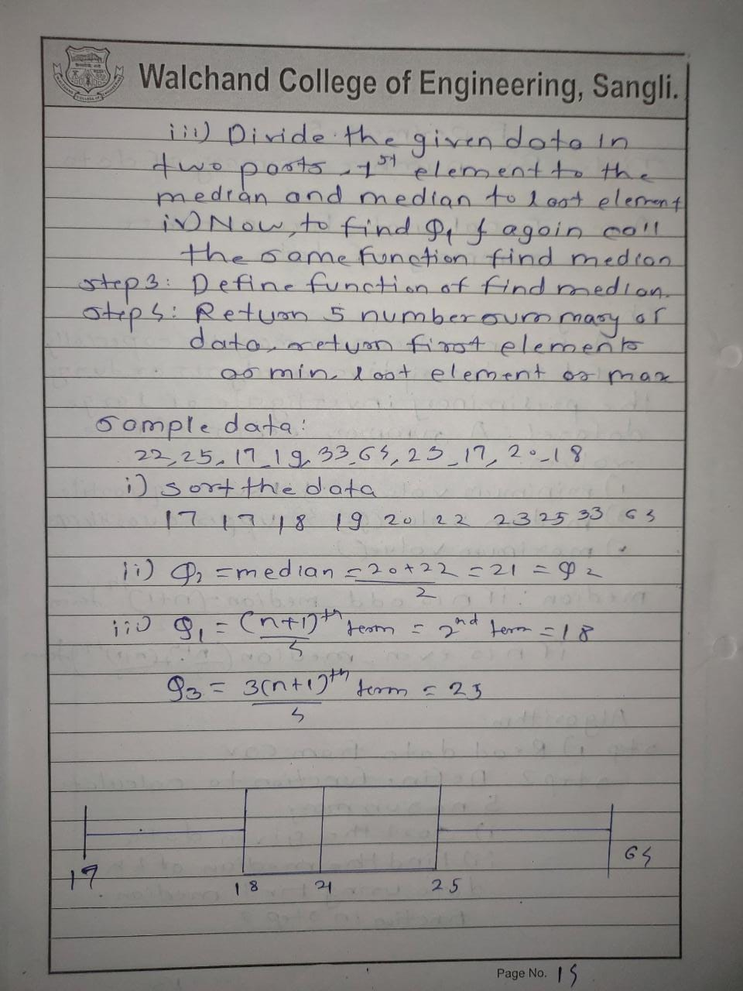

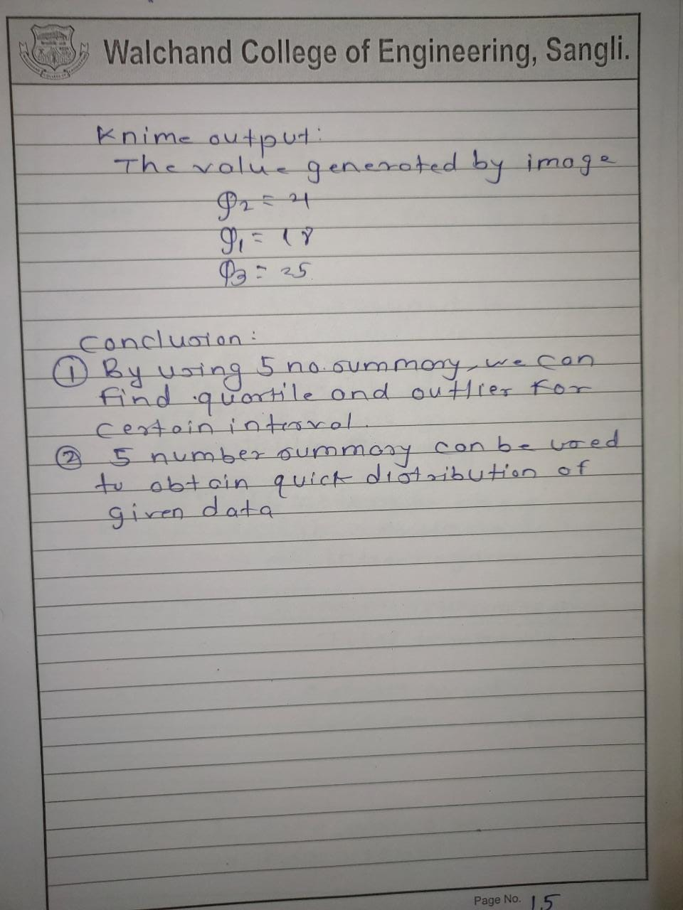

Using knime

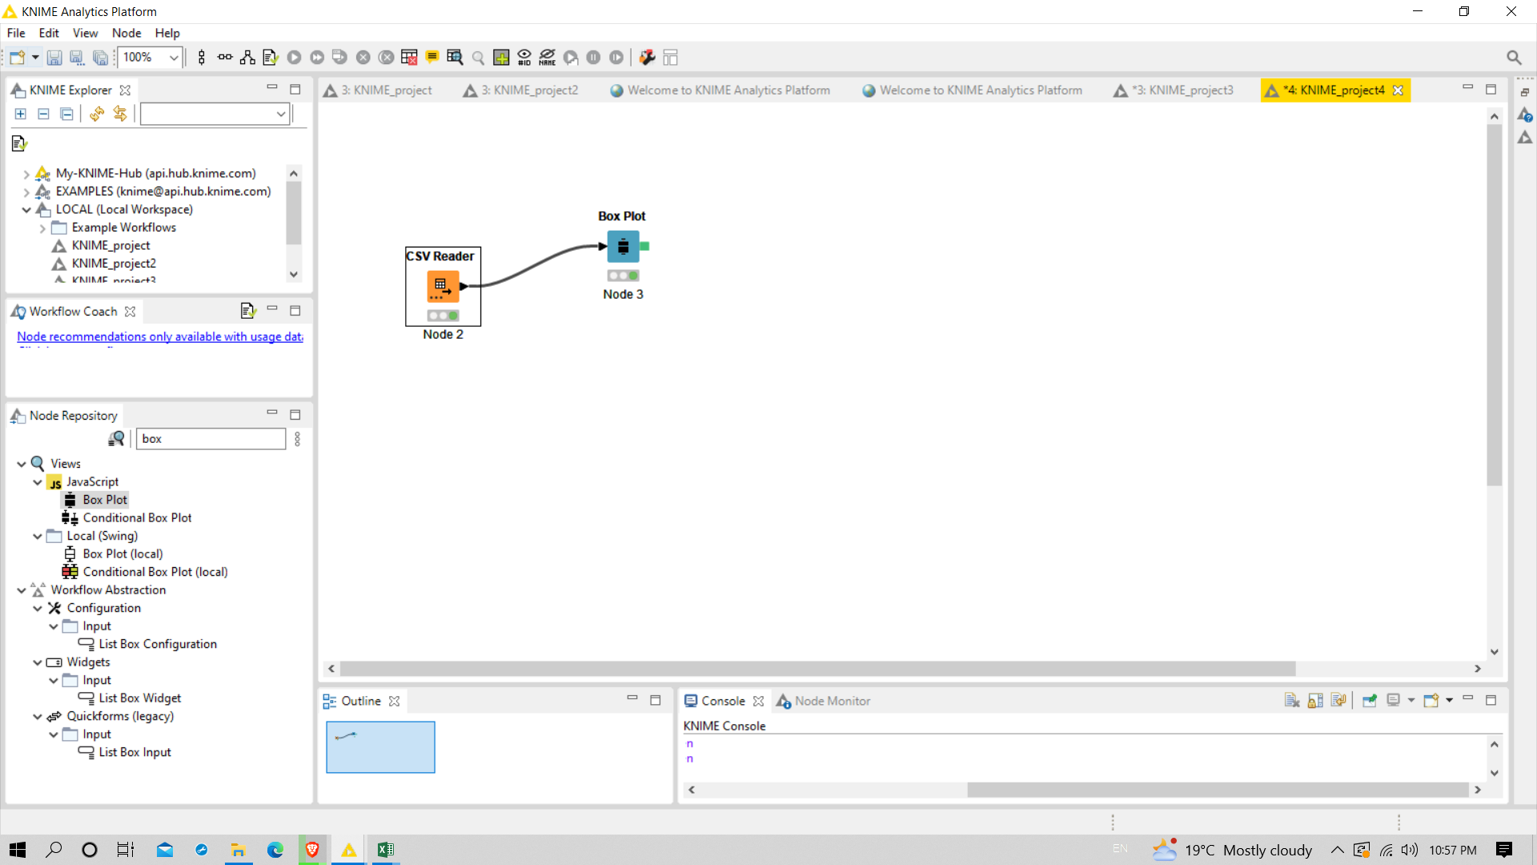

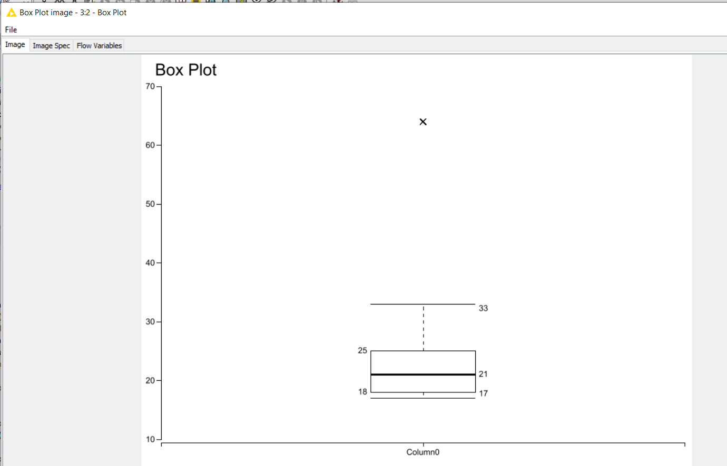

**Program:**

**//PRN:2019BTEIT00084**

**//Name:Rohan Nivas chavan**

**import java.lang.*;**

**import java.util.*;**

**import java.io.*;**

**class BoxPlot**

**{**

**public static double findMedian(int arr[],int start,int end)**

**{**

**int n=end-start+1;**

**if(n%2==0)**

**{**

**return (arr[start+n/2-1]+arr[start+n/2])/2;**

**}**

**else**

**{**

**return arr[start+n/2];**

**}**

**}**

**public static void main(String[] args) throws Exception**

**{**

**BufferedReader br = new BufferedReader(new FileReader("C://Users/Dell/Desktop/input_boxplot.csv"));**

**String [] fields = br.readLine().trim().split(","); // Splits at the space**

**int i=0;**

**int [] arr=new int[fields.length];**

**for(String str:fields){**

**int x=Integer.parseInt(str); //prints out name**

**arr[i++]=x;**

**}**

**Arrays.sort(arr);**

**int n=arr.length;**

**double median=findMedian(arr,0,n-1);**

**double q1=findMedian(arr,0,n/2-1);**

**double q3=0;**

**q3=findMedian(arr,n/2+1,n-1);**

**PrintWriter out=new PrintWriter(new File("output_boxplot.csv"));**

**out.printf("%s,%s","Attribute","Value");**

**out.printf("\n");**

**out.printf("%s,%d\n","Max",arr[n-1]);**

**out.printf("%s,%d\n","Min",arr[0]);**

**out.printf("%s,%.3f\n","Median",median);**

**out.printf("%s,%.3f\n","Q1",q1);**

**out.printf("%s,%.3f\n","Q3",q3);**

**double iqr=q3-q1;**

**double upper_out=q3 + (1.5)*iqr;**

**double lower_out=q1 - (1.5)*iqr;**

**out.printf("%s,%.3f\n","upper_out",upper_out);**

**out.printf("%s,%.3f\n","lower_out",lower_out);**

**out.close();**

**}**

**}**

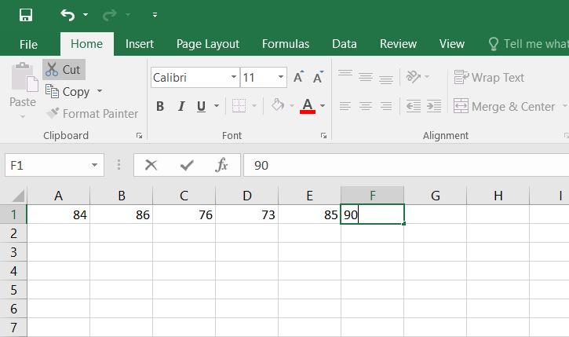

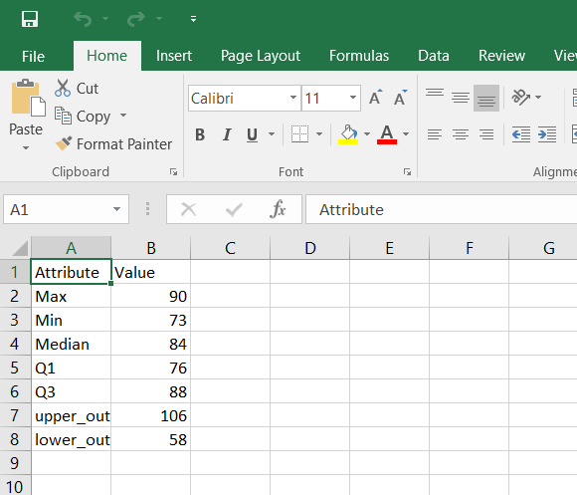

**Conclusion: Successfully performed 5 number summary on array of numbers.**

**2019BTEIT00084**

**Data Mining Lab**

**Experiment No.6 Find frequent item set from given transaction data.**

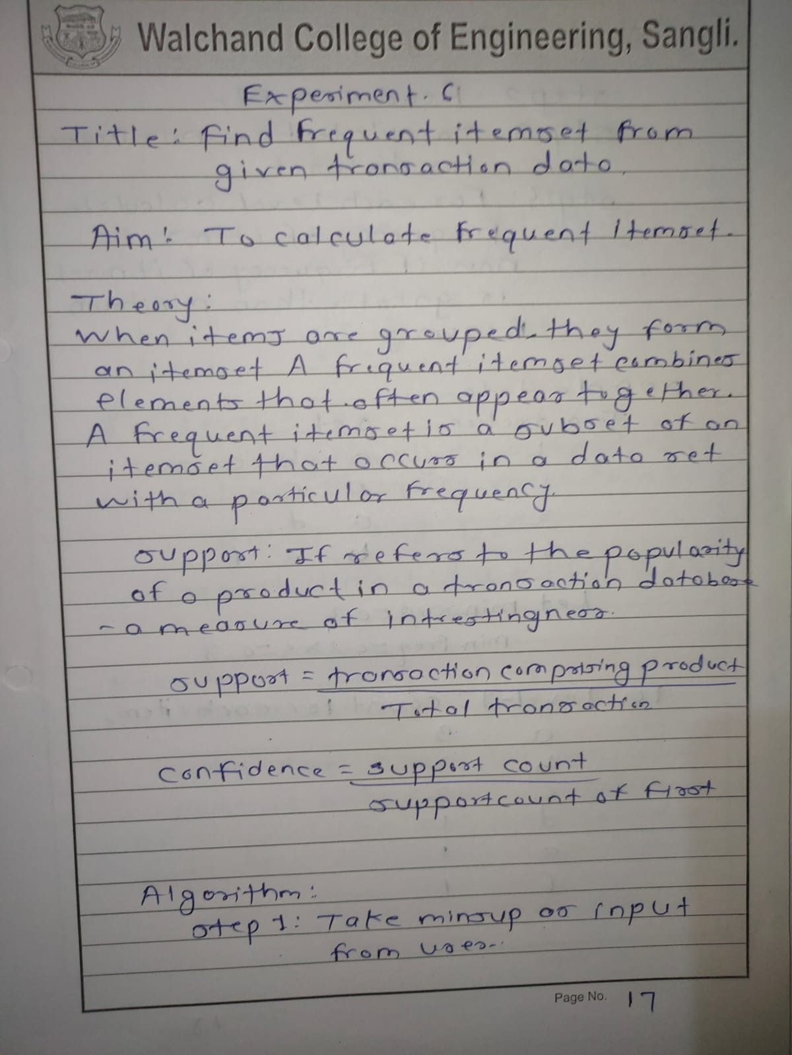

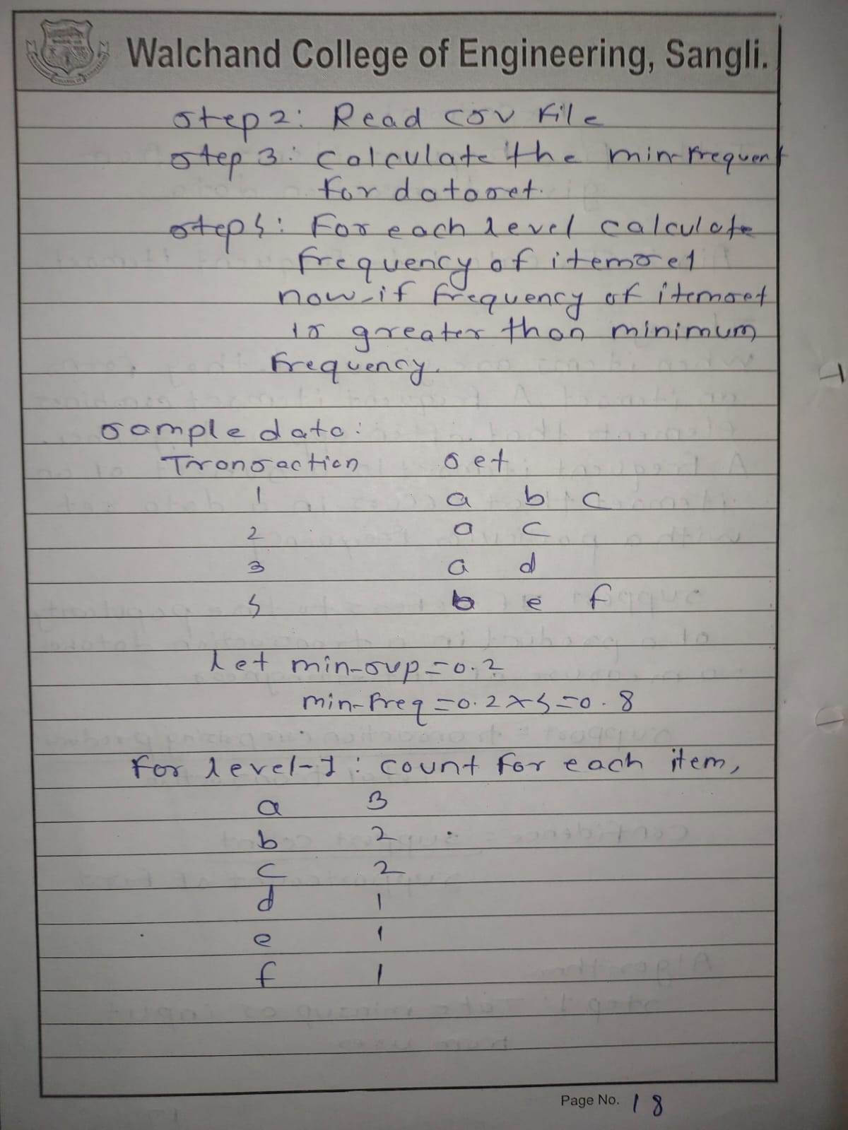

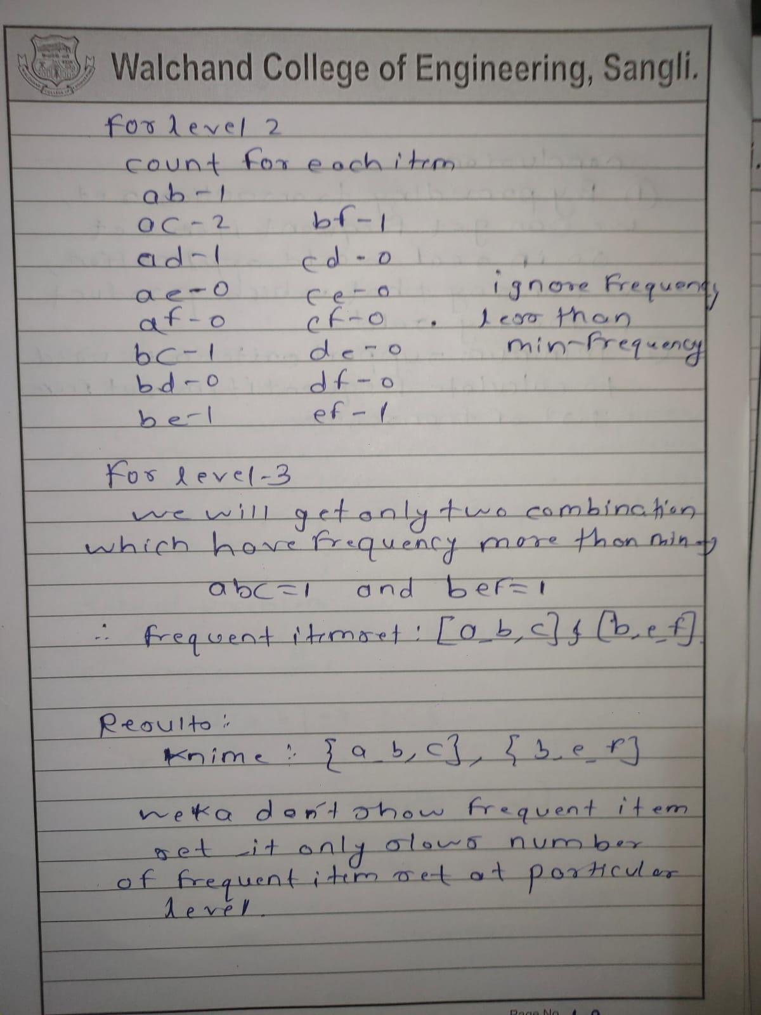

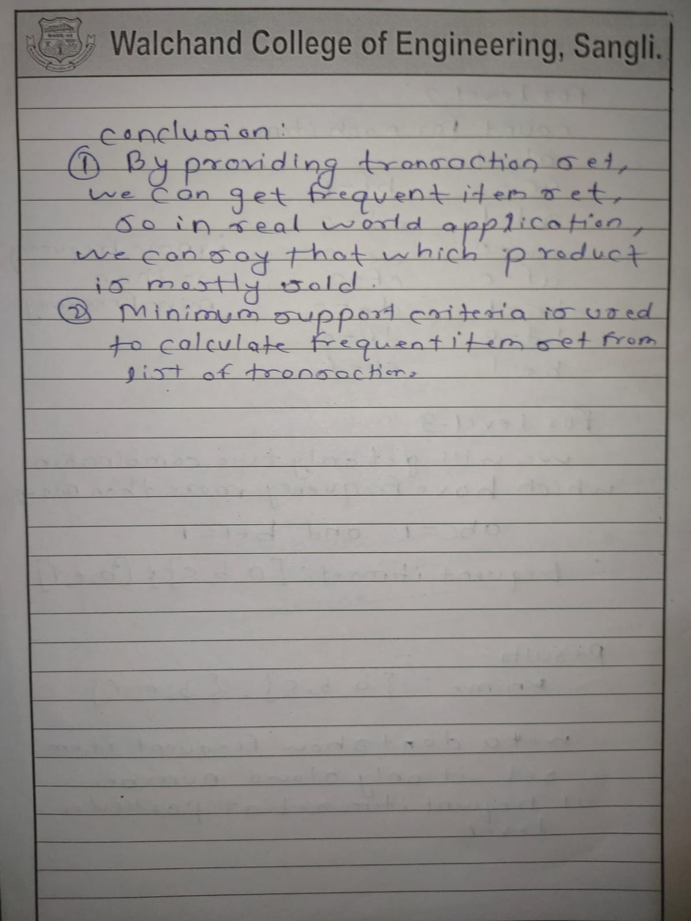

**Using knime**

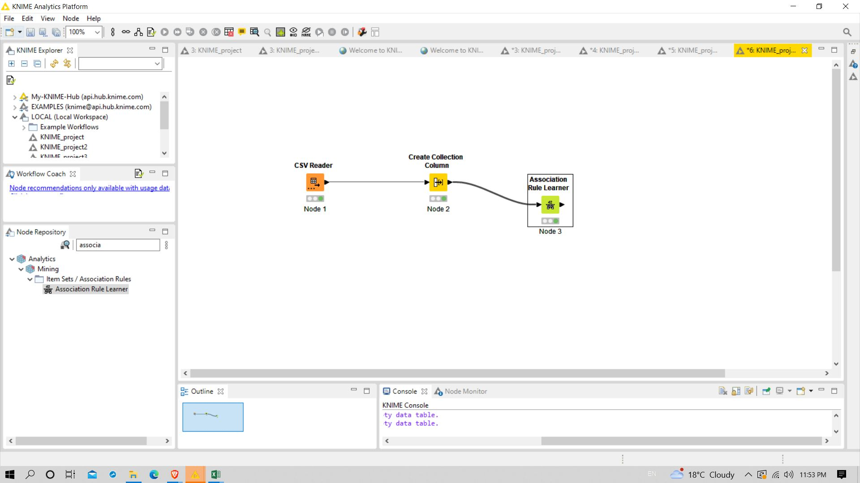

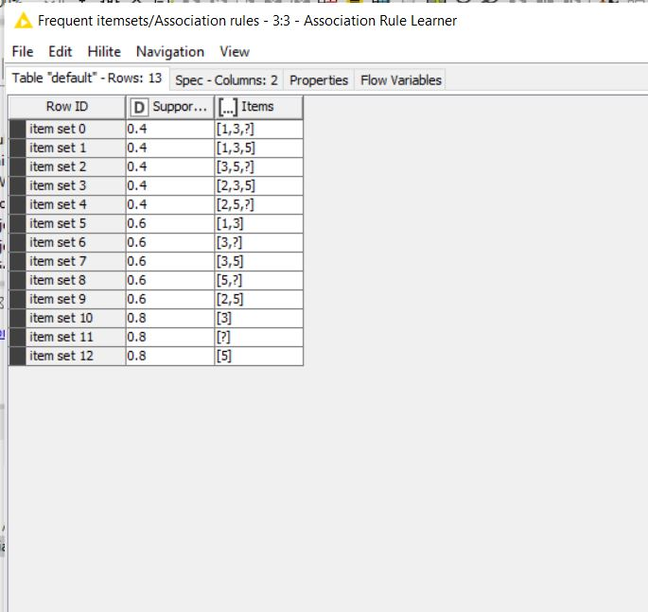

**Program:**

**import java.io.*;**

**import java.util.*;**

**public class AprioriDataMining**

**{**

**Vector<String> candidates=new Vector<String>();**

**List<String> itemSet = new ArrayList<String>();**

**List<String> finalFrequentItemSet = new ArrayList<>();**

**HashMap<String,Integer> frequentItems = new HashMap<String, Integer>();**

**String newLine = System.getProperty("line.separator");**

**int itemsCount,countItemOccurrence=0,displayFrequentItemSetNumber=2,displayTransactionNumber=1;**

**public static void main(String args[]) throws IOException**

**{**

**BufferedReader br = new BufferedReader(new InputStreamReader(System.in));**

**int noOfTransactions,minimumSupport;**

**double minimumConfidence;**

**String sampleFile = args[0];**

**List<String> transactions = new ArrayList<String>();**

**String newLine = System.getProperty("line.separator");**

**System.out.println(newLine+"'APRIORI ALGORITHM'");**

**System.out.print("Enter the Minimum Support = ");**

**minimumSupport = Integer.parseInt(br.readLine());**

**System.out.print("Enter the Minimum Confidence (in %) = ");**

**minimumConfidence = Double.parseDouble(br.readLine());**

**minimumConfidence = minimumConfidence/100;**

**File file = new File(sampleFile);**

**Scanner sc = new Scanner(file);**

**while (sc.hasNextLine())**

**{**

**String str = sc.nextLine();**

**transactions.add(str);**

**}**

**noOfTransactions = transactions.size();**

**AprioriDataMining a = new AprioriDataMining();**

**a.display(noOfTransactions, transactions, minimumSupport, minimumConfidence);**

**}**

**public void display(int noOfTransactions, List<String> transactions, int minimumSupport, double minimumConfidence)**

**{**

**for(int i = 0; i<noOfTransactions;i++)**

**{**

**String str = transactions.get(i);**

**String[] words = str.split(" ");**

**int count = words.length;**

**for(int j=0;j<count;j++)**

**{**

**if(i==0)**

**{**

**itemSet.add(words[j]);**

**}**

**else**

**{**

**if(!(itemSet.contains(words[j])))**

**{**

**itemSet.add(words[j]);**

**}**

**}**

**}**

**}**

**itemsCount = itemSet.size();**

**System.out.println(newLine+"No of Items = "+itemsCount);**

**System.out.println("No of Transactions = "+noOfTransactions);**

**System.out.println("Minimum Support = "+minimumSupport);**

**System.out.println("Minimum Confidence = "+minimumConfidence+newLine);**

**System.out.println("'Items present in the Database'");**

**for(String i : itemSet)**

**{**

**System.out.println("------> "+i);**

**}**

**System.out.println(newLine+"TRANSACTION ITEMSET");**

**for(String i : transactions)**

**{**

**System.out.println("Transaction "+displayTransactionNumber+" = "+i);**

**displayTransactionNumber++;**

**}**

**firstFrequentItemSet(noOfTransactions,transactions,minimumSupport,minimumConfidence);**

**}**

**public void firstFrequentItemSet(int noOfTransactions,List<String> transactions,int minimumSupport, double minimumConfidence)**

**{**

**System.out.println();**

**System.out.println("Frequent Itemset 1");**

**for(int items=0;items<itemSet.size();items++)**

**{**

**countItemOccurrence=0;**

**String itemStr = itemSet.get(items);**

**for(int t=0;t<noOfTransactions;t++)**

**{**

**String transactionStr = transactions.get(t);**

**if(transactionStr.contains(itemStr))**

**{**

**countItemOccurrence++;**

**}**

**}**

**if(countItemOccurrence >= minimumSupport)**

**{**

**System.out.println(itemStr+" => support = "+countItemOccurrence);**

**finalFrequentItemSet.add(itemStr);**

**frequentItems.put(itemStr, countItemOccurrence);**

**}**

**}**

**aprioriStart(noOfTransactions,transactions,minimumSupport,minimumConfidence);**

**}**

**public void aprioriStart(int noOfTransactions,List<String> transactions,int minimumSupport, double minimumConfidence)**

**{**

**int itemsetNumber=1;**

**for(int i=0;i<finalFrequentItemSet.size();i++)**

**{**

**String str = finalFrequentItemSet.get(i);**

**candidates.add(str);**

**}**

**do**

**{**

**itemsetNumber++;**

**generateCombinations(itemsetNumber);**

**checkFrequentItems(noOfTransactions,transactions,minimumSupport);**

**}**

**while(candidates.size()>1);**

**// System.out.println("Association Rules for Frequent Itemset"+newLine);**

**// generateAssociationRules(noOfTransactions, transactions, minimumConfidence);**

**}**

**private void generateCombinations(int itr)**

**{**

**Vector<String> candidatesTemp = new Vector<String>();**

**String s1, s2;**

**StringTokenizer strToken1, strToken2;**

**if(itr==2)**

**{**

**for(int i=0; i<candidates.size(); i++)**

**{**

**strToken1 = new StringTokenizer(candidates.get(i));**

**s1 = strToken1.nextToken();**

**for(int j=i+1; j<candidates.size(); j++)**

**{**

**strToken2 = new StringTokenizer(candidates.elementAt(j));**

**s2 = strToken2.nextToken();**

**String addString = s1+" "+s2;**

**candidatesTemp.add(addString);**

**}**

**}**

**}**

**else**

**{**

**for(int i=0; i<candidates.size(); i++)**

**{**

**for(int j=i+1; j<candidates.size(); j++)**

**{**

**s1 = new String();**

**s2 = new String();**

**strToken1 = new StringTokenizer(candidates.get(i));**

**strToken2 = new StringTokenizer(candidates.get(j));**

**for(int s=0; s<itr-2; s++)**

**{**

**s1 = s1 + " " + strToken1.nextToken();**

**s2 = s2 + " " + strToken2.nextToken();**

**}**

**if(s2.compareToIgnoreCase(s1)==0)**

**{**

**String addString = (s1 + " " + strToken1.nextToken() + " " + strToken2.nextToken()).trim();**

**candidatesTemp.add(addString);**

**}**

**}**

**}**

**}**

**candidates.clear();**

**candidates = new Vector<String>(candidatesTemp);**

**candidatesTemp.clear();**

**System.out.println();**

**}**

**public void checkFrequentItems(int noOfTransactions,List<String> transactions, int minimumSupport)**

**{**

**List<String> combList = new ArrayList<String>();**

**for(int i=0;i<candidates.size();i++)**

**{**

**String str = candidates.get(i);**

**combList.add(str);**

**}**

**System.out.println("Frequent Itemset "+displayFrequentItemSetNumber);**

**for(int i=0;i<combList.size();i++)**

**{**

**String str = combList.get(i);**

**String[] words = str.split(" ");**

**int count = words.length;**

**int flag = 0, itemSetOccurence=0;**

**for(int t=0;t<noOfTransactions;t++)**

**{**

**String transac = transactions.get(t);**

**for(int j=0;j<count;j++)**

**{**

**String wordStr = words[j];**

**if(transac.contains(wordStr))**

**{**

**flag++;**

**}**

**}**

**if(flag==count)**

**{**

**itemSetOccurence++;**

**}**

**flag=0;**

**}**

**if(itemSetOccurence>=minimumSupport)**

**{**

**System.out.println(str+" => support = "+itemSetOccurence);**

**frequentItems.put(str, itemSetOccurence);**

**finalFrequentItemSet.add(str);**

**}**

**itemSetOccurence=0;**

**}**

**displayFrequentItemSetNumber++;**

**}**

**public void generateAssociationRules(int noOfTransactions,List<String> transactions,double minimumConfidence)**

**{**

**double confidence,confidence1;**

**for(int i=0;i<finalFrequentItemSet.size();i++)**

**{**

**int spring2019count=0;**

**String itemSetStr = finalFrequentItemSet.get(i);**

**double value = frequentItems.get(itemSetStr);**

**String str = "",str1="";**

**String[] words = itemSetStr.split(" ");**

**int wordCountInString = words.length;**

**if(wordCountInString==2) /* for FrequentItemSet = 2*/**

**{**

**double s = frequentItems.get(words[0]);**

**confidence = value/s;**

**spring2019count++;**

**if(confidence>=minimumConfidence)**

**{**

**System.out.println(words[0]+" -> "+words[1]+" = Confidence = "+ confidence*100 +" and Support = "+(int)value+"");**

**}**

**double s1 = frequentItems.get(words[1]);**

**confidence = value/s1;**

**spring2019count++;**

**if(confidence>=minimumConfidence)**

**{**

**System.out.println(words[1]+" -> "+words[0]+" = Confidence = "+ confidence*100+" and Support = "+(int)value+"");**

**}**

**}**

**else /* for FrequentItemSet > 2 */**

**{**

**for(int a=0;a<wordCountInString-1;a++)**

**{**

**if(a==0)**

**{**

**str = str+words[a];**

**spring2019count++;**

**}**

**else**

**{**

**str = str+" "+words[a];**

**spring2019count++;**

**}**

**for(int j=a+1;j<wordCountInString;j++)**

**{**

**{**

**str1=str1+" "+words[j];**

**spring2019count++;**

**}**

**}**

**double s = frequentItems.get(str);**

**confidence = value/s;**

**String st = str1.trim();**

**double s1 = frequentItems.get(st);**

**confidence1 = value/s1;**

**if(confidence>=minimumConfidence)**

**{**

**System.out.println(str+" -> "+str1+" = Confidence = "+confidence*100+" and Support = "+(int)value+"");**

**}**

**if(confidence1>=minimumConfidence)**

**{**

**System.out.println(st+" -> "+str+" = Confidence = "+confidence1*100+" and Support = "+(int)value+"");**

**}**

**str1="";**

**}**

**str="";str1="";**

**}**

**//System.out.println(spring2019count++);**

**}**

**}**

**}**

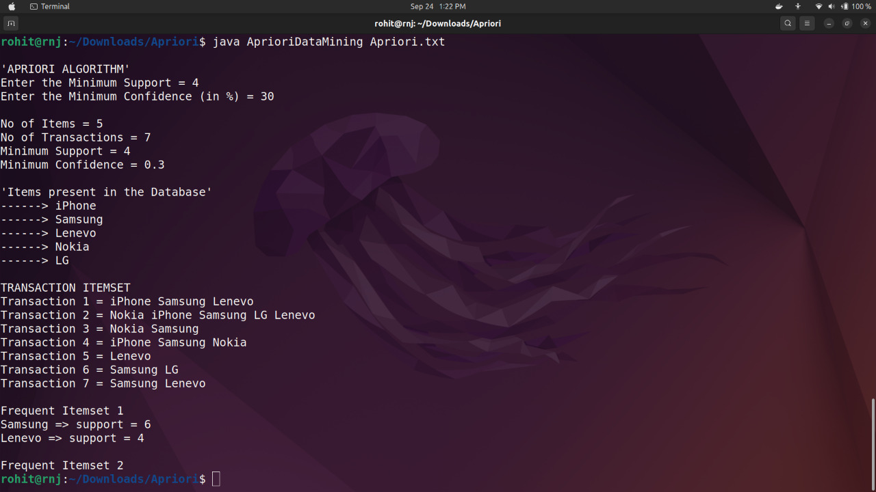

**Using knime**

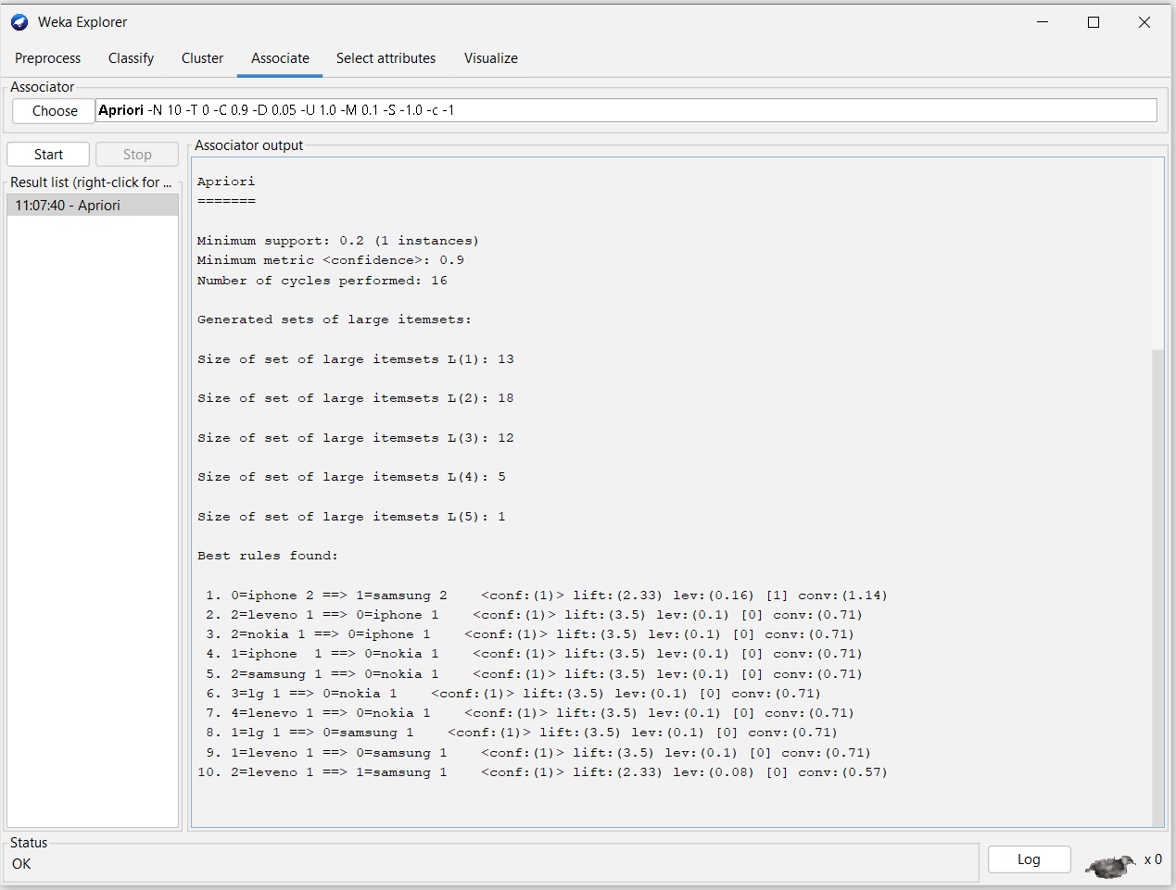

**Input file:**

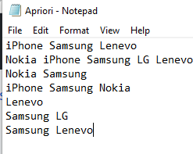

**conclusion:Successfully found frequent data set from given data set.**

**2019BTEIT00084**

**DM LAB**

**Experiment No.7 Generate association rules.**

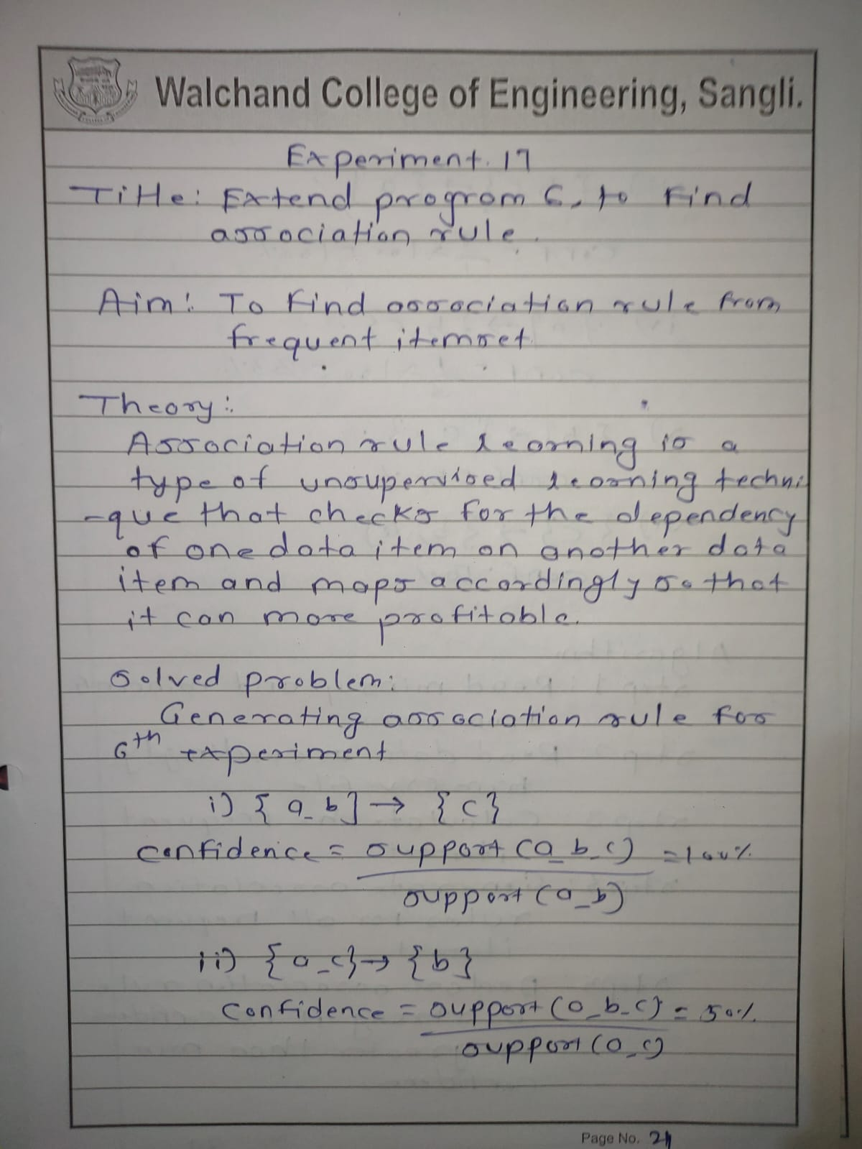

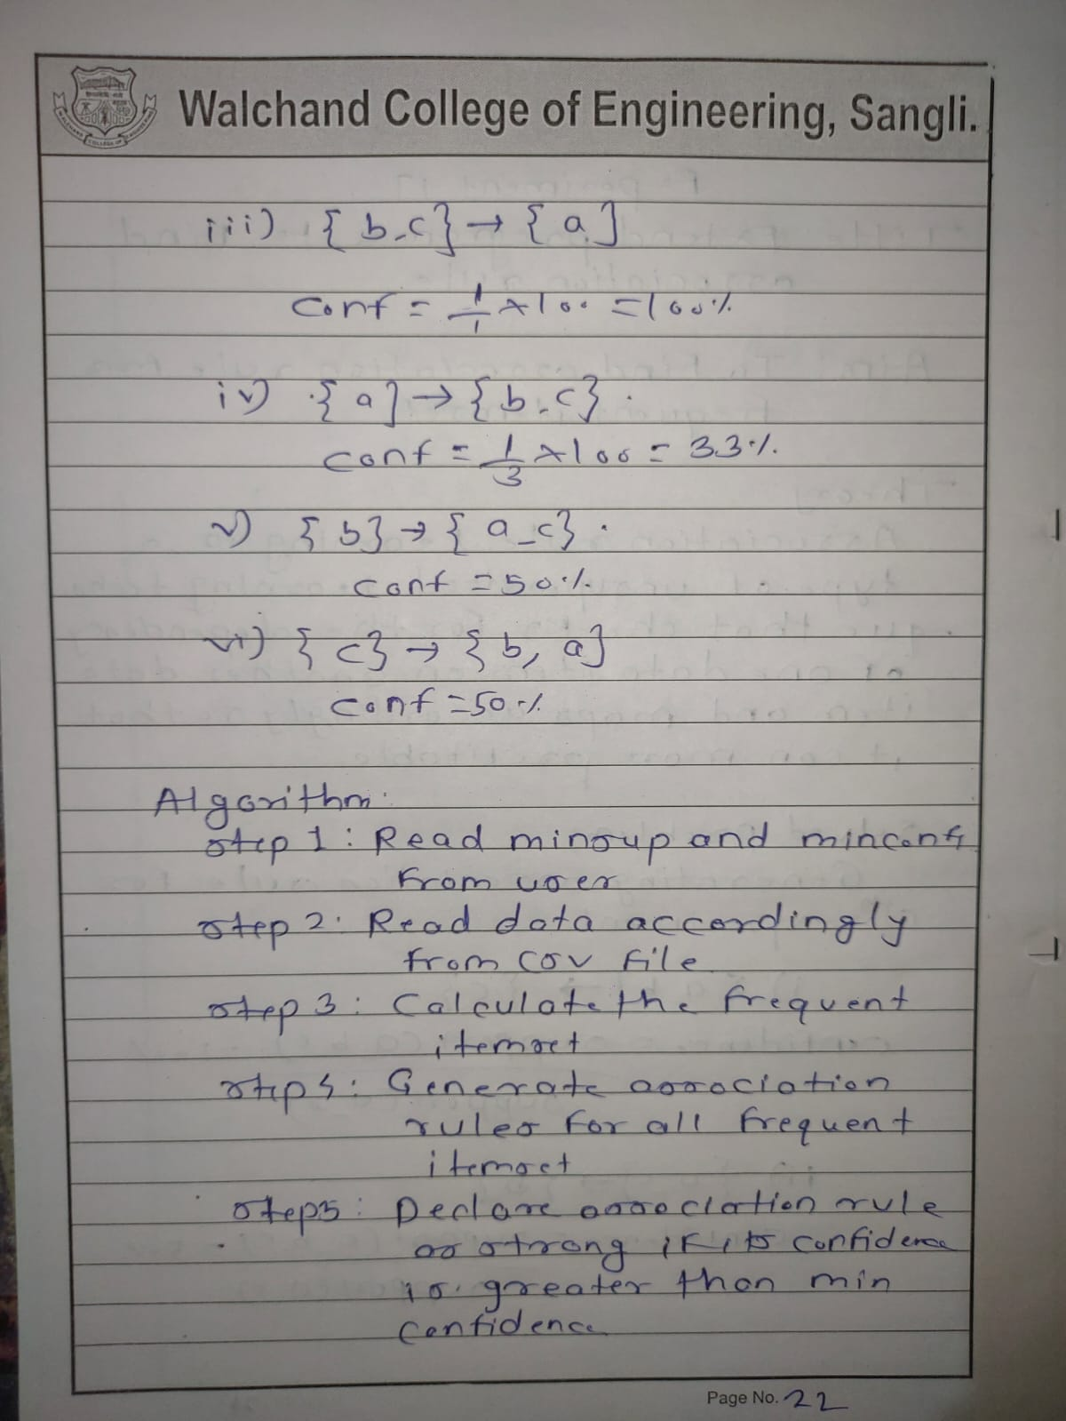

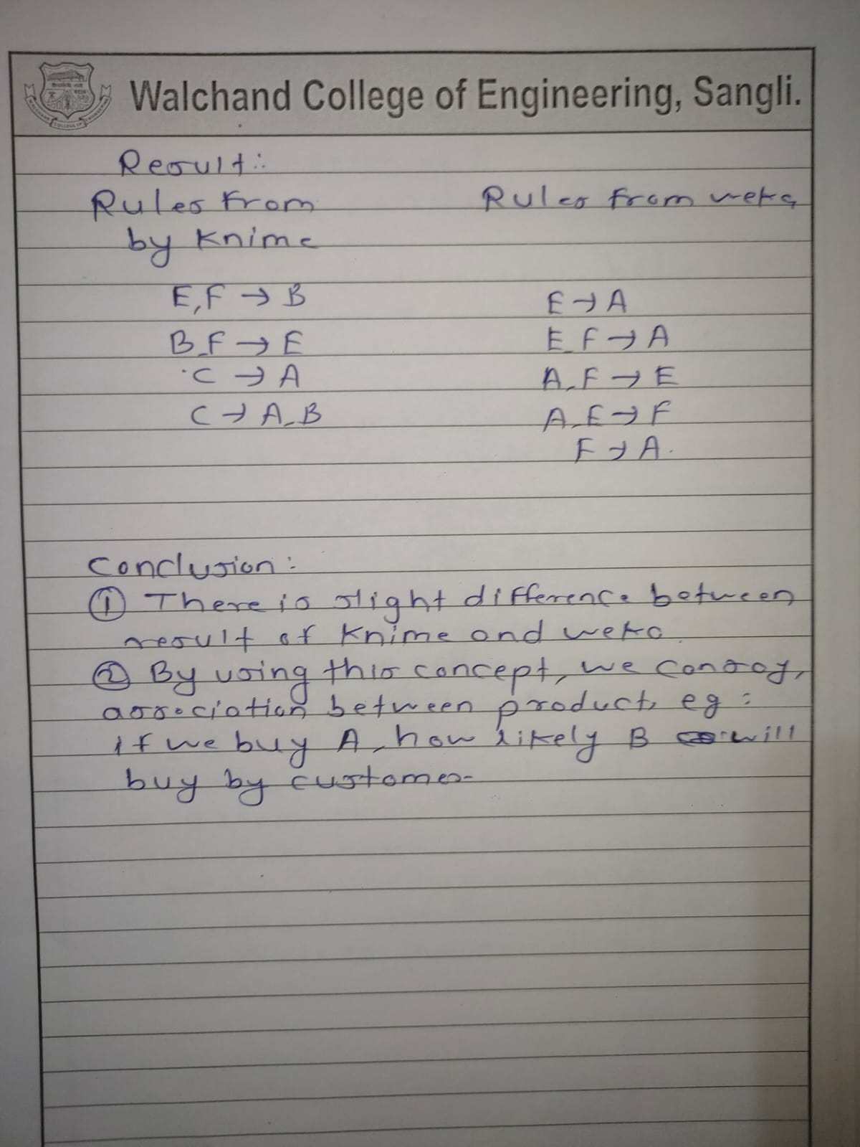

Using knime



\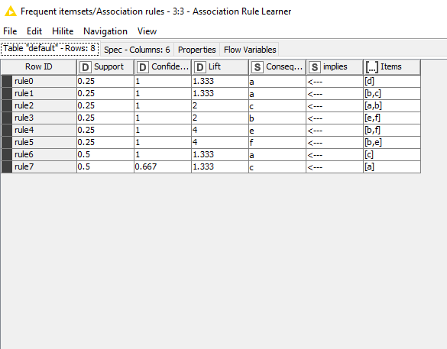

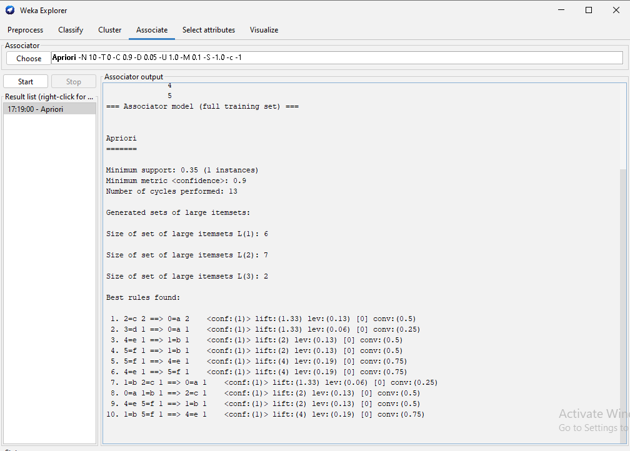

Program:

import java.io.*;

import java.util.*;

public class AprioriDataMining

{

Vector<String> candidates=new Vector<String>();

List<String> itemSet = new ArrayList<String>();

List<String> finalFrequentItemSet = new ArrayList<>();

HashMap<String,Integer> frequentItems = new HashMap<String, Integer>();

String newLine = System.getProperty("line.separator");

int itemsCount,countItemOccurrence=0,displayFrequentItemSetNumber=2,displayTransactionNumber=1;

public static void main(String args[]) throws IOException

{

BufferedReader br = new BufferedReader(new InputStreamReader(System.in));

int noOfTransactions,minimumSupport;

double minimumConfidence;

String sampleFile = args[0];

List<String> transactions = new ArrayList<String>();

String newLine = System.getProperty("line.separator");

System.out.println(newLine+"'APRIORI ALGORITHM'");

System.out.print("Enter the Minimum Support = ");

minimumSupport = Integer.parseInt(br.readLine());

System.out.print("Enter the Minimum Confidence (in %) = ");

minimumConfidence = Double.parseDouble(br.readLine());

minimumConfidence = minimumConfidence/100;

File file = new File(sampleFile);

Scanner sc = new Scanner(file);

while (sc.hasNextLine())

{

String str = sc.nextLine();

transactions.add(str);

}

noOfTransactions = transactions.size();

AprioriDataMining a = new AprioriDataMining();

a.display(noOfTransactions, transactions, minimumSupport, minimumConfidence);

}

public void display(int noOfTransactions, List<String> transactions, int minimumSupport, double minimumConfidence)

{

for(int i = 0; i<noOfTransactions;i++)

{

String str = transactions.get(i);

String[] words = str.split(" ");

int count = words.length;

for(int j=0;j<count;j++)

{

if(i==0)

{

itemSet.add(words[j]);

}

else

{

if(!(itemSet.contains(words[j])))

{

itemSet.add(words[j]);

}

}

}

}

itemsCount = itemSet.size();

System.out.println(newLine+"No of Items = "+itemsCount);

System.out.println("No of Transactions = "+noOfTransactions);

System.out.println("Minimum Support = "+minimumSupport);

System.out.println("Minimum Confidence = "+minimumConfidence+newLine);

System.out.println("'Items present in the Database'");

for(String i : itemSet)

{

System.out.println("------> "+i);

}

System.out.println(newLine+"TRANSACTION ITEMSET");

for(String i : transactions)

{

System.out.println("Transaction "+displayTransactionNumber+" = "+i);

displayTransactionNumber++;

}

firstFrequentItemSet(noOfTransactions,transactions,minimumSupport,minimumConfidence);

}

public void firstFrequentItemSet(int noOfTransactions,List<String> transactions,int minimumSupport, double minimumConfidence)

{

System.out.println();

System.out.println("Frequent Itemset 1");

for(int items=0;items<itemSet.size();items++)

{

countItemOccurrence=0;

String itemStr = itemSet.get(items);

for(int t=0;t<noOfTransactions;t++)

{

String transactionStr = transactions.get(t);

if(transactionStr.contains(itemStr))

{

countItemOccurrence++;

}

}

if(countItemOccurrence >= minimumSupport)

{

System.out.println(itemStr+" => support = "+countItemOccurrence);

finalFrequentItemSet.add(itemStr);

frequentItems.put(itemStr, countItemOccurrence);

}

}

aprioriStart(noOfTransactions,transactions,minimumSupport,minimumConfidence);

}

public void aprioriStart(int noOfTransactions,List<String> transactions,int minimumSupport, double minimumConfidence)

{

int itemsetNumber=1;

for(int i=0;i<finalFrequentItemSet.size();i++)

{

String str = finalFrequentItemSet.get(i);

candidates.add(str);

}

do

{

itemsetNumber++;

generateCombinations(itemsetNumber);

checkFrequentItems(noOfTransactions,transactions,minimumSupport);

}

while(candidates.size()>1);

System.out.println("Association Rules for Frequent Itemset"+newLine);

generateAssociationRules(noOfTransactions, transactions, minimumConfidence);

}

private void generateCombinations(int itr)

{

Vector<String> candidatesTemp = new Vector<String>();

String s1, s2;

StringTokenizer strToken1, strToken2;

if(itr==2)

{

for(int i=0; i<candidates.size(); i++)

{

strToken1 = new StringTokenizer(candidates.get(i));

s1 = strToken1.nextToken();

for(int j=i+1; j<candidates.size(); j++)

{

strToken2 = new StringTokenizer(candidates.elementAt(j));

s2 = strToken2.nextToken();

String addString = s1+" "+s2;

candidatesTemp.add(addString);

}

}

}

else

{

for(int i=0; i<candidates.size(); i++)

{

for(int j=i+1; j<candidates.size(); j++)

{

s1 = new String();

s2 = new String();

strToken1 = new StringTokenizer(candidates.get(i));

strToken2 = new StringTokenizer(candidates.get(j));

for(int s=0; s<itr-2; s++)

{

s1 = s1 + " " + strToken1.nextToken();

s2 = s2 + " " + strToken2.nextToken();

}

if(s2.compareToIgnoreCase(s1)==0)

{

String addString = (s1 + " " + strToken1.nextToken() + " " + strToken2.nextToken()).trim();

candidatesTemp.add(addString);

}

}

}

}

candidates.clear();

candidates = new Vector<String>(candidatesTemp);

candidatesTemp.clear();

System.out.println();

}

public void checkFrequentItems(int noOfTransactions,List<String> transactions, int minimumSupport)

{

List<String> combList = new ArrayList<String>();

for(int i=0;i<candidates.size();i++)

{

String str = candidates.get(i);

combList.add(str);

}

System.out.println("Frequent Itemset "+displayFrequentItemSetNumber);

for(int i=0;i<combList.size();i++)

{

String str = combList.get(i);

String[] words = str.split(" ");

int count = words.length;

int flag = 0, itemSetOccurence=0;

for(int t=0;t<noOfTransactions;t++)

{

String transac = transactions.get(t);

for(int j=0;j<count;j++)

{

String wordStr = words[j];

if(transac.contains(wordStr))

{

flag++;

}

}

if(flag==count)

{

itemSetOccurence++;

}

flag=0;

}

if(itemSetOccurence>=minimumSupport)

{

System.out.println(str+" => support = "+itemSetOccurence);

frequentItems.put(str, itemSetOccurence);

finalFrequentItemSet.add(str);

}

itemSetOccurence=0;

}

displayFrequentItemSetNumber++;

}

public void generateAssociationRules(int noOfTransactions,List<String> transactions,double minimumConfidence)

{

double confidence,confidence1;

for(int i=0;i<finalFrequentItemSet.size();i++)

{

int spring2019count=0;

String itemSetStr = finalFrequentItemSet.get(i);

double value = frequentItems.get(itemSetStr);

String str = "",str1="";

String[] words = itemSetStr.split(" ");

int wordCountInString = words.length;

if(wordCountInString==2) /* for FrequentItemSet = 2*/

{

double s = frequentItems.get(words[0]);

confidence = value/s;

spring2019count++;

if(confidence>=minimumConfidence)

{

System.out.println(words[0]+" -> "+words[1]+" = Confidence = "+ confidence*100 +" and Support = "+(int)value+"");

}

double s1 = frequentItems.get(words[1]);

confidence = value/s1;

spring2019count++;

if(confidence>=minimumConfidence)

{

System.out.println(words[1]+" -> "+words[0]+" = Confidence = "+ confidence*100+" and Support = "+(int)value+"");

}

}

else /* for FrequentItemSet > 2 */

{

for(int a=0;a<wordCountInString-1;a++)

{

if(a==0)

{

str = str+words[a];

spring2019count++;

}

else

{

str = str+" "+words[a];

spring2019count++;

}

for(int j=a+1;j<wordCountInString;j++)

{

{

str1=str1+" "+words[j];

spring2019count++;

}

}

double s = frequentItems.get(str);

confidence = value/s;

String st = str1.trim();

double s1 = frequentItems.get(st);

confidence1 = value/s1;

if(confidence>=minimumConfidence)

{

System.out.println(str+" -> "+str1+" = Confidence = "+confidence*100+" and Support = "+(int)value+"");

}

if(confidence1>=minimumConfidence)

{

System.out.println(st+" -> "+str+" = Confidence = "+confidence1*100+" and Support = "+(int)value+"");

}

str1="";

}

str="";str1="";

}

//System.out.println(spring2019count++);

}

}

}

**Output**:

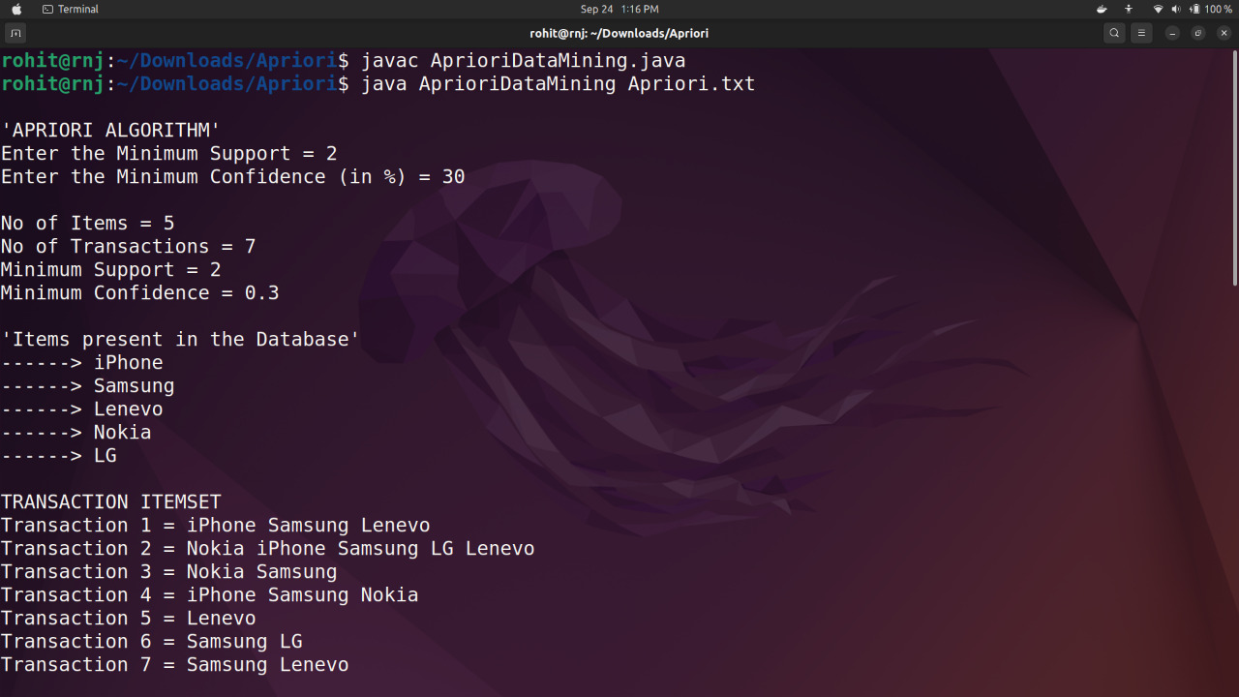

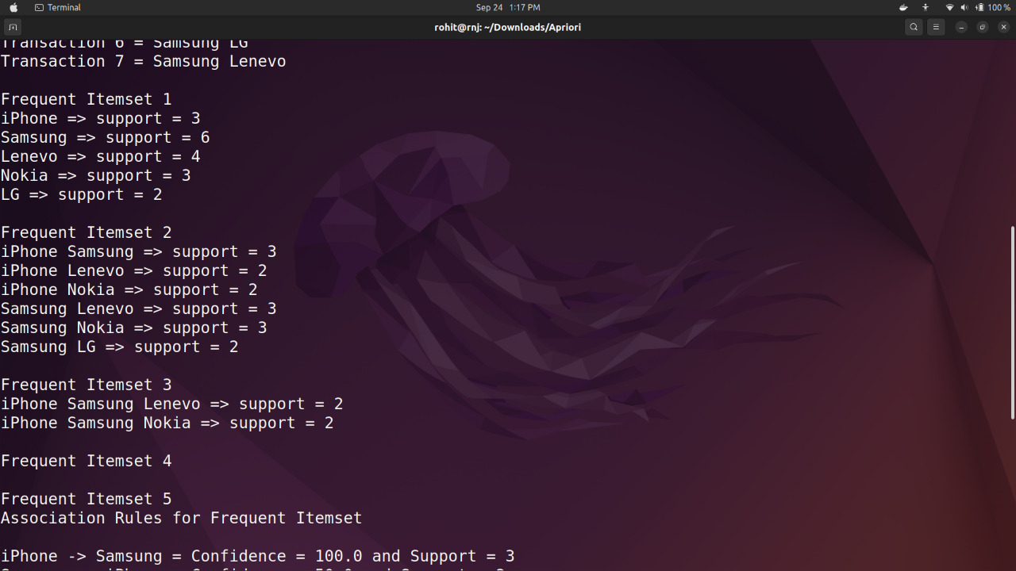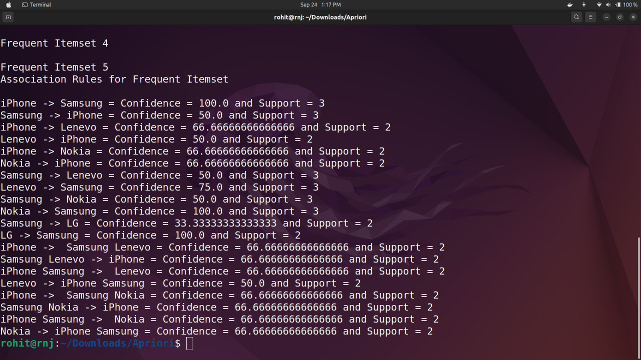

**Input file:**



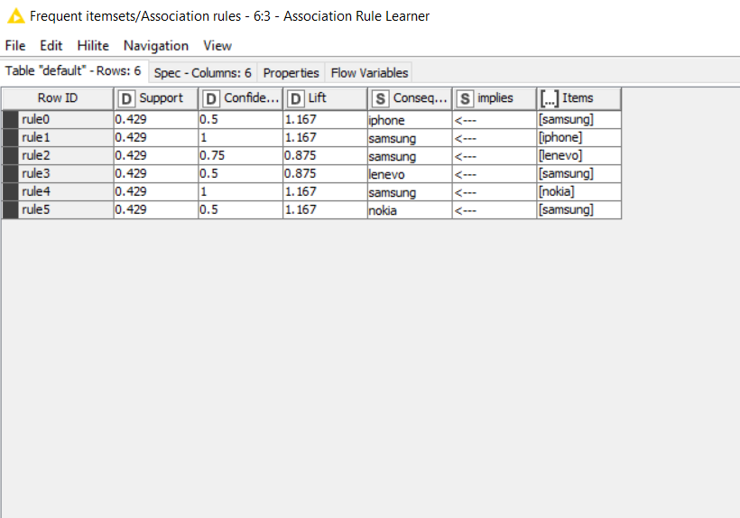

**Using weka**



**Conclusion:Successfully generated association rules from frequent item set.**

**2019BTEIT00084**

**DM Lab**

**Exp 8.Finding correlation between item sets.**

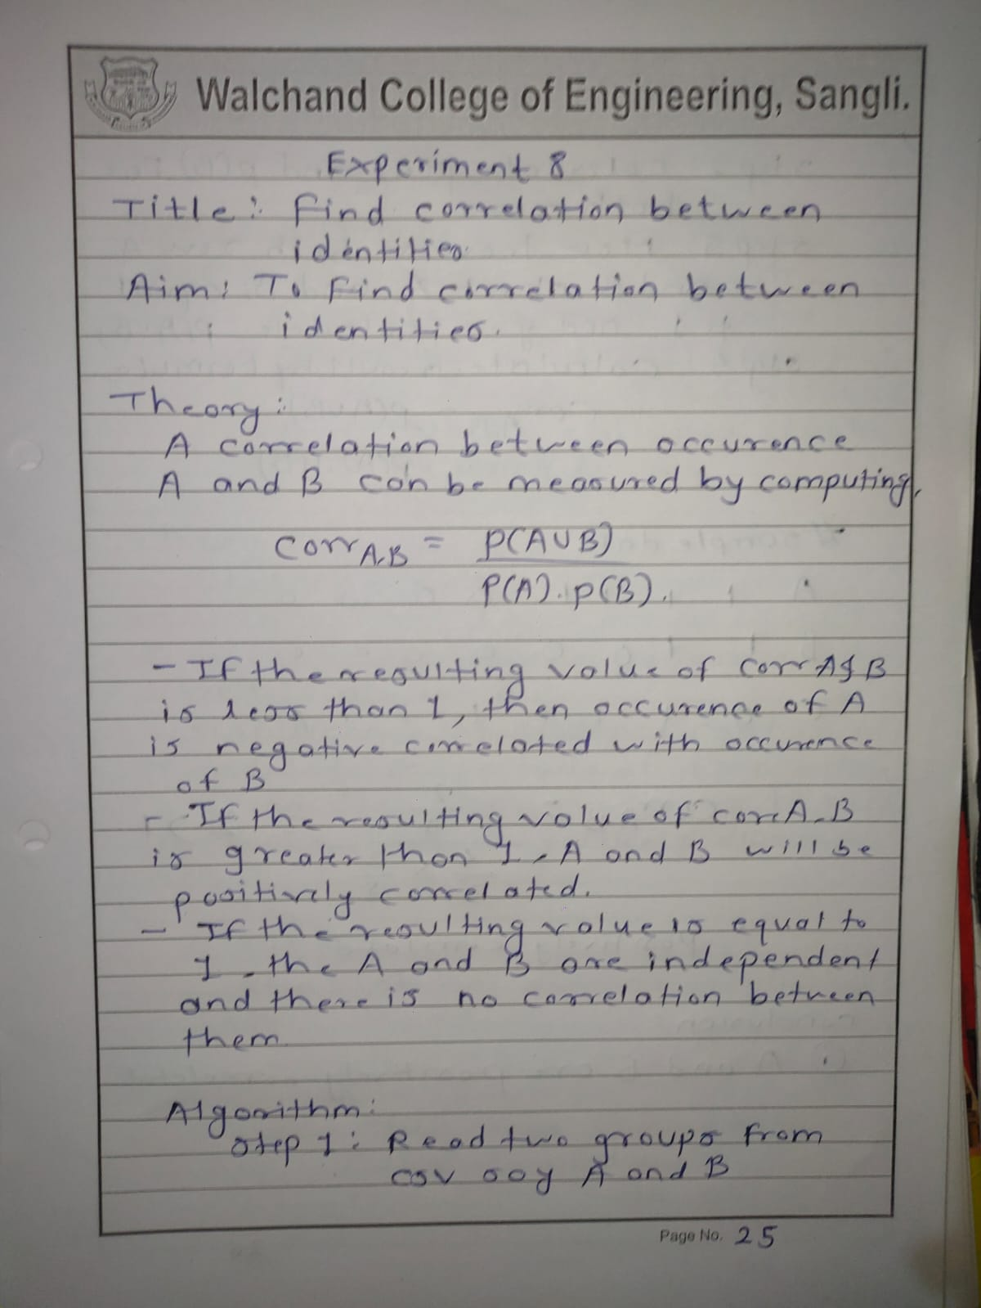

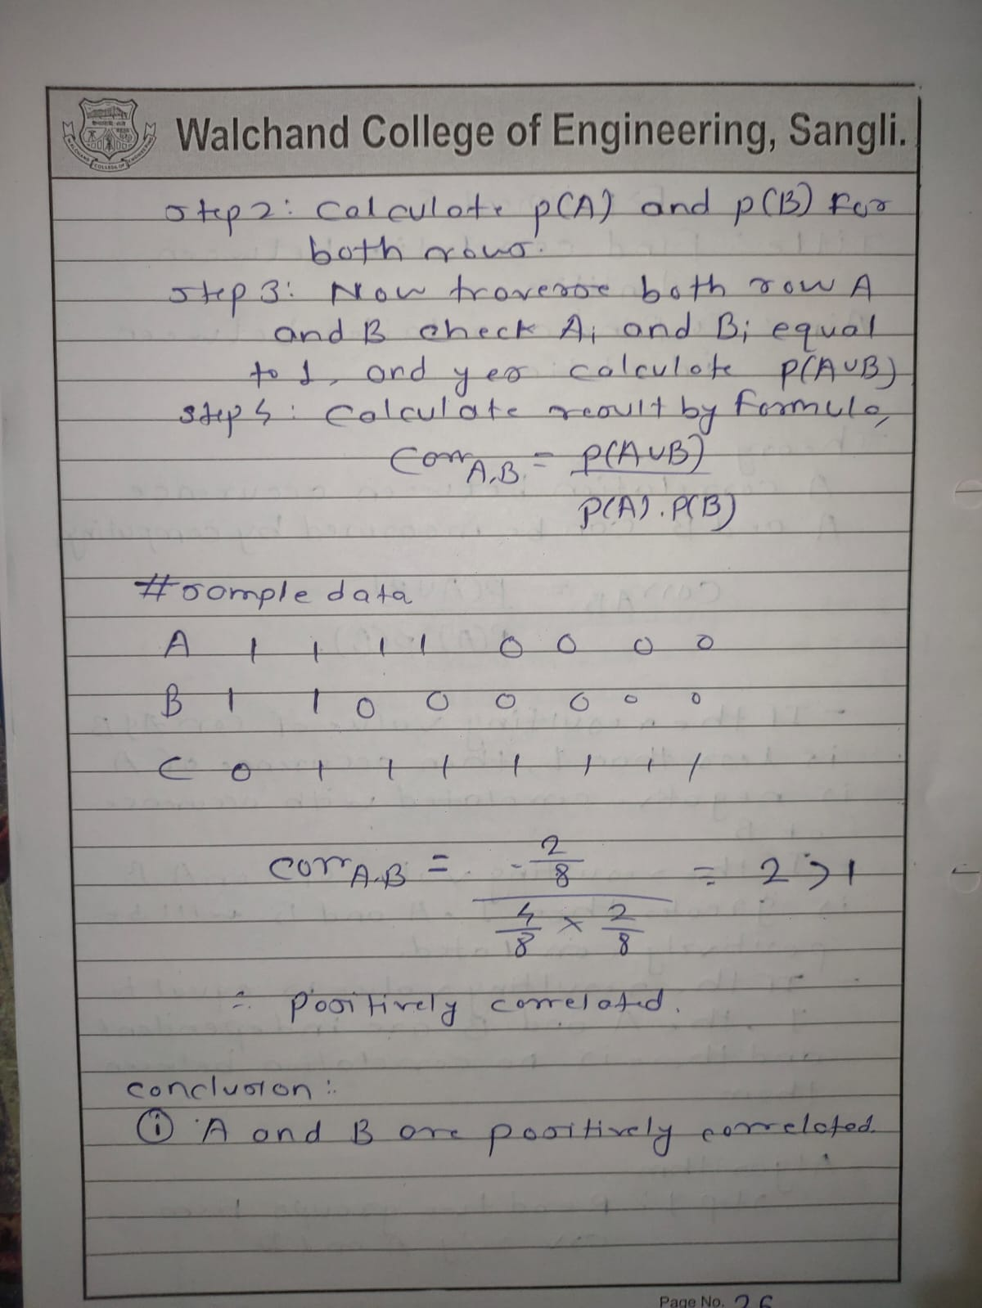

**Program**:

import openpyxl

import math

wb=openpyxl.load_workbook("Experiment8.xlsx")

sheet_obj = wb.active

row = sheet_obj.max_row

col = sheet_obj.max_column

def std_dev(X,l,x_mean):

ans=0

for i in range(0,l):

ans = ans + (X[i]-x_mean)*(X[i]-x_mean)

return ans

X=[]

Y=[]

x_mean=0

y_mean=0

for i in range(2,row+1):

val=sheet_obj.cell(row=i,column=2)

val2=sheet_obj.cell(row=i,column=3)

X.append(val.value)

x_mean=x_mean+val.value

Y.append(val2.value)

y_mean=y_mean+val2.value

l=len(X)

x_mean=x_mean/l

y_mean=y_mean/l

cov=0

for i in range(0,l):

cov=cov + (X[i]-x_mean)*(Y[i]-y_mean)

s = math.sqrt(std_dev(X,l,x_mean)*std_dev(Y,l,y_mean))

corelation = cov/s

print(corelation)

**Output**:

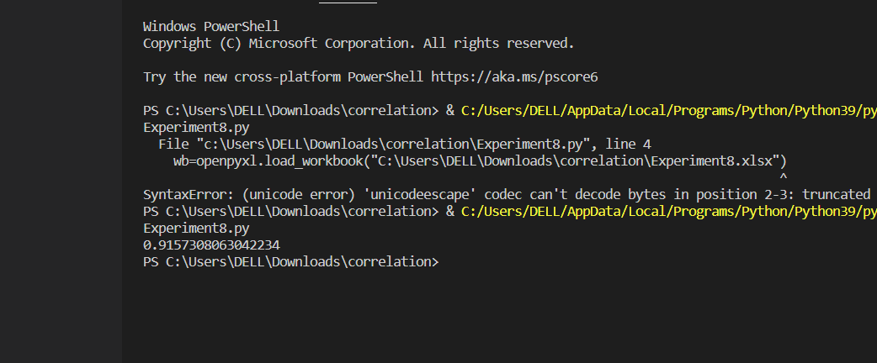

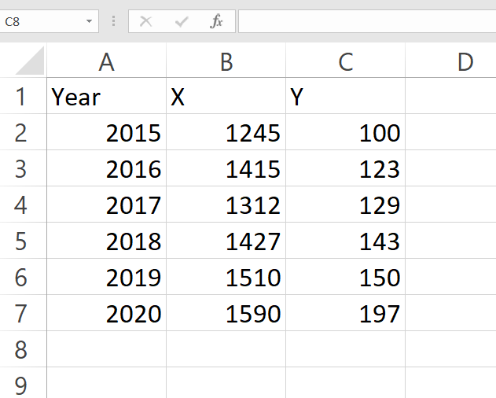

**Conclusion:Successfully performed correlation on given item sets.**

**Experiment No.9**

**Distance and cluster**

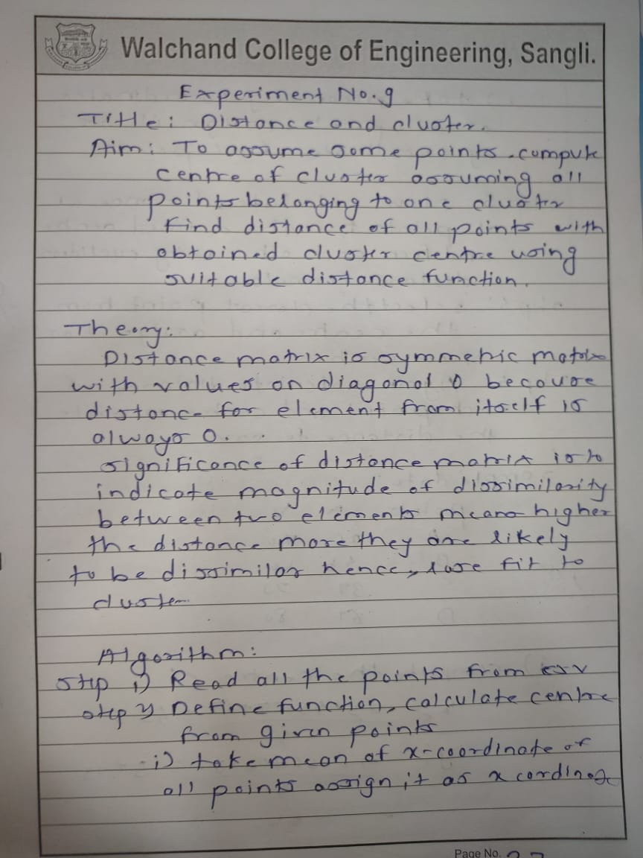

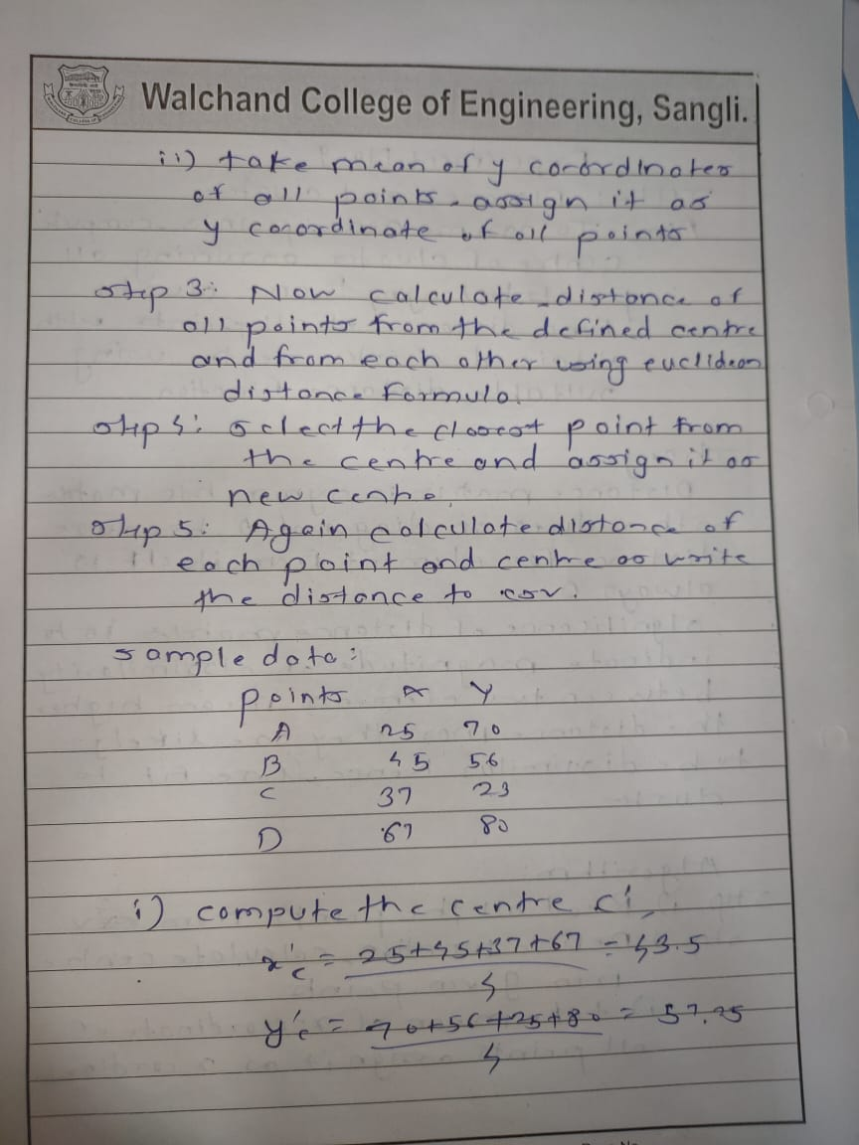

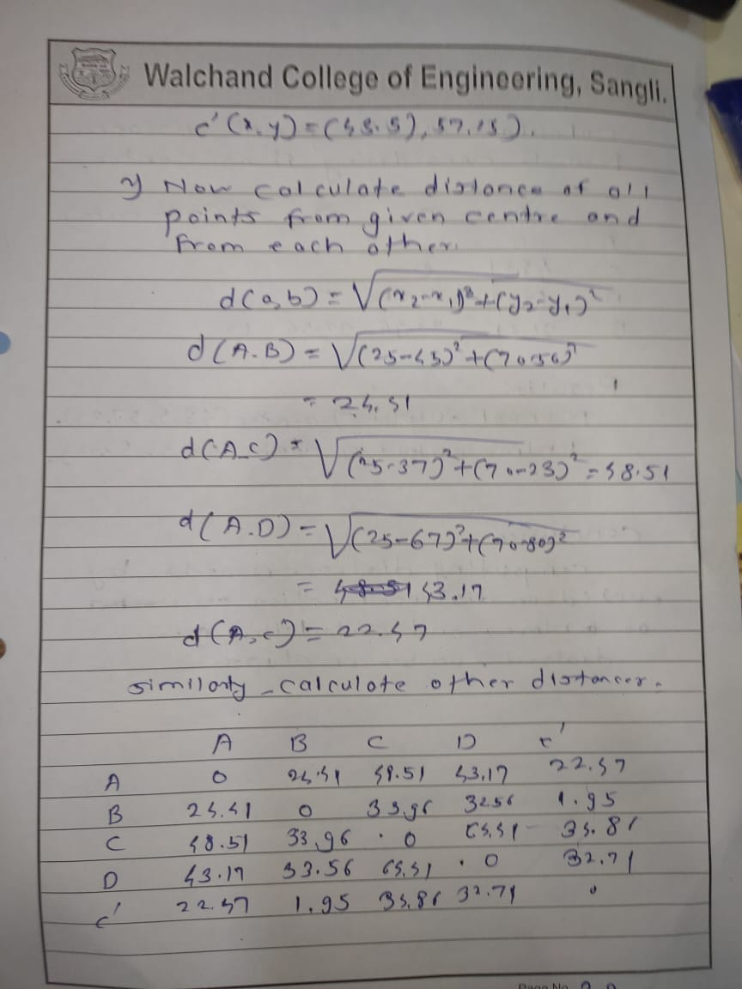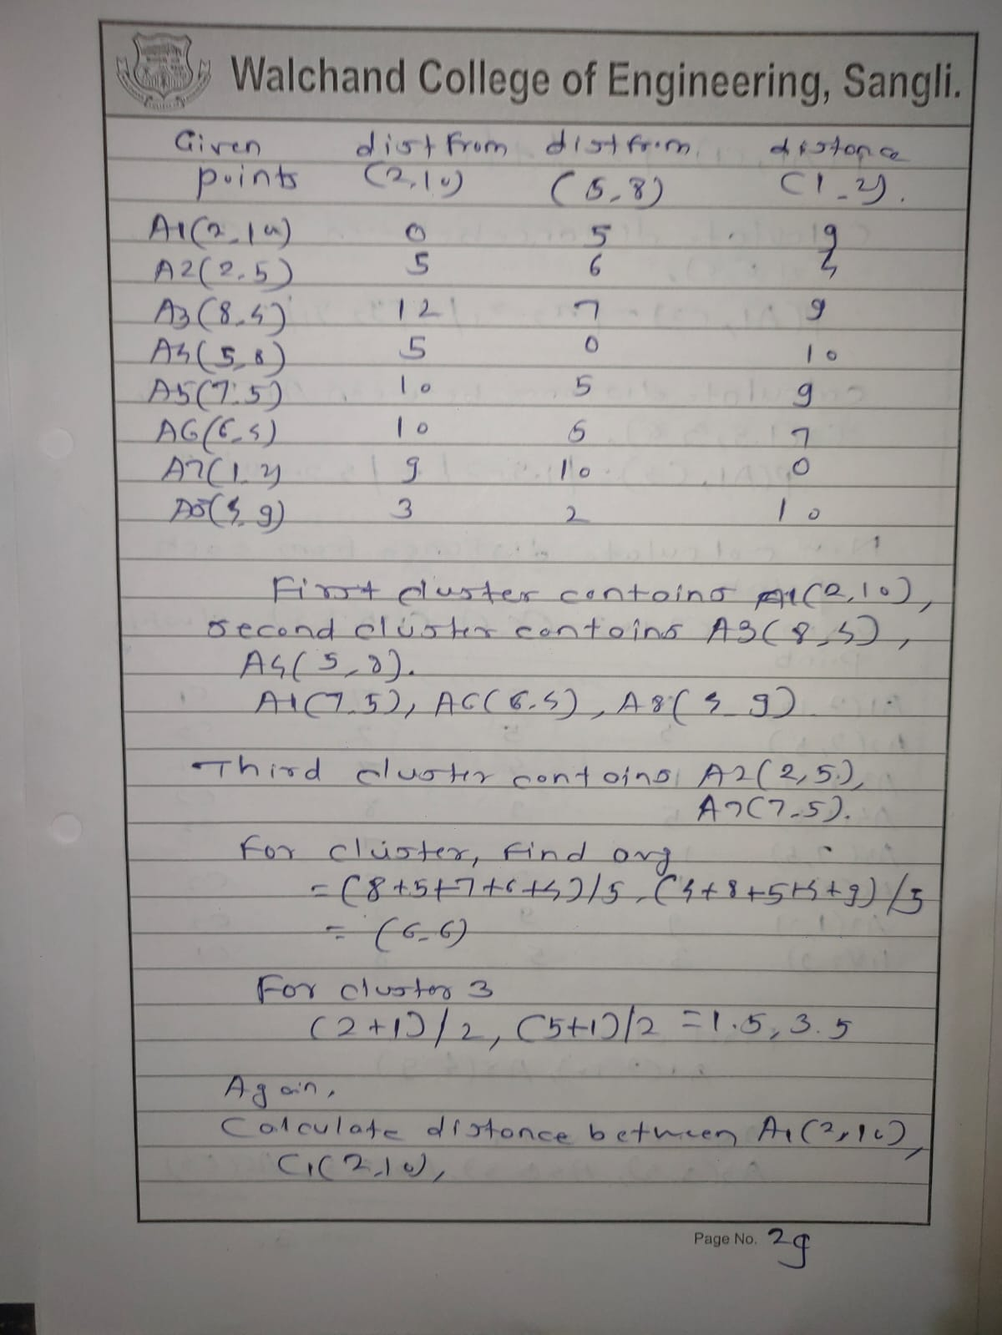

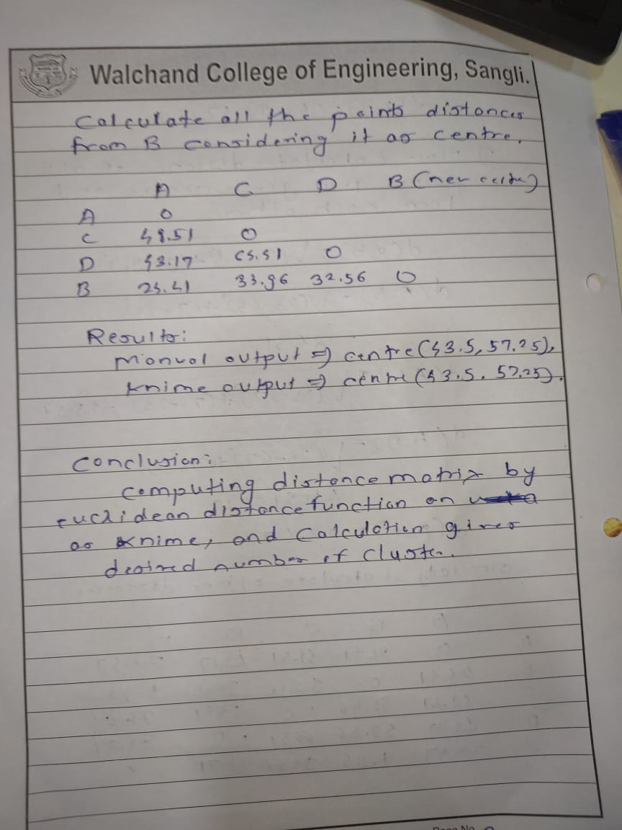

**Using knime**

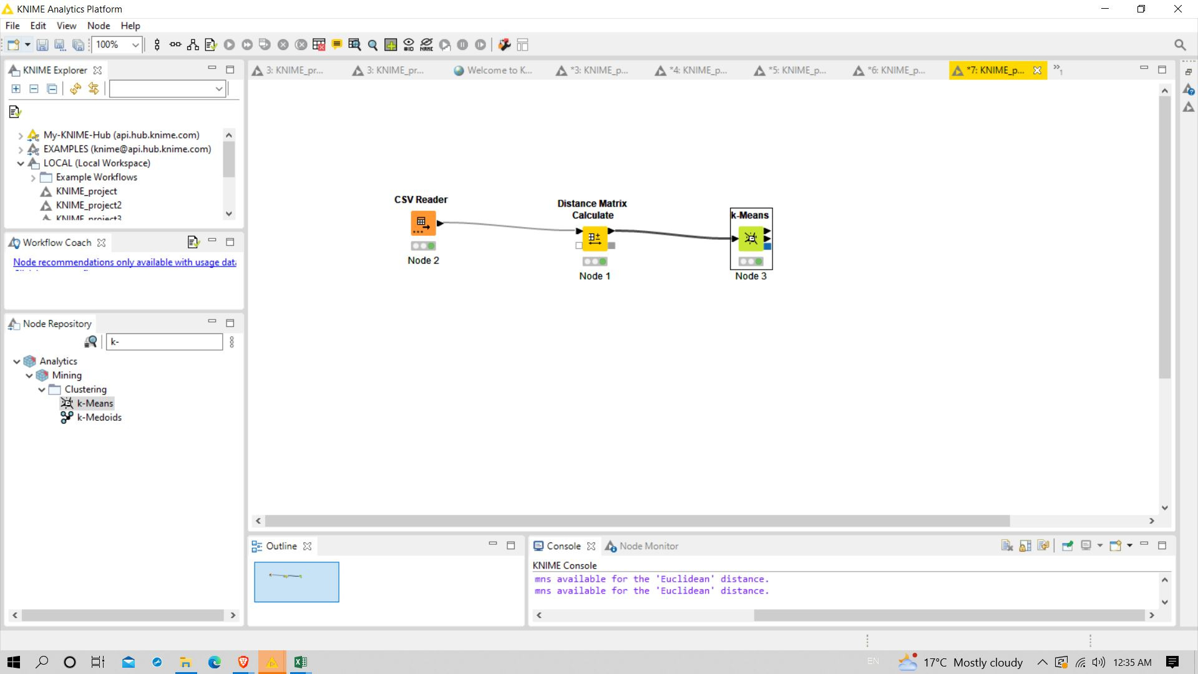

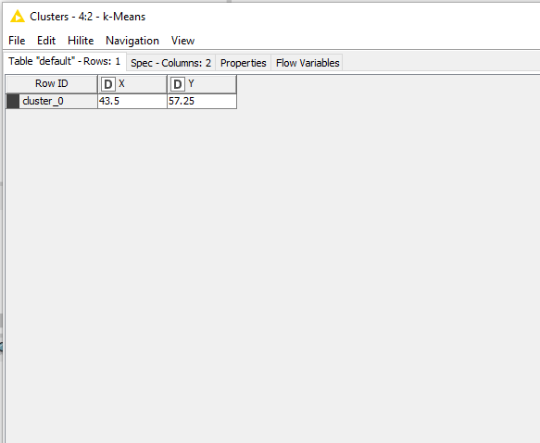

**Using weka**

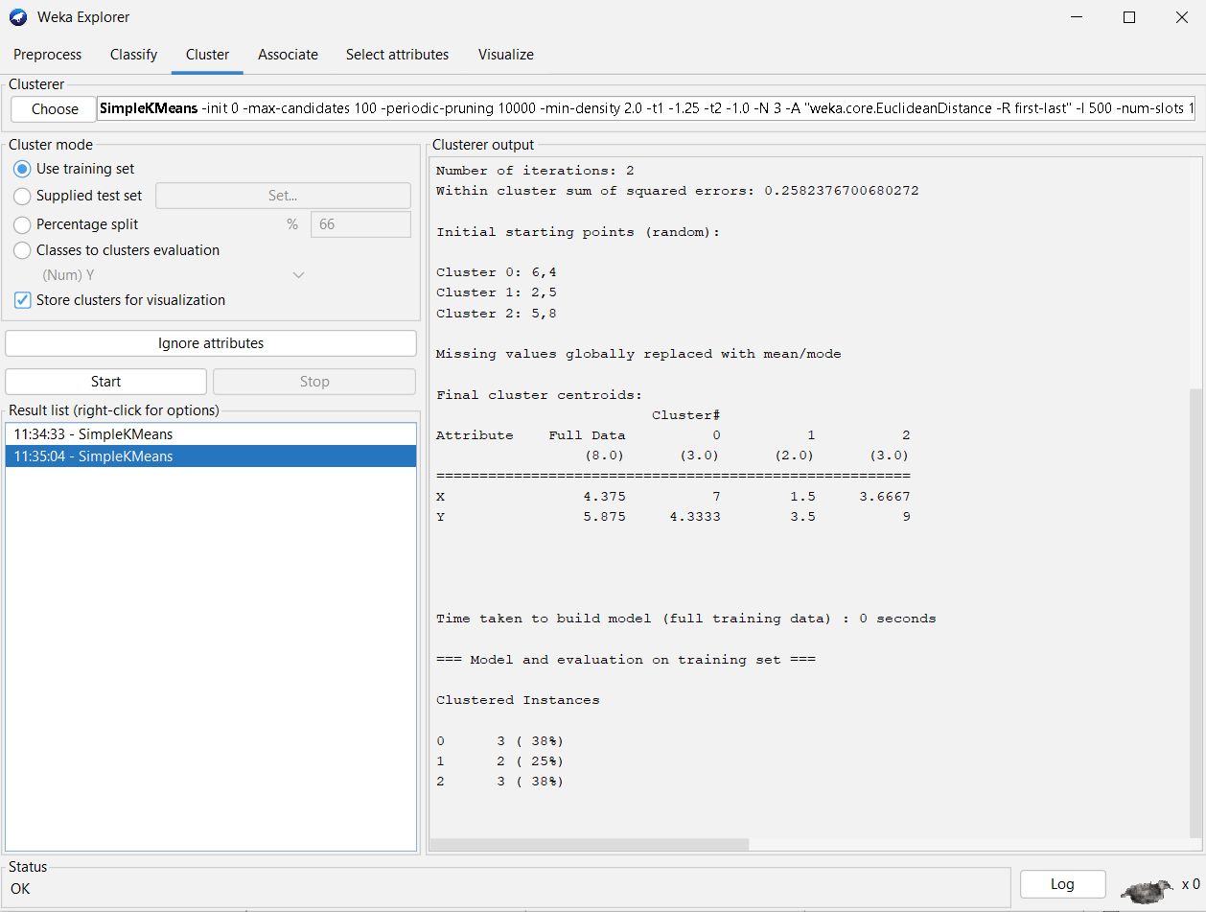

**Program:**

import java.lang.*;

import java.util.*;

import java.io.*;

public class Clustering

{

public static void main(String[] args) throws Exception

{

List<int[]> data=new ArrayList<>();

data.add(new int[]{3,4});

data.add(new int[] {13,27});

data.add(new int[]{15,10});

data.add(new int[] {20,30});

int n=data.size();

int sum_x=0;

int sum_y=0;

for(int i=0;i<n;i++)

{

sum_x+=data.get(i)[0];

sum_y+=data.get(i)[1];

}

sum_x/=data.size();

sum_y/=data.size();

int cx=sum_x;

int cy=sum_y;

double[][] matrix=new double[data.size()+1][data.size()];

for(int i=0;i<data.size();i++)

{

int x=data.get(i)[0];

int y=data.get(i)[1];

matrix[0][i]=Math.sqrt((x-cx)*(x-cx) + (y-cy)*(y-cy));

}

for(int i=0;i<data.size();i++)

{

int x=data.get(i)[0];

int y=data.get(i)[1];

for(int j=i;j<data.size();j++)

{

int x1=data.get(j)[0];

int y1=data.get(j)[1];

matrix[i+1][j]=Math.sqrt((x-x1)*(x-x1) + (y-y1)*(y-y1));

}

}

PrintWriter out=new PrintWriter(new File("cluster_out.csv"));

out.printf("%s,"," ");

for(int i=0;i<data.size();i++)

{

out.printf("%s,","P"+(i+1));

}

out.printf("\n");

for(int i=0;i<=data.size();i++)

{

if(i==0)

out.printf("%s,","C");

else

out.printf("%s,","P"+i);

for(int j=0;j<data.size();j++)

{

out.printf("%.3f,",matrix[i][j]);

}

out.printf("\n");

}

out.close();

}

}

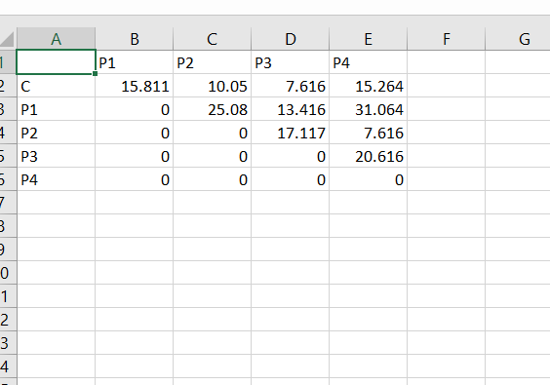

Conclusion:

Successfully performed clustering.

Experiment no.10

Agglomerative hierarchical clustering

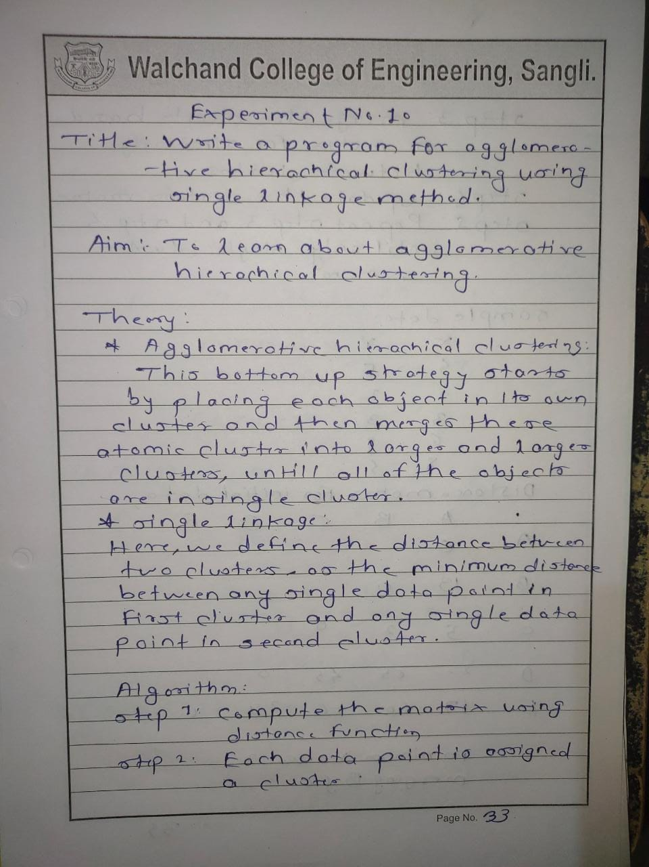

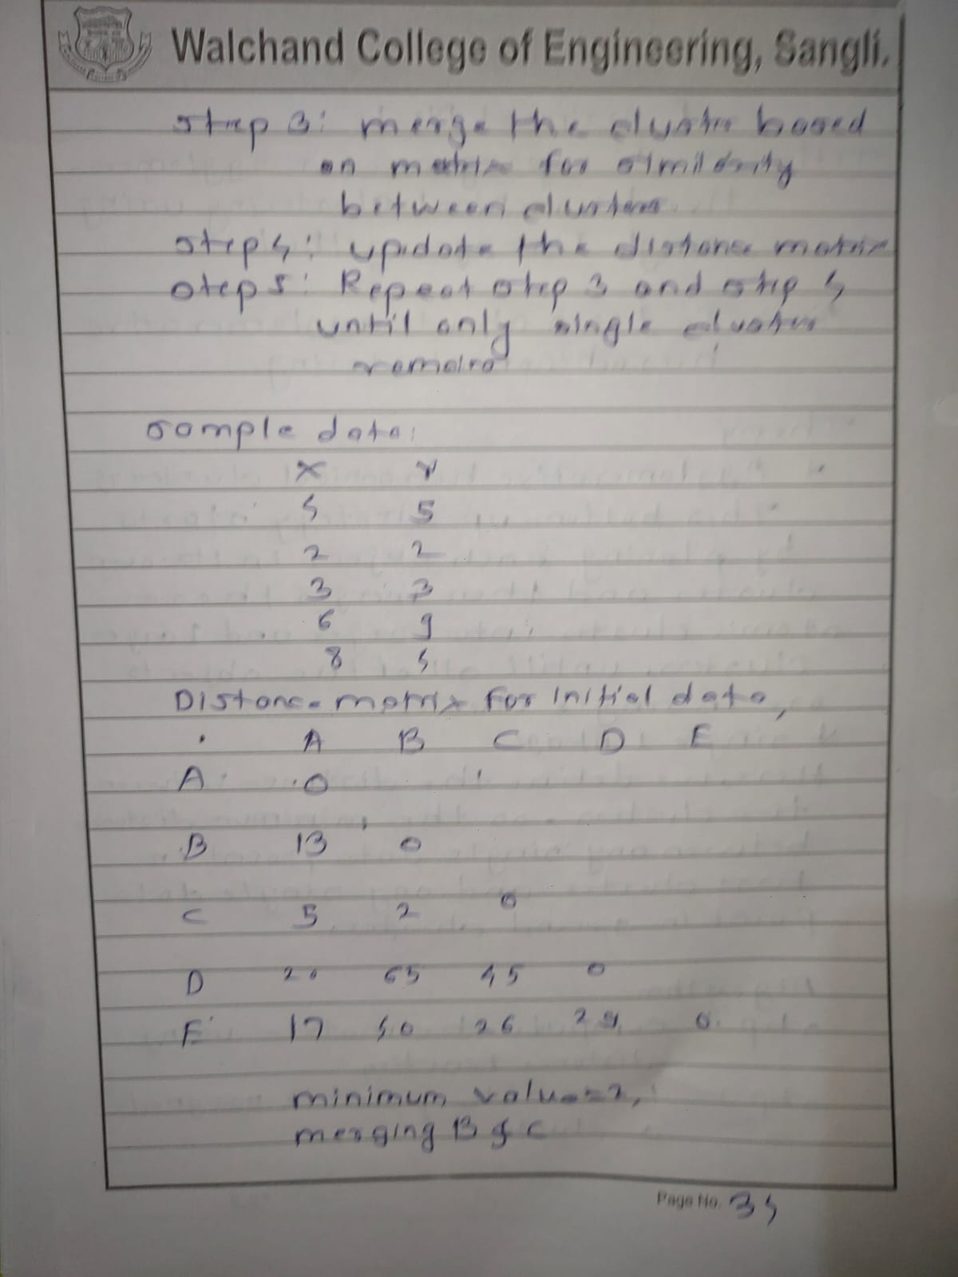

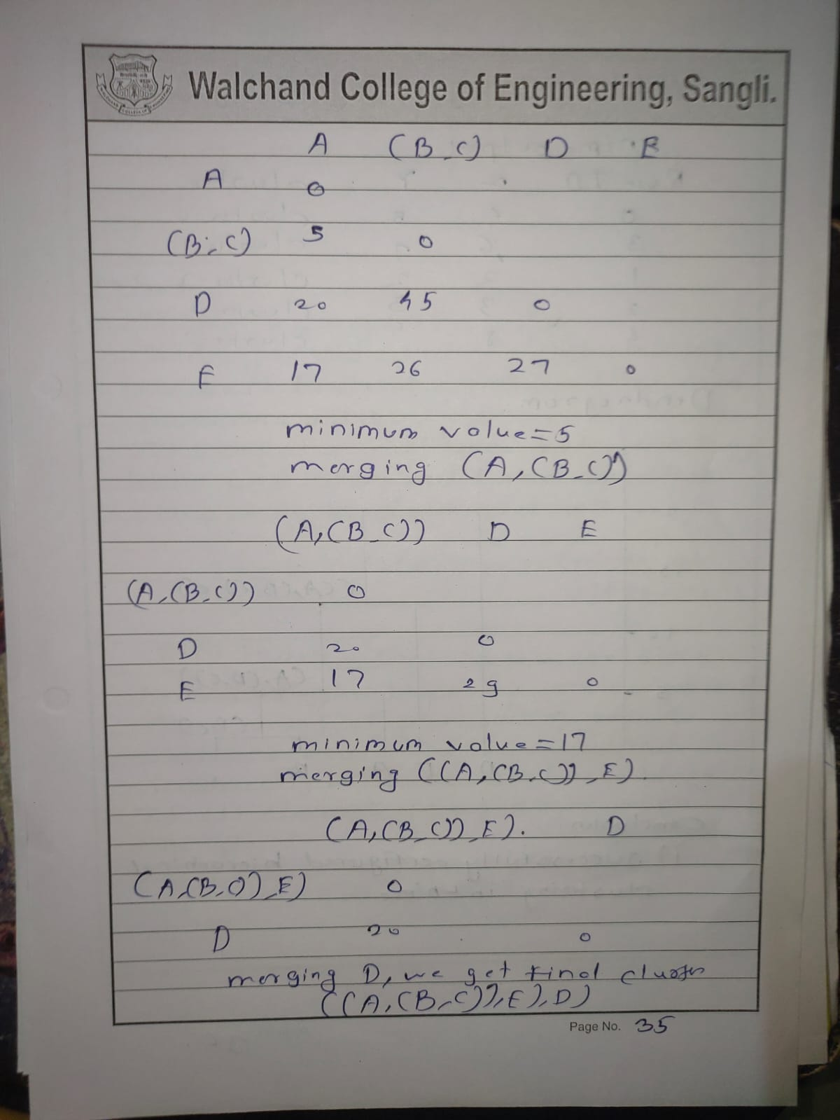

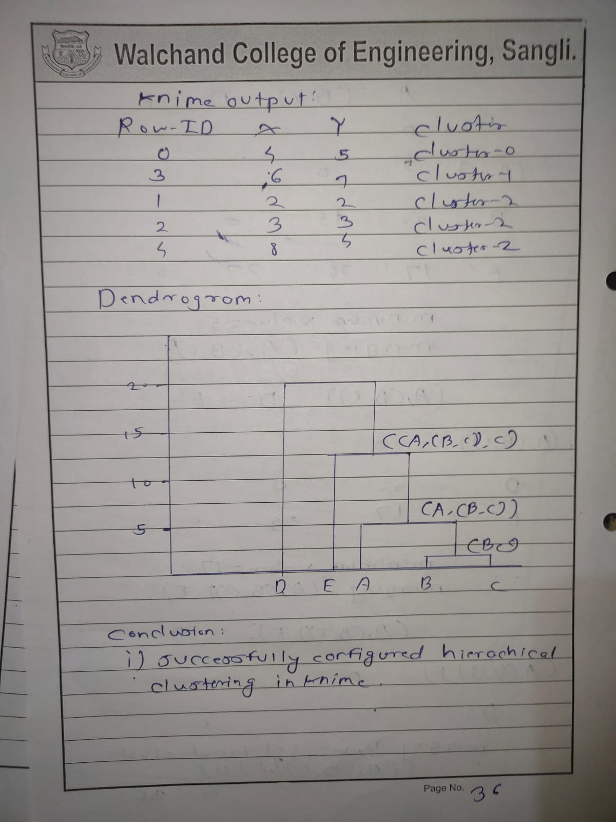

Using knime

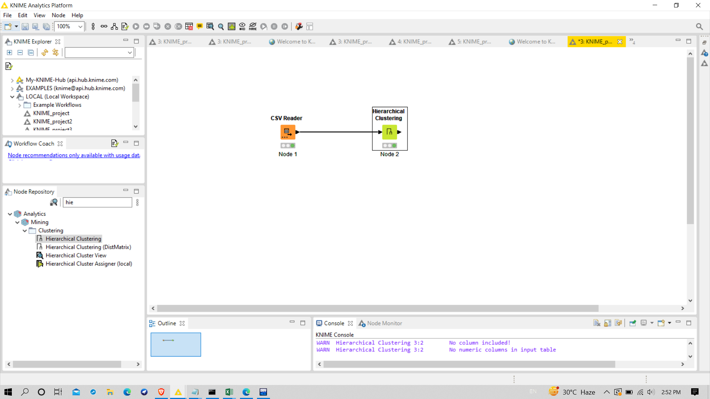

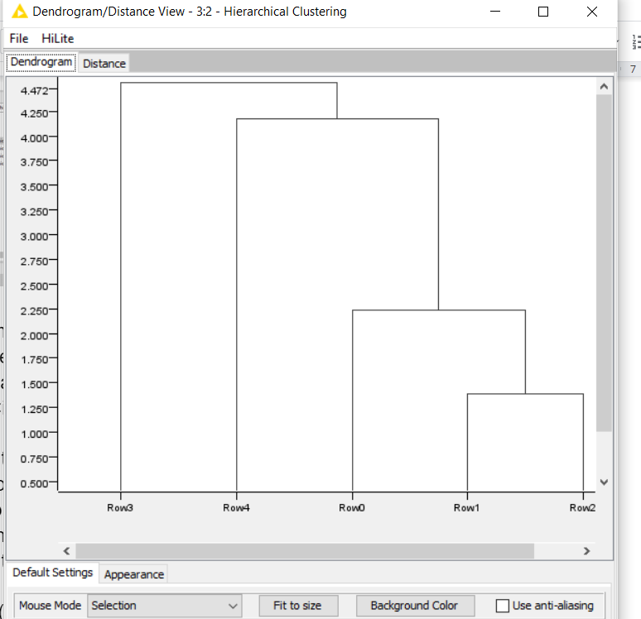

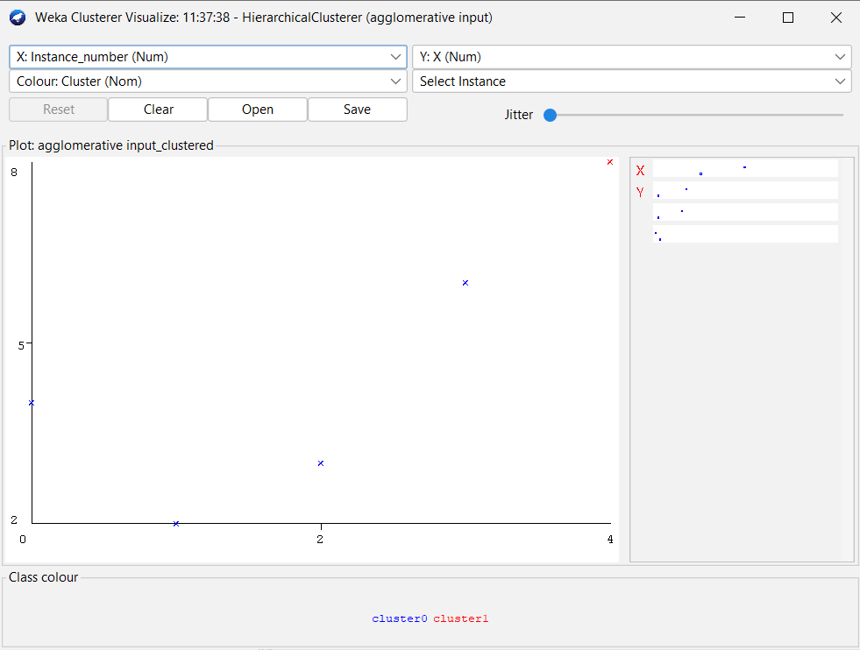

Program:

#include<bits/stdc++.h>

using namespace std;

vector<int> calmin(vector<vector<double>>arr)

{

int tr,tc;

vector<int>v;

double min1=arr[1][0];

int cnt=0;

// cout<<arr.size()<<"hi"<<endl;

for(int i=0;i<arr.size();i++)

{

for(int j=i+1;j<arr[i].size();j++)

{

if(min1>arr[i][j])

{

min1=arr[i][j];

tr=j;

tc=i;

}

else if(min1==arr[i][j])

{

if(cnt==0)

{

tr=j;

tc=i;

}

cnt++;

}

}

}

cout<<min1<<endl;

v.push_back(tr);

v.push_back(tc);

return v;

}

int main()

{

fstream fin("points.csv",ios::in);

vector<vector<string> > content;

vector<string> row;

string line, word;

if(fin.is_open())

{

while(getline(fin,line))

{

// cout<<line<<endl;

row.clear();

stringstream s(line);

while(getline(s,word,','))

{

row.push_back(word);

}

content.push_back(row);

}

}

vector<vector<double>>arr(content.size(),vector<double>(content.size(),0.0));

// vector<vector<double>>arr{{0,0.71,5.66,3.61,4.24,3.20},

// {0.71,0,4.95,2.92,3.54,2.50},

// {5.66,4.95,0,2.24,1.41,2.50},

// {3.61,2.92,2.24,0,1.00,0.50},

// {4.24,3.54,1.41,1.00,0,1.12},

// {3.20,2.50,2.50,0.50,1.12,0}};

for(int i=0;i<arr.size();i++)

{

for(int j=0;j<arr.size();j++)

{

cout<<arr[i][j]<<" ";

}

cout<<endl;

}

double arr1[content.size()][content.size()];

for(int i=0;i<content.size();i++)

{

for(int j=i+1;j<content.size();j++)

{

double ans=0;

for(int k=0;k<content[0].size();k++)

{

ans+=pow(stoi(content[i][k])-stoi(content[j][k]),2);

}

// cout<<ans<<" ";

ans=sqrt(ans);

arr[i][j]=ans;

arr[j][i]=ans;

}

}

vector<string>v(arr.size(),"");

for(int i=0;i<v.size();i++)

{

v[i]=to_string(i);

}

int tr,tc;

double min1=arr[1][0];

while(arr.size()!=2)

{

vector<int>pos=calmin(arr);

tr=pos[0];

tc=pos[1];

if(tr<tc)

{

v[tr]="("+v[tr]+","+v[tc]+")";

v.erase(v.begin()+tc);

}

else

{

v[tc]="("+v[tc]+","+v[tr]+")";

v.erase(v.begin()+tr);

}

//cout<<tr<<tc<<endl;

//break;

for(int i=0;i<arr.size();i++)

{

if(tr<tc && tr!=i)

{

arr[tr][i]=min(arr[tr][i],arr[tc][i]);

arr[i][tr]=arr[tr][i];

}

else if(tc<tr && tc!=i)

{

arr[tc][i]=min(arr[tr][i],arr[tc][i]);

arr[i][tc]=arr[tc][i];

}

}

if(tr<tc)

{

arr.erase(arr.begin()+tc);

for(int i=0;i<arr.size();i++)

{

arr[i].erase(arr[i].begin()+tc);

}

}

else

{

arr.erase(arr.begin()+tr);

for(int i=0;i<arr.size();i++)

{

arr[i].erase(arr[i].begin()+tr);

}

}

for(int i=0;i<arr.size();i++)

{

for(int j=0;j<arr.size();j++)

{

cout<<arr[i][j]<<" ";

}

cout<<endl;

}

}

v[0]="("+v[0]+","+v[1]+")";

cout<<v[0];

}

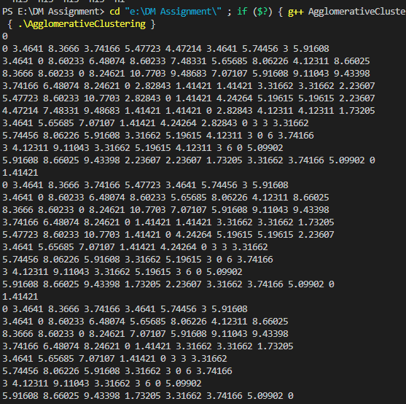

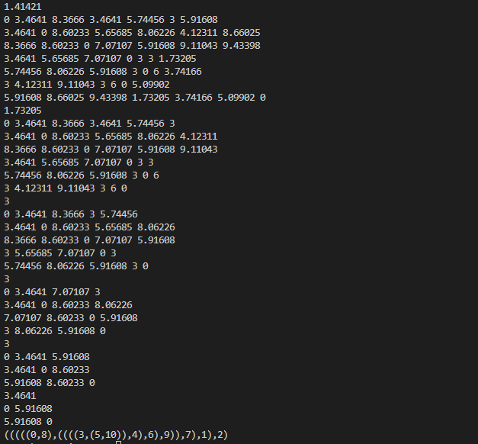

**Experiment no.11**

**Attribute for classification**

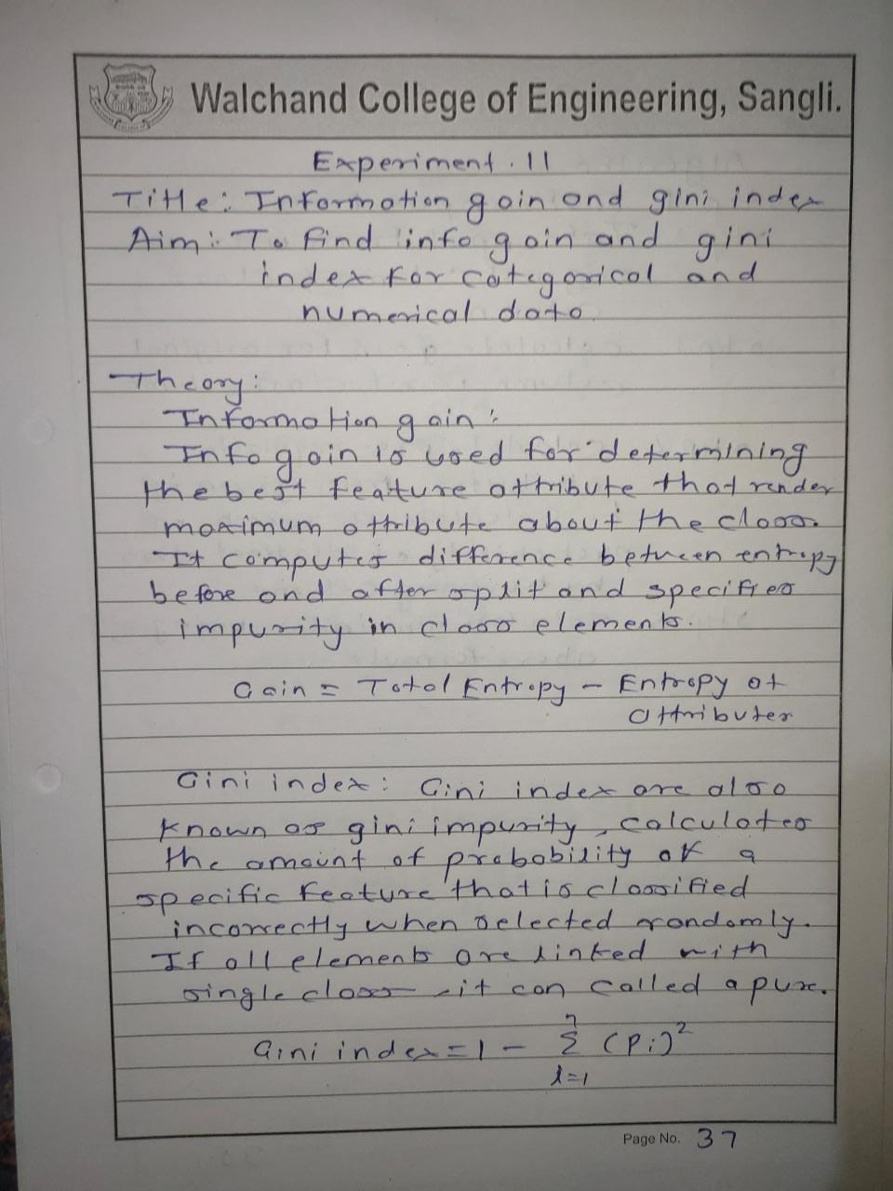

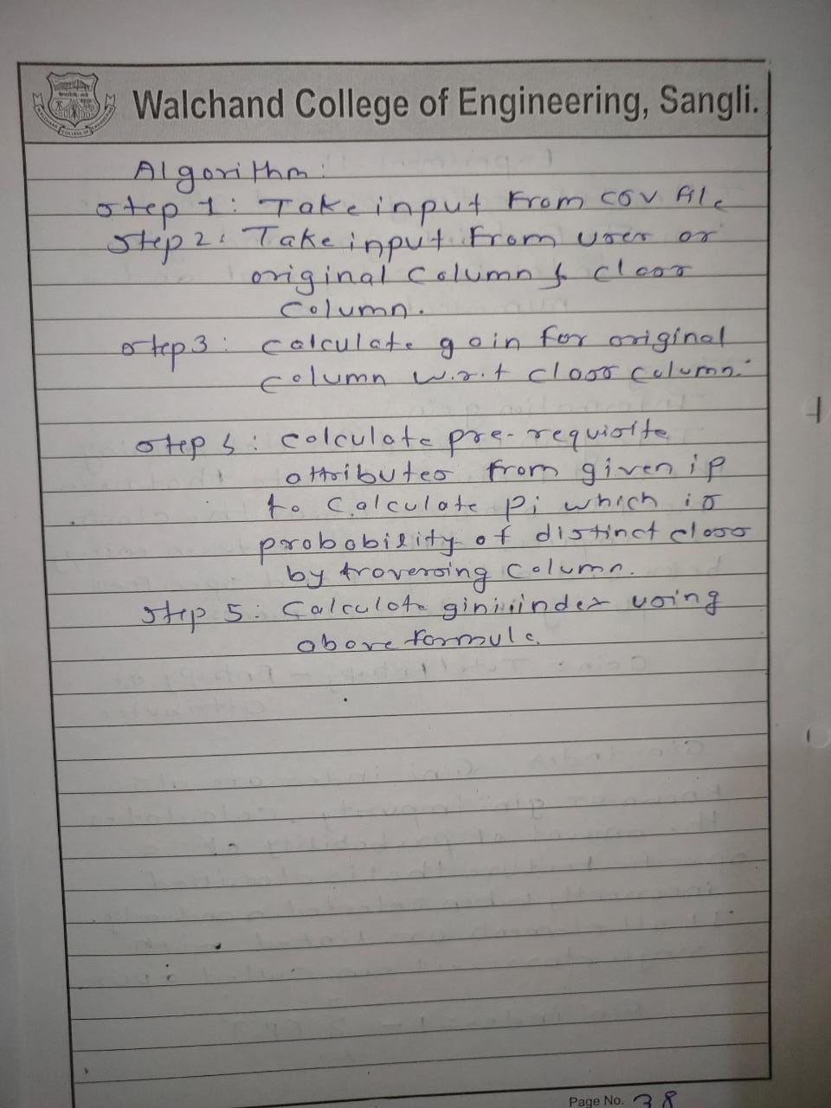

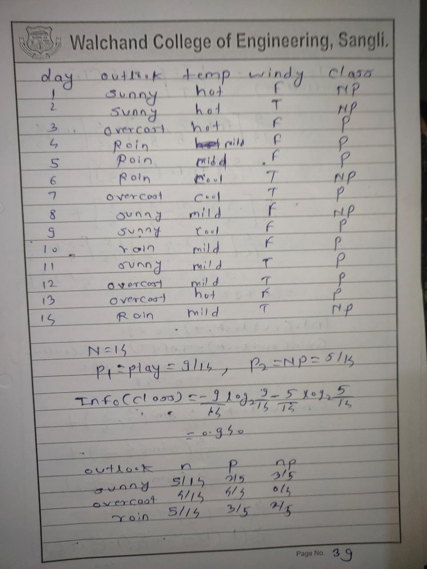

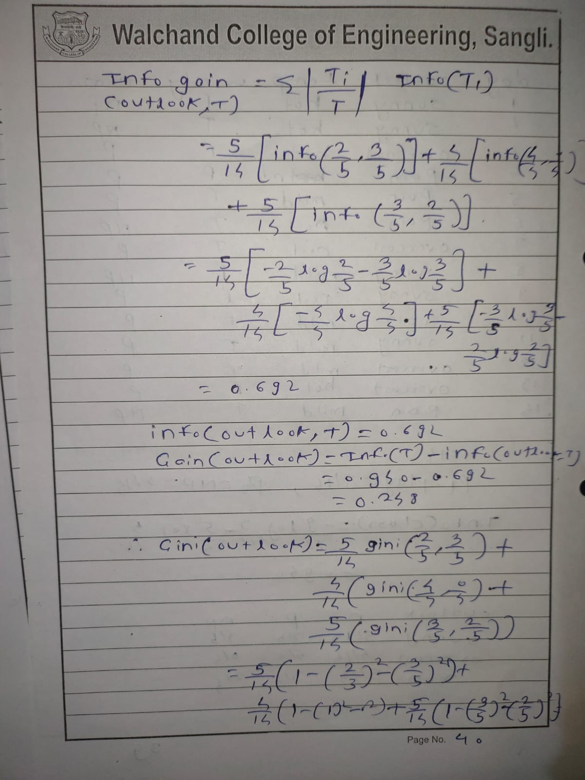

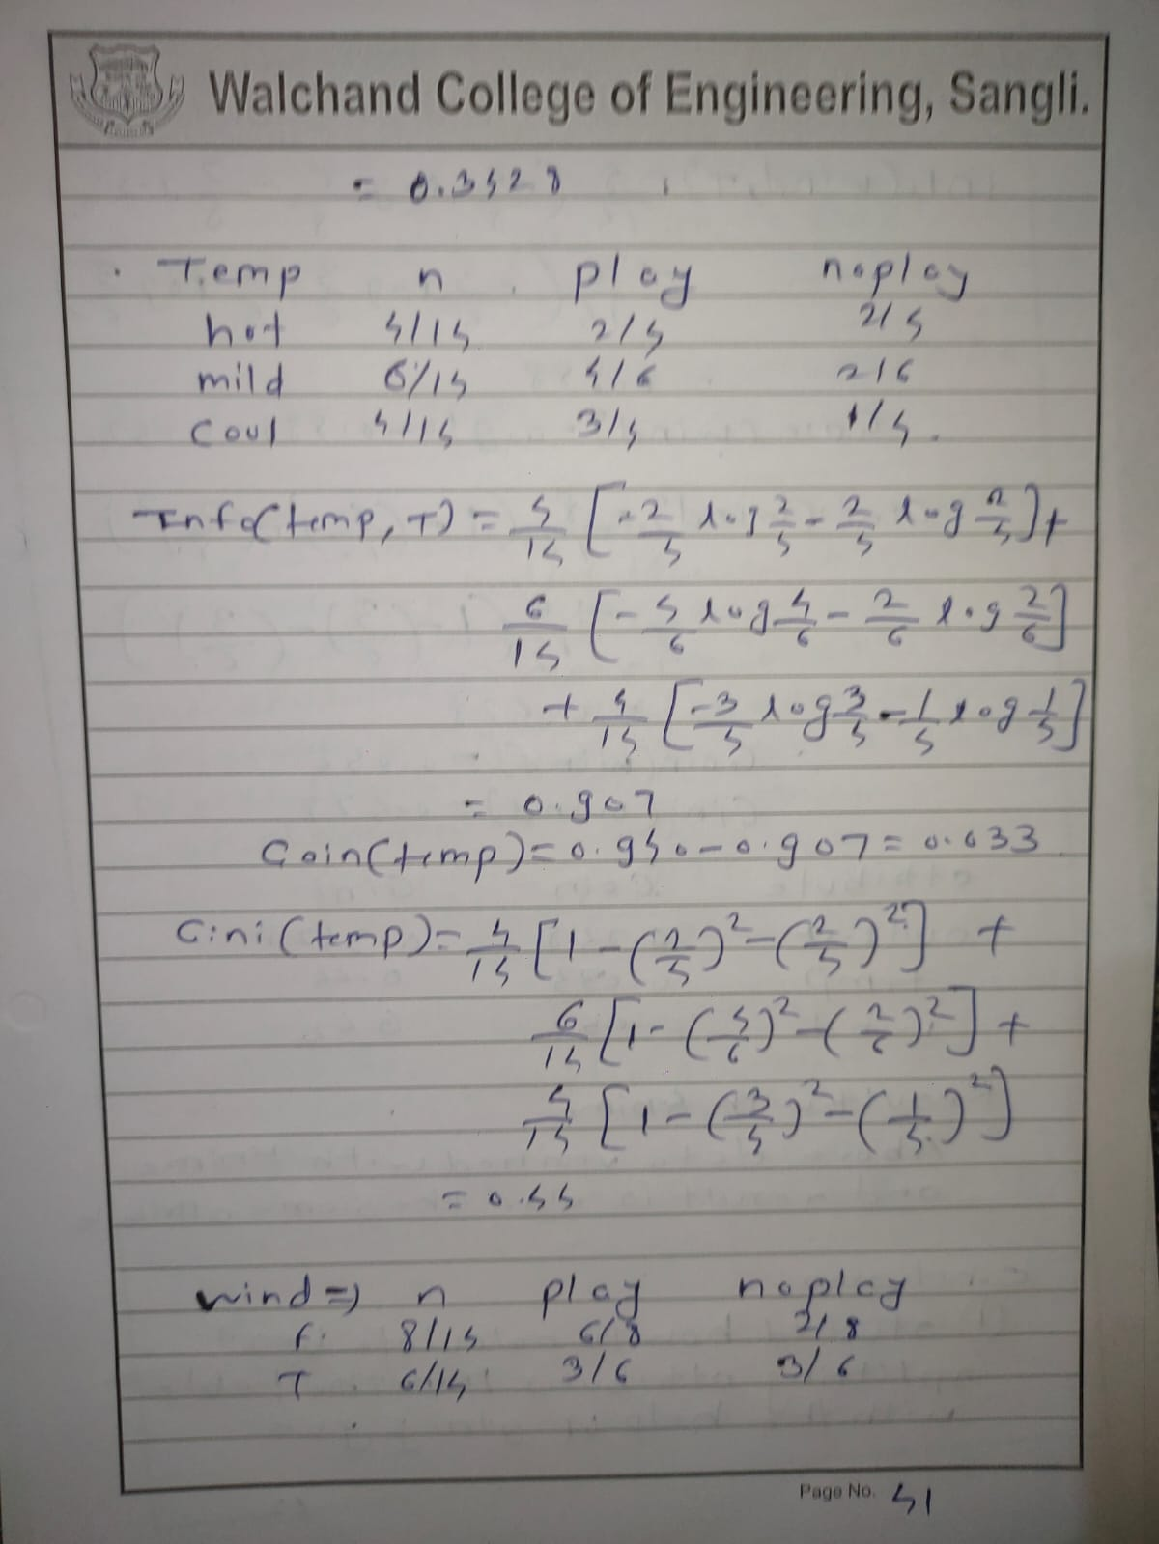

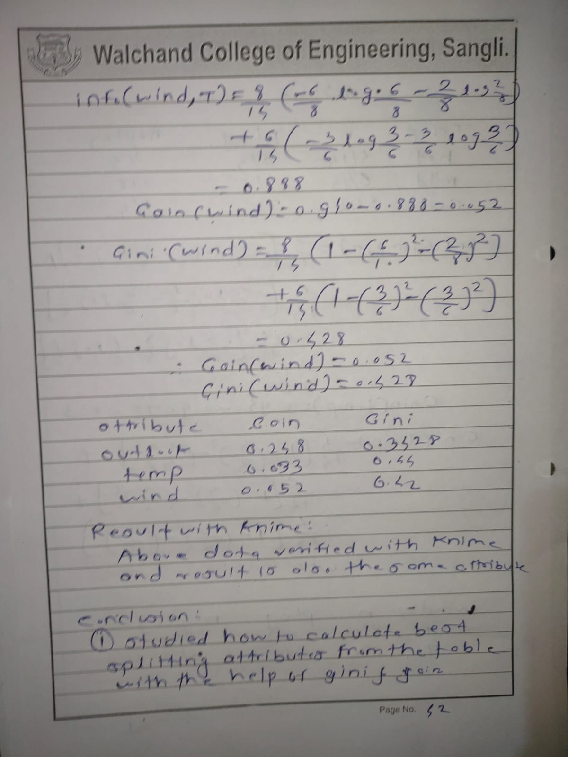

**Using knime**

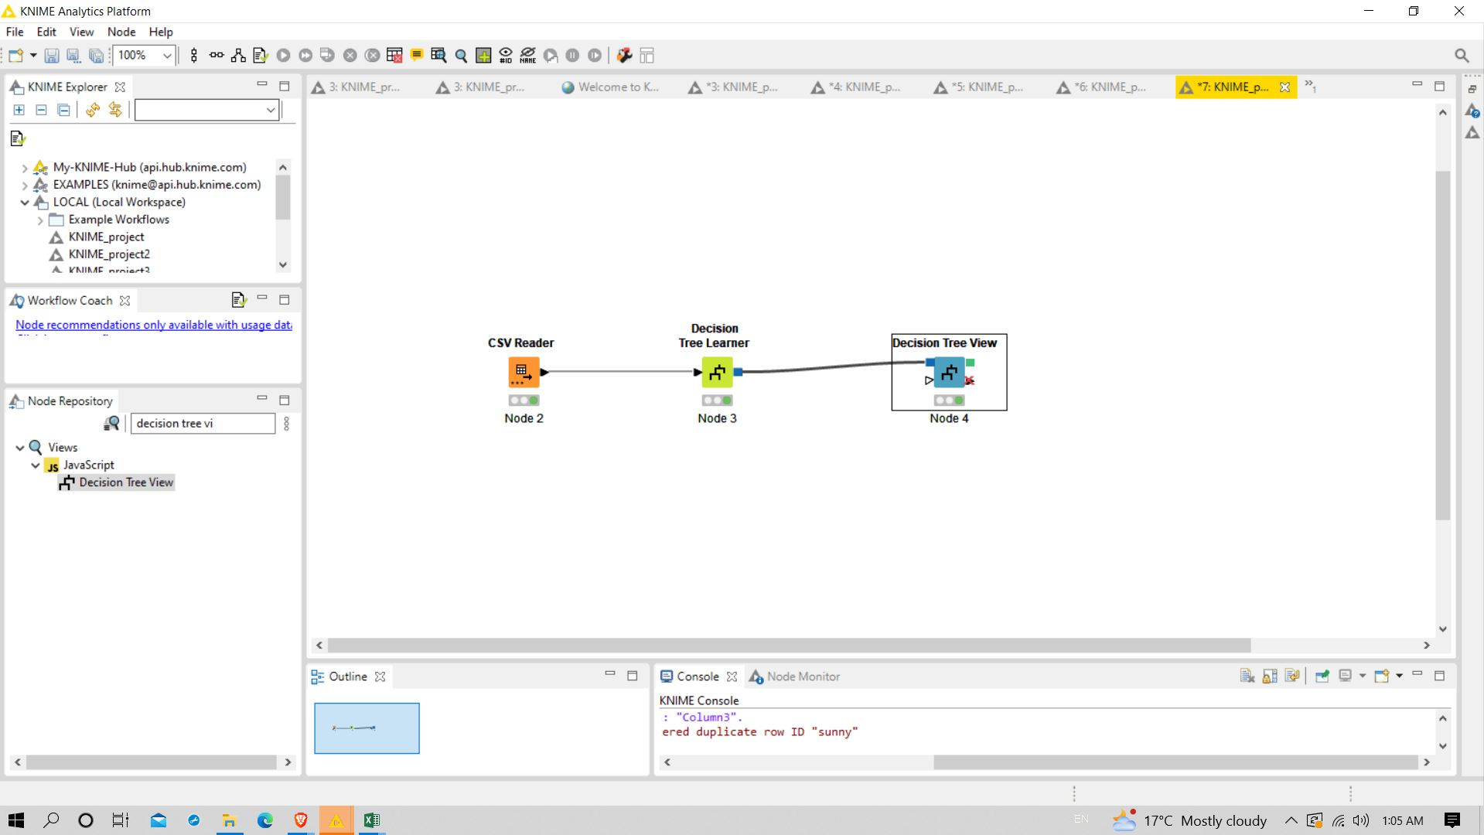

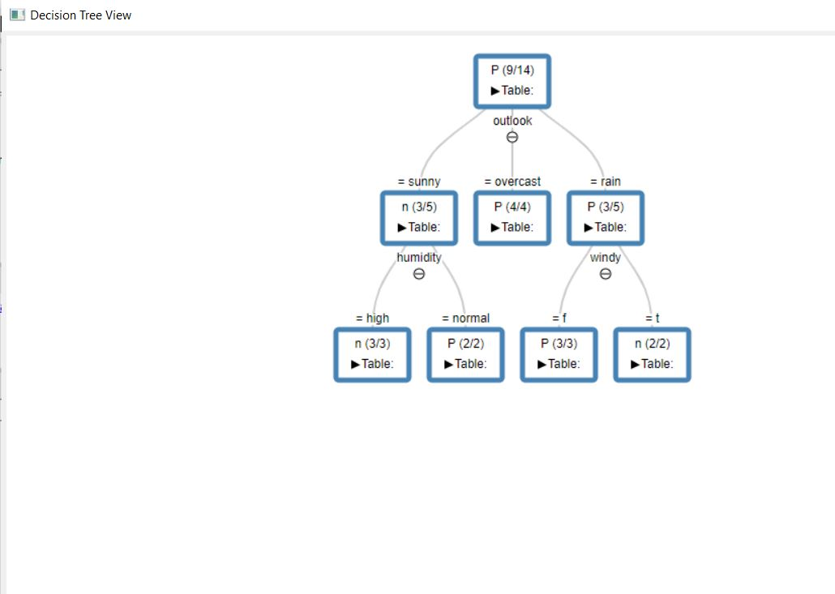

**Using weka**

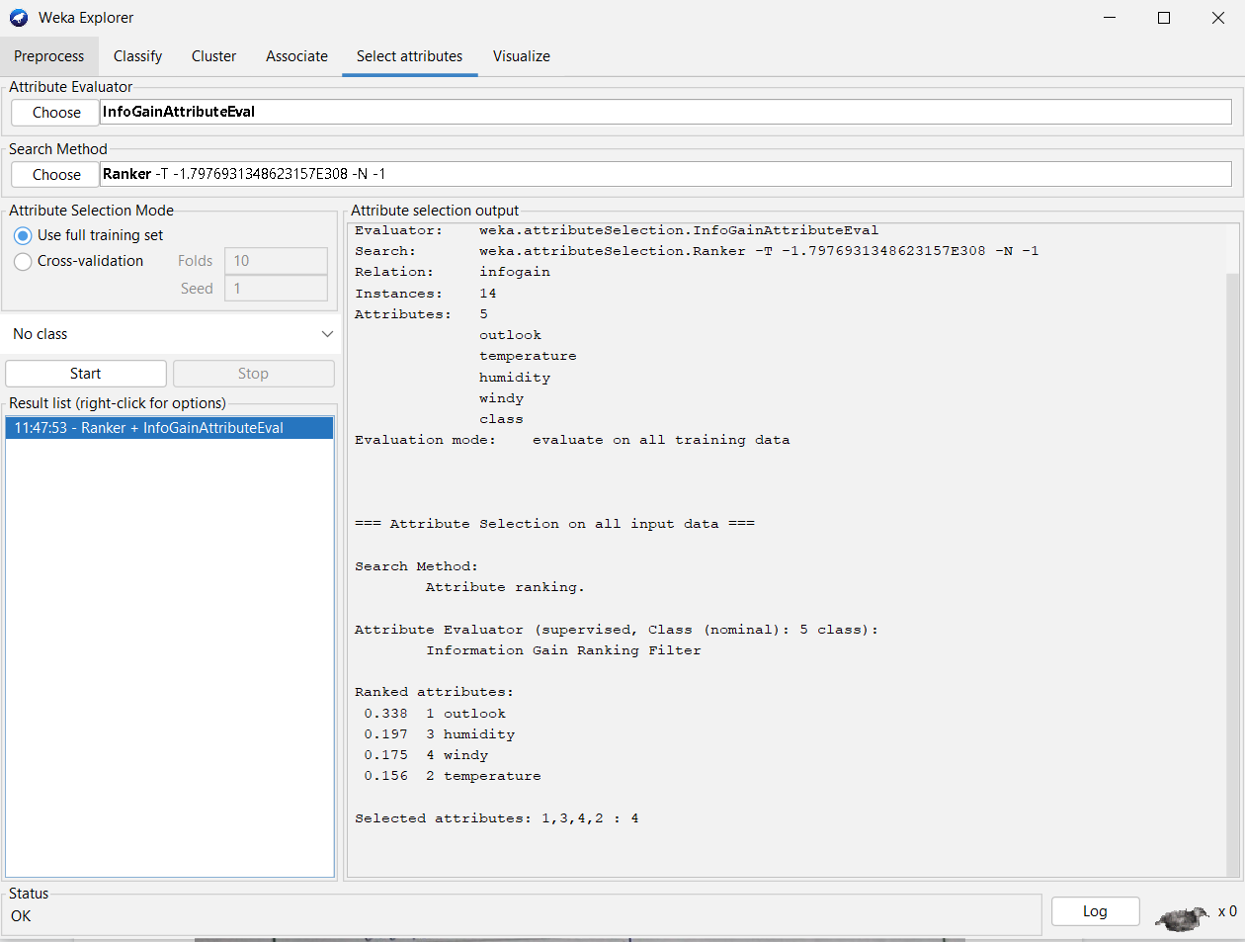

**Program:**

import java.lang.*;

import java.util.*;

import java.io.*;

public class Gain_Gini

{

public static void main(String[] args) throws Exception

{

BufferedReader br = new BufferedReader(new FileReader("data1.csv"));

ArrayList<ArrayList<String>> data = new ArrayList<>();

String line="";

while((line=br.readLine())!=null)

{

String str[] =line.split(",");

ArrayList<String> temp = new ArrayList<>();

for (String s : str)

temp.add(s);

data.add(temp);

}

int play = 0, noPlay = 0;

for (int i = 0; i < data.size(); i++) {

if (data.get(i).get(4).equals("Play"))//considering target value as 5th attribute

play++;

else

noPlay++;

}

double totRecord = data.size();

double infoGain= -((1.0 * play / totRecord) * (Math.log(1.0 * play / totRecord)) / Math.log(2)) - ((1.0 * noPlay / totRecord) * (Math.log(1.0 * noPlay / totRecord) / Math.log(2)));

PrintWriter out=new PrintWriter(new File("gain_gini_out.csv"));

out.printf("%s,%s,%s","Attribute","Info_Gain","Gini_Index");

out.printf("\n");

for(int i=0;i<data.get(0).size()-1;i++)

{

double[] ans=findGainGini(i,infoGain,data);

out.printf("%s,%.3f,%.3f\n",data.get(0).get(i),ans[0],ans[1]);

}

out.close();

}

private static double[] findGainGini(int i, double infoGain, ArrayList<ArrayList<String>> data) {

Set<String> attribute=new HashSet<>();

for(ArrayList<String>x:data)

attribute.add(x.get(i));

Map<String,double[]>total=new HashMap<>();

for(String x:attribute)

{

total.put(x,new double[2]);

}

for(ArrayList<String> x:data)

{

if(x.get(4).equals(("Play")))

total.get(x.get(i))[0]++;

else

total.get(x.get(i))[1]++;

}

double totalE=0.0;

for(Map.Entry<String,double[]> x:total.entrySet())

{

double total1=x.getValue()[0]+x.getValue()[1];

if(x.getValue()[0]==0||x.getValue()[1]==0)

continue;

double temp= -((1.0 * x.getValue()[0] / total1) * (Math.log(1.0 * x.getValue()[0] / total1)) / Math.log(2)) - ((1.0 * x.getValue()[1]/ total1) * (Math.log(1.0 * x.getValue()[1] / total1) / Math.log(2)));

totalE+=(total1/ data.size())*temp;

}

double totalG=0;

for(Map.Entry<String,double[]> p:total.entrySet())

{

double total2=p.getValue()[0] + p.getValue()[1];

double x=(1 - Math.pow(p.getValue()[0]/total2,2) - Math.pow(p.getValue()[1]/total2,2));

totalG+=(total2/data.size())*(x);

}

double[] result=new double[2];

double gain=infoGain-totalE;

result[0]=gain;

result[1]=totalG;

return result;

}

}

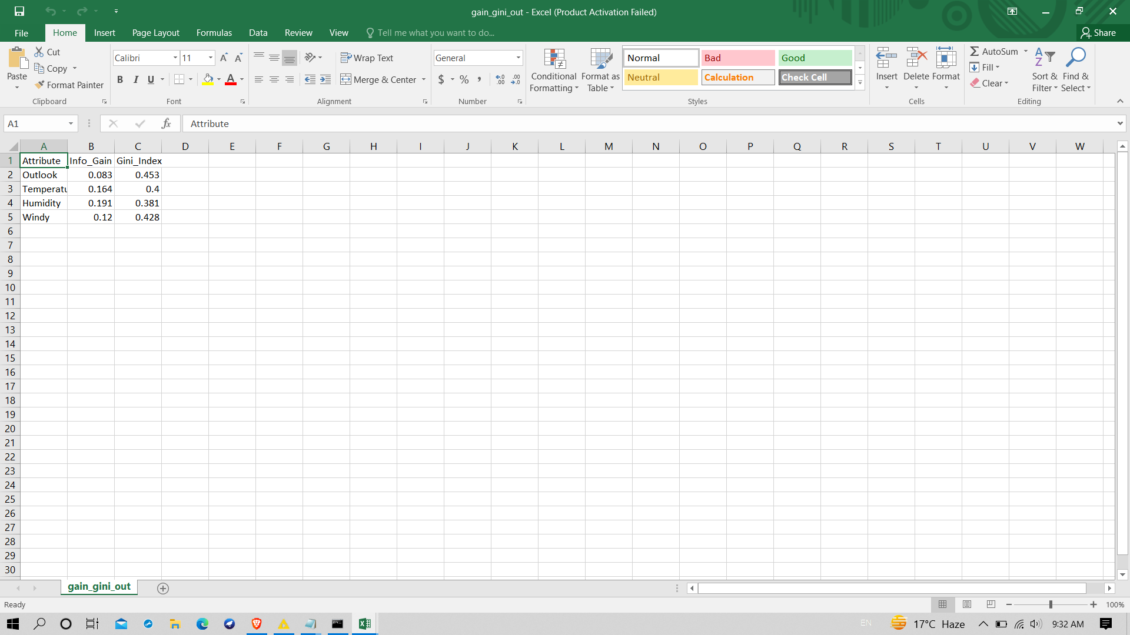

Conclusion:Successfully performed classification.

Experiment No.12

Baye’s Classification

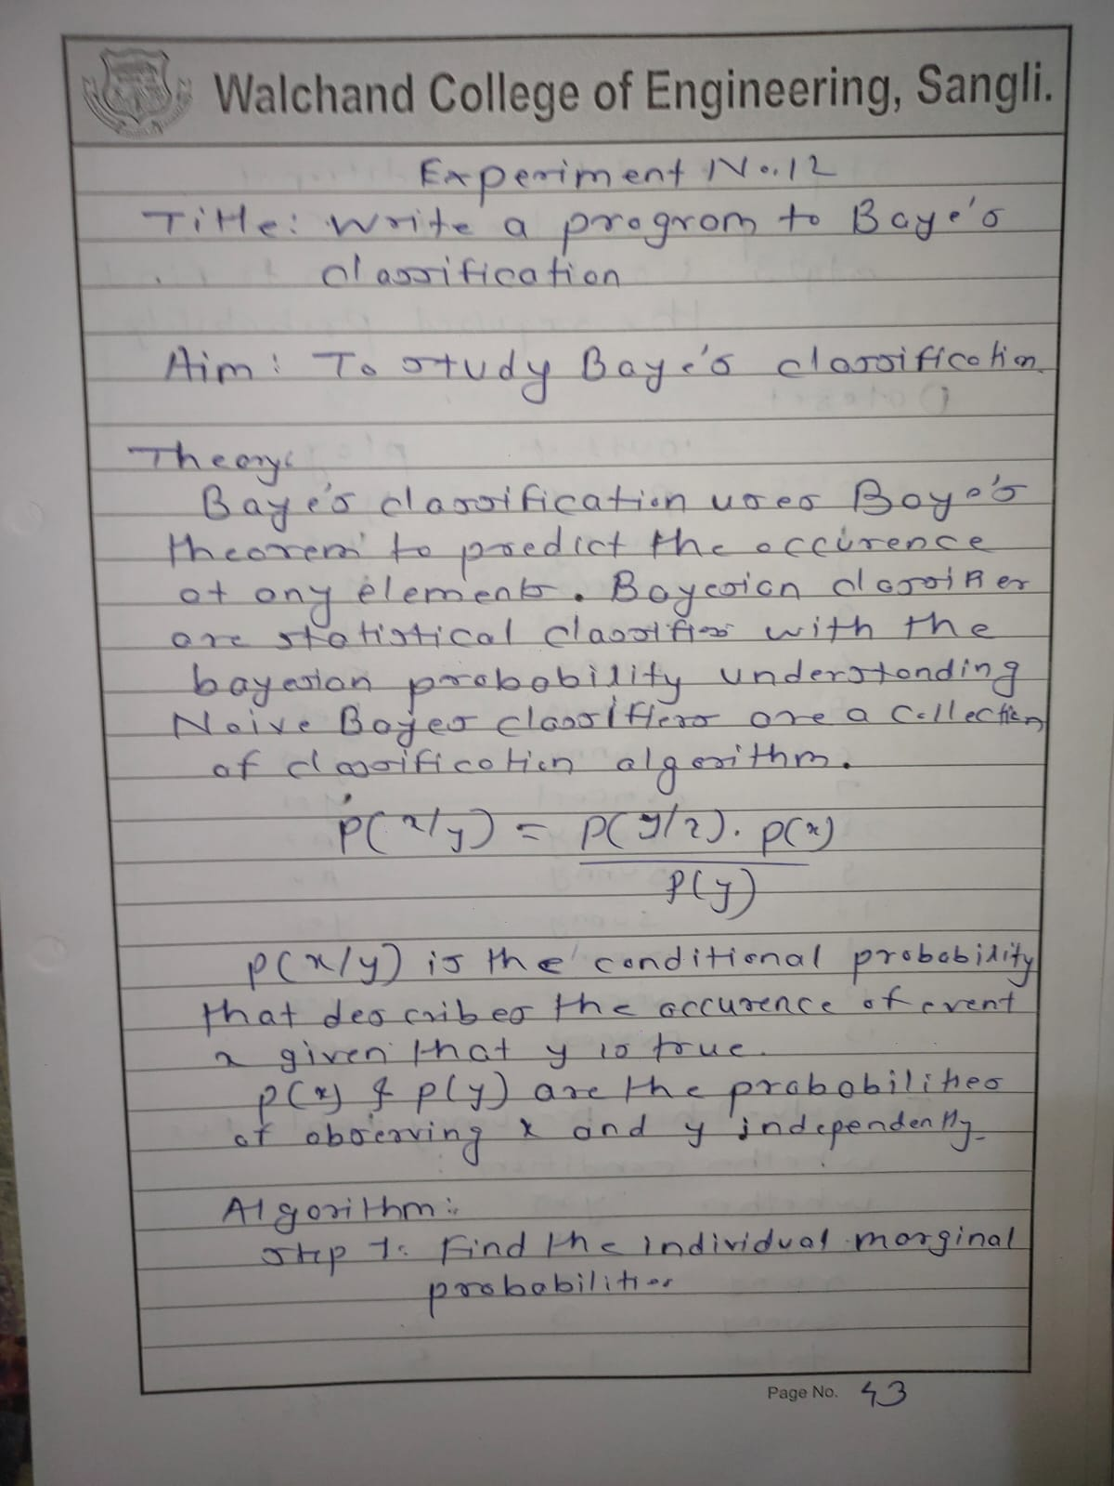

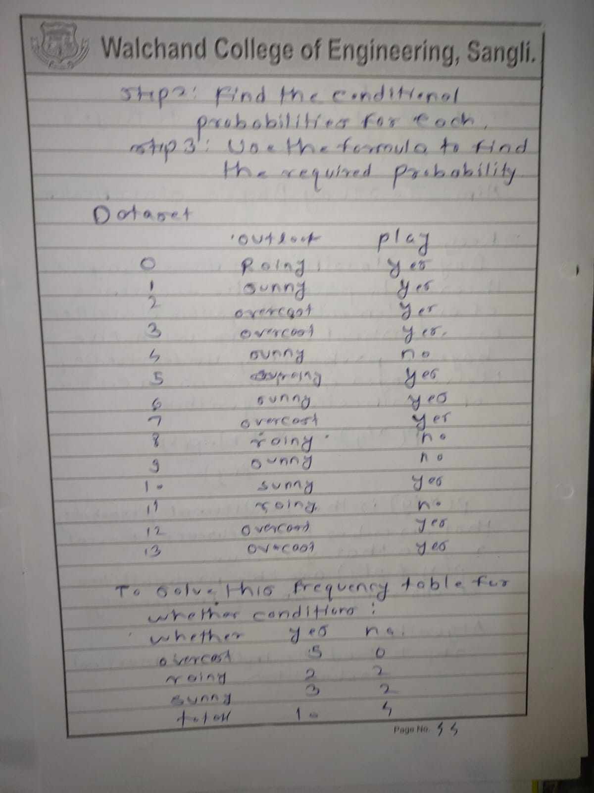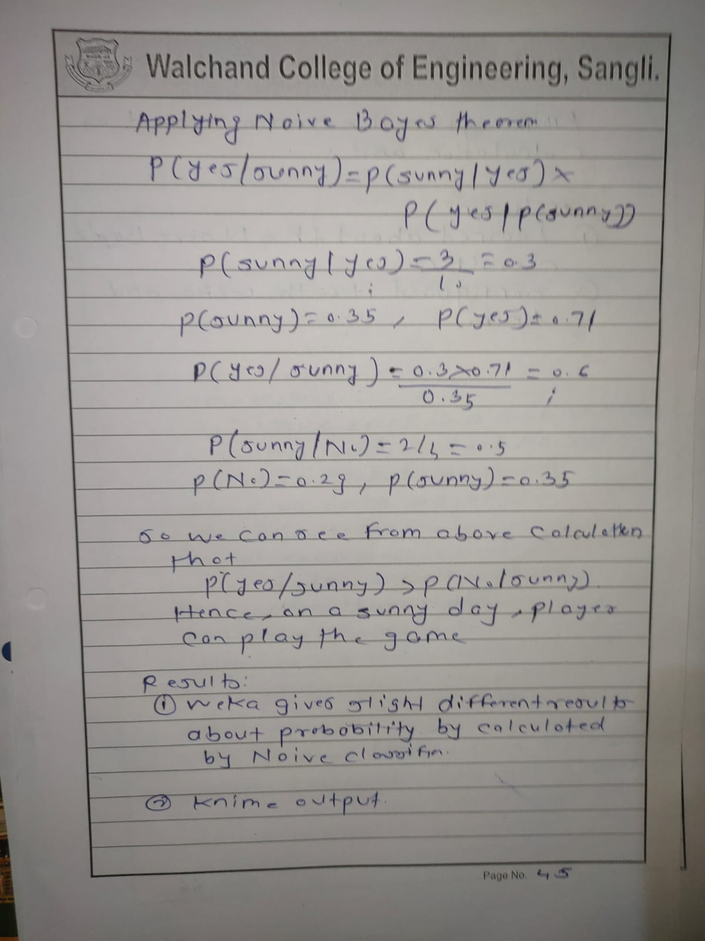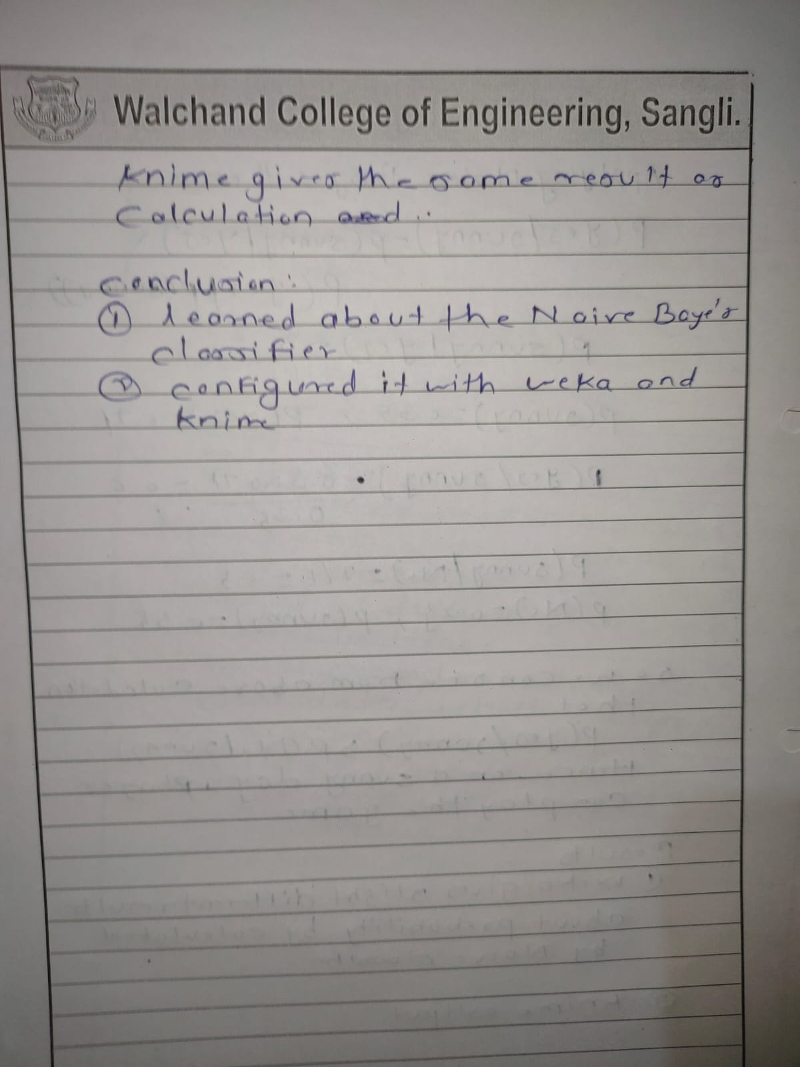

Using knime

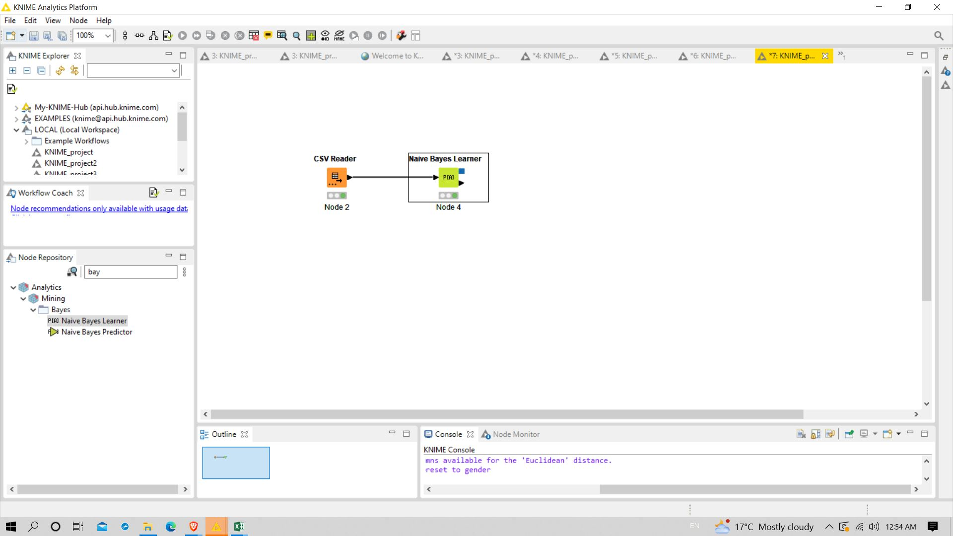

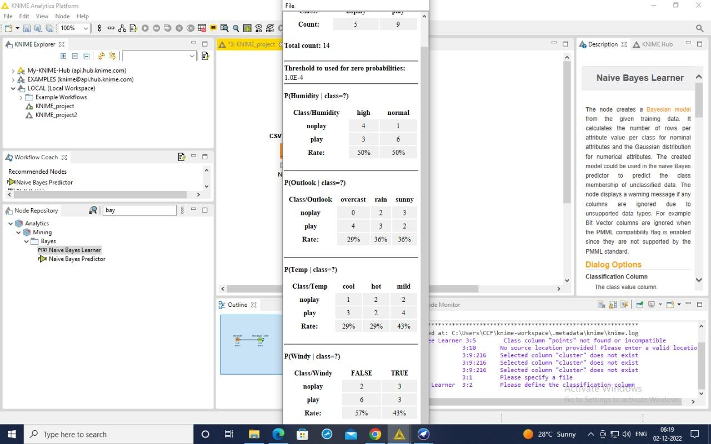

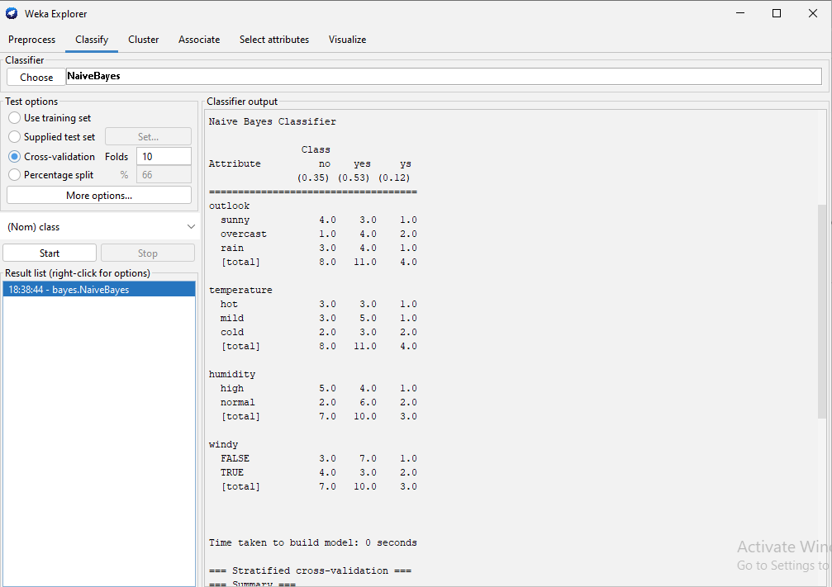

Program:

// Bayes classifier

#include <iostream>

#include <fstream>

#include <string>

#include <vector>

#include <sstream>

#include <ostream>

#include <bits/stdc++.h>

using namespace std;

int main()

{

string line, word;

ifstream file("infogain_cpp.csv");

string day, outlook, three, four, five, six;

map<string, double> parent;

map<string, map<string, map<string, double>>> child;

int count = 0;

vector<string> title;

if (file.is_open())

{

int i = 0;

while (file >> line)

{

stringstream str(line);

if (i == 0)

{

string heading;

while (getline(str, heading, ','))

{

title.push_back(heading);

}

i++;

continue;

}

vector<string> columns;

while (getline(str, day, ','))

{

columns.push_back(day);

}

int n = columns.size();

parent[columns[n - 1]]++;

for (int i = 1; i < n - 1; i++)

{

child[title[i]][columns[i]][columns[n - 1]]++;

}

count++;

}

vector<string> resultclass;

for (auto it : parent)

{

resultclass.push_back(it.first);

}

vector<double> output(resultclass.size(), 1);

for (auto it : child)

{

string input;

again:

cout << "Enter " << it.first << " condition \n";

cin >> input;

auto curr = child[it.first].find(input);

if (curr == child[it.first].end())

{

cout << "no match\n";

goto again;

}

for (int i = 0; i < resultclass.size(); i++)

{

cout << child[it.first][input][resultclass[i]] << " / " << parent[resultclass[i]] << endl;

double val = child[it.first][input][resultclass[i]] / parent[resultclass[i]];

output[i] *= val;

cout << output[i] << endl;

}

}

for (int i = 0; i < resultclass.size(); i++)

{

output[i] *= parent[resultclass[i]] / count;

}

double sum = accumulate(output.begin(), output.end(), 0.0f);

cout << "sum " << sum << endl;

cout << "output---------" << endl;

for (int i = 0; i < resultclass.size(); i++)

{

cout << resultclass[i] << " " << output[i] << endl;

cout << "Percentage " << (output[i] / sum) * 100 << endl;

}

}

else

{

cout << "Could not open the file\n";

}

return 0;

}

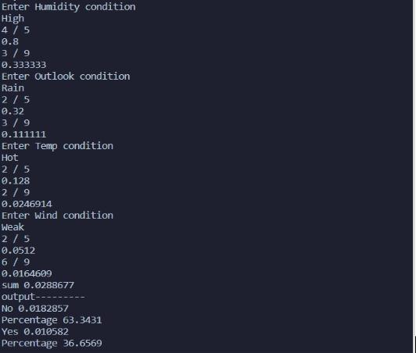

Conclusion:Successfully performed baye’s Classification.

Experiment .13

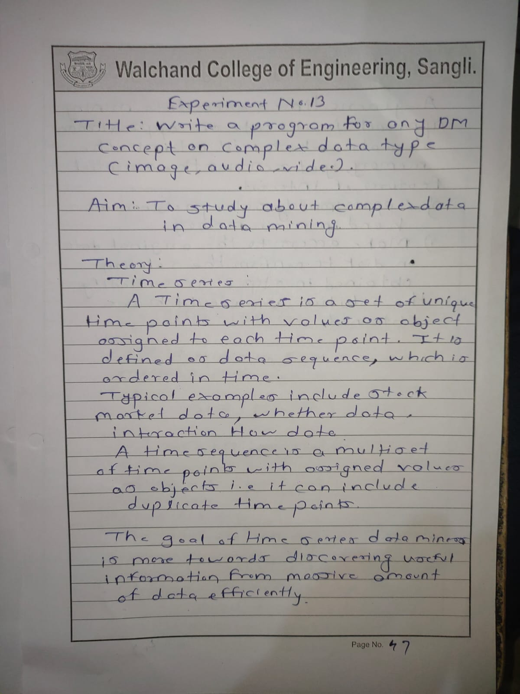

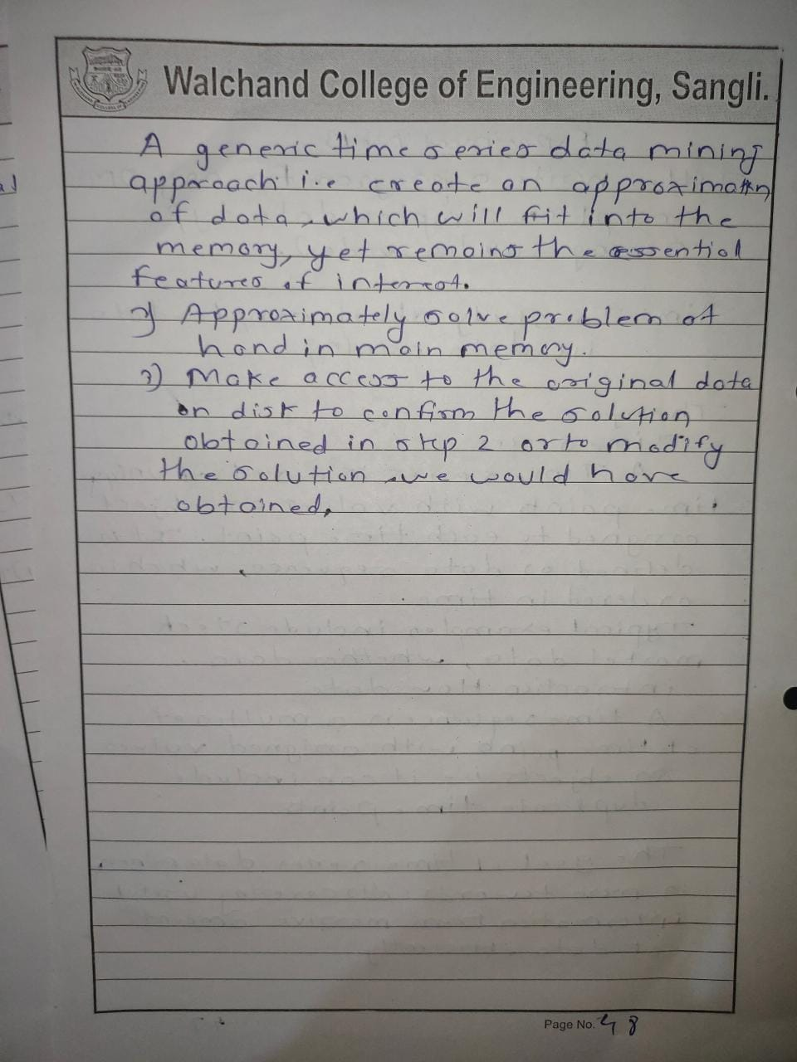

**Homework:**

